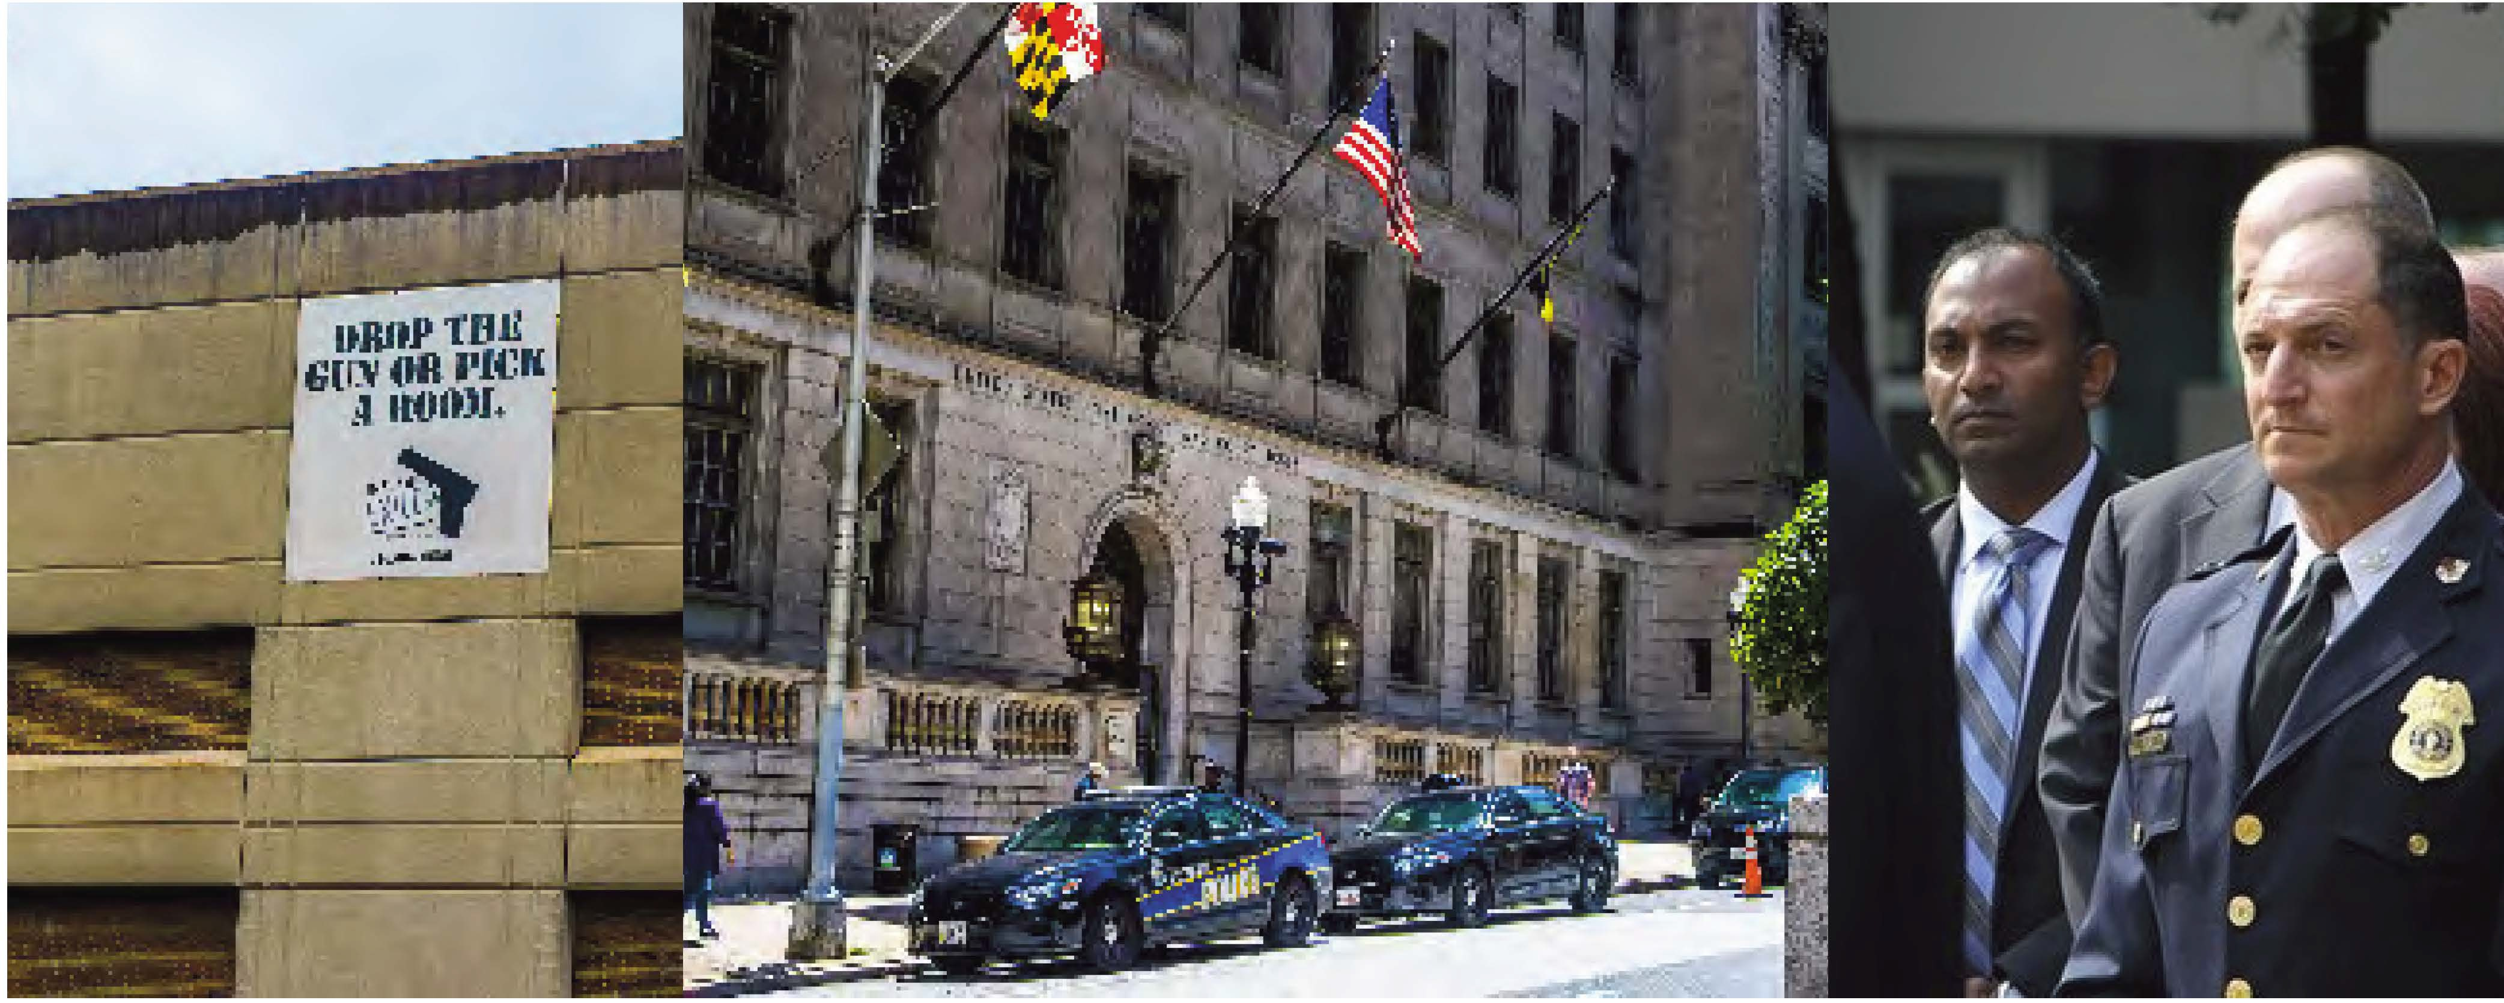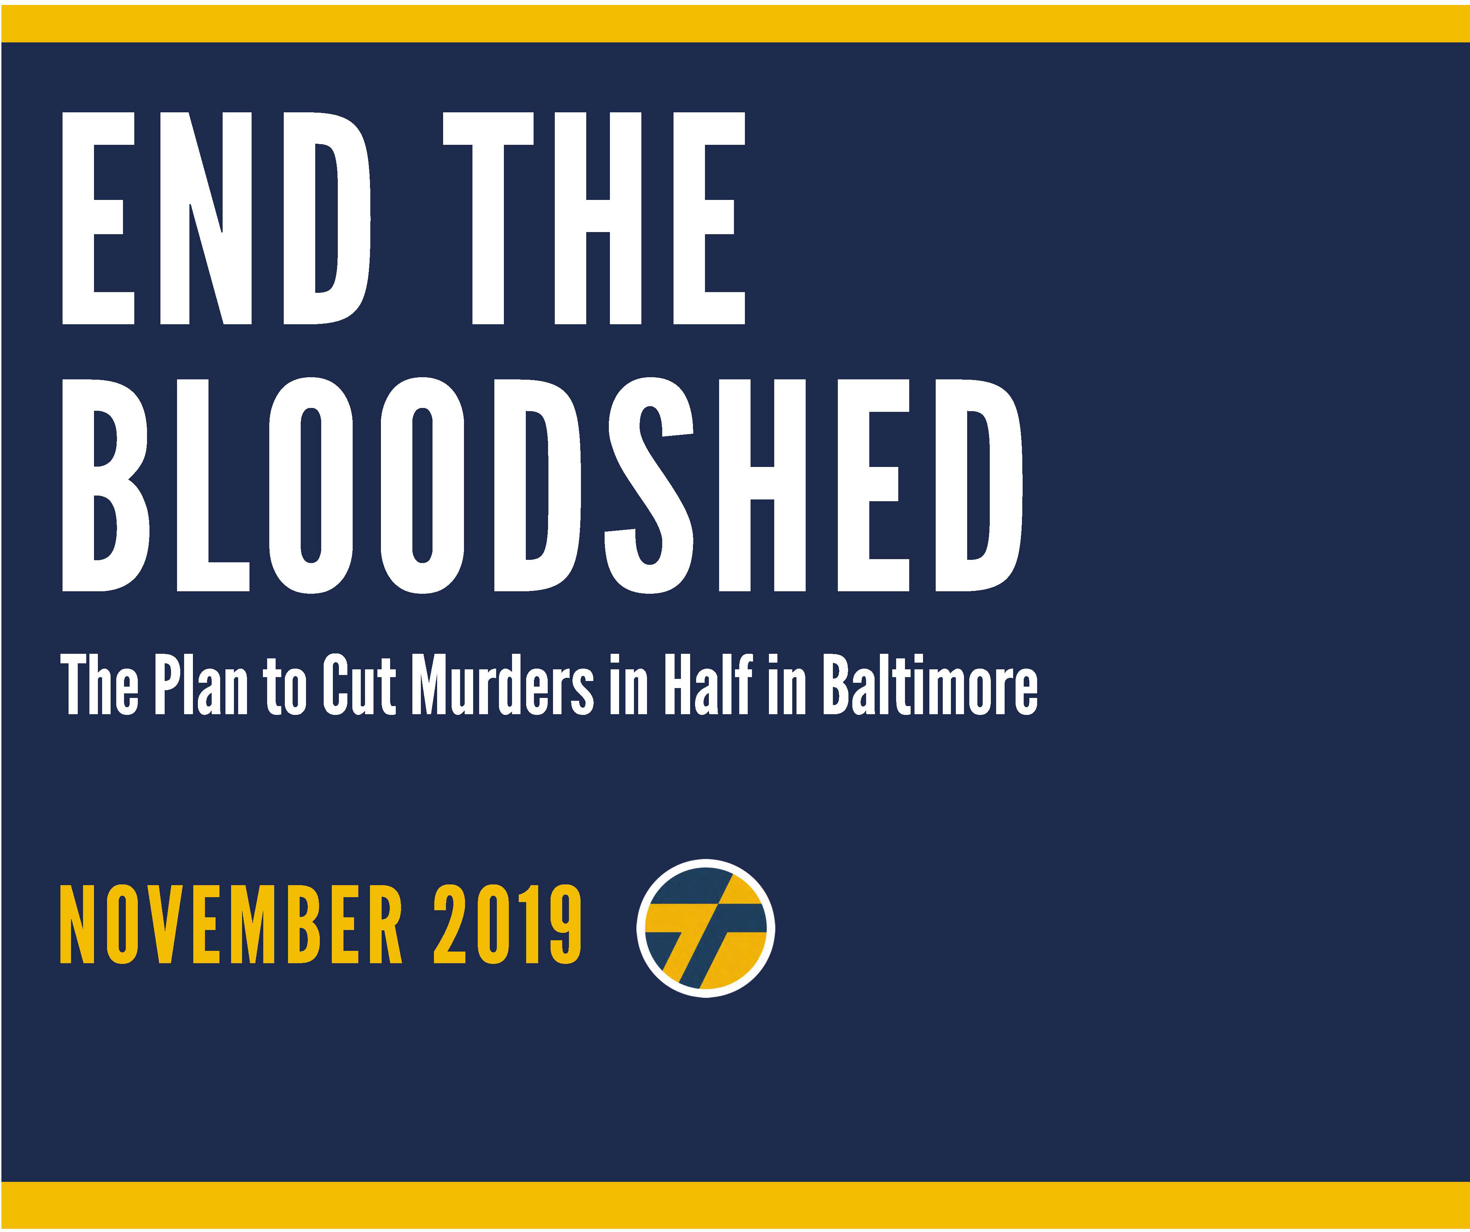





Thiru’s “End the Bloodshed” plan sets forth a comprehensive strategy that goes beyond the platitudes and empty prescriptions that have been recycled and repackaged for decades. Enough is enough.

End the Bloodshed certainly adopts and incorporates important components of prior plans around which there is clear consensus — from investments in schools, jobs, and youth initiatives, to better strategies to address trauma and mental health, to dismantling institutional racism. However, Thiru’s plan, focused on solutions, presents 20 unique proposals that are specific, actionable, and unprecedented.

Conduct Simultaneous Wiretap Investigations

For the first time, Baltimore will conduct simultaneous wiretap investigations targeting gangs and drug organizations in the city’s 12 deadliest neighborhoods, culminating in coordinated arrests of 150-250 violent criminals around April 2025, just before the annual summer surge of gun violence. (The arrest of a couple hundred defendants pales in comparison to the tens of thousands arrested every year in Baltimore.)

Automatic Review of the U.S. Attorney's Office

For the first time, Baltimore will refer to the U.S. Attorney’s Office for automatic review all carjackings, bank and commercial robberies, and felon-in-possession cases for potential federal prosecution. (These are categories of crimes over which there is federal jurisdiction.)

Aerial Surveillance Program

For the first time, Baltimore will get off the ground—with public disclosure—the aerial surveillance program to aid detectives with violent crime investigations, this time with specific limits to respect community privacy and confirm the program’s legal validity.

Additional Ground Cameras

For the first time, Baltimore will offer $100 rebates to residential and commercial property owners who purchase cloud- based security cameras and register them with BPD, with the ultimate goal of adding 10,000 ground cameras to the city’s private camera network.

Clear the Backlog of Burglary Evidence

For the first time, Baltimore will use private grant funding to clear the backlog of untested burglary crime scene evidence, which will be used to pursue burglary prosecutions against individuals who have committed robberies, carjackings, shootings, and murders, but have escaped prosecution for these more serious violent crimes.

Launch Cold Case Initiative

For the first time, Baltimore will launch a cold case initiative within City Hall, which will coordinate with BPD, as well as other law enforcement agencies, to keep open or reopen murder investigations involving high-caliber weaponry, 10 or more casings, and headshots.

Anonymous Monitoring of Juvenile Cases

For the first time, Baltimore will facilitate anonymized monitoring of juvenile cases, so the public can better track outcomes in violent crime cases involving juvenile offenders.

Non-Public Repeat Juvenile Offender List

For the first time, Baltimore will prepare a non-public list of repeat violent juvenile offenders and develop customized strategies to ensure they are brought to justice.

Create a Deputy Mayor for Public Safety

For the first time, Baltimore will create a Deputy Mayor for Public Safety who will ensure inter-agency cooperation to support BPD fully in the fight against crime, a post that will be filled by a respected crime fighter.





For the first time, Baltimore will form the Office of the Public Advocate, which will ensure that policing satisfies

community expectations and constitutional standards, a post that will be filled by a respected community activist and civil rights leader.

Dedicate $10 Million to a Diversion Program

For the first time, Baltimore will dedicate $10 million to a diversion program that permits qualifying juvenile offenders and adults charged with low-level offenses to avoid prison by agreeing, as a condition of probation, to enroll in skills training, workforce development, and a job placement program.

Forgive Outstanding Debt Owed to the Government

For the first time, Baltimore will forgive outstanding debt owed to the government by returning citizens if they maintain stable employment and avoid criminal conduct for 2 years.

Faith in Justice Reentry Initiative

For the first time, Baltimore will launch its “Faith in Justice” reentry initiative, securing $5,000,000 in federal grant money

from the Second Chance Act, which is dispersed to 100 nonprofits and faith organizations selected by 500 returning citizens to support their reentry.

College Cadet Program

For the first time, Baltimore will create a College Cadet program to recruit 100-150 graduating seniors each year from local universities, particularly HBCUs like Morgan State and Coppin State, in order to rapidly produce a net gain of 600 officers and forge a more diverse, local, and professional police force.

Lifting Arbitrary Police Eligibility Restrictions

For the first time, Baltimore will drive BPD recruitment by lifting arbitrary police eligibility restrictions, including the ban on permanent resident non-citizens and people who have used marijuana in the last three years.

Redeploy 90+ School Resource Officers

For the first time, Baltimore will redeploy 90+ school resource officers (SROs) from their posts inside public schools to perform much-needed foot patrols in the neighborhoods around their schools, instead of fueling the school-to-prison pipeline.

Hiring Private Security in Limited, Site-Specific Contexts

For the first time, Baltimore will free up detectives to return to doing detective work by hiring private security in limited, site- specific contexts to ensure adequate coverage of business districts and public events.

Instituting Automatic Audits of Over Time

For the first time, Baltimore will deter police corruption by instituting automatic audits of overtime where an officer has claimed more than $10,000 in overtime compensation.

Annual Reports of Public Health Indicators that Drive Violence

For the first time, Baltimore will publish an annual report of public health indicators that drive violence to ensure that the work of all agencies is evaluated in the fight against crime.

Open ComStat to the Press and Public

For the first time, Baltimore will once a month open ComStat to press and the public in order to promote police accountability and greater transparency.

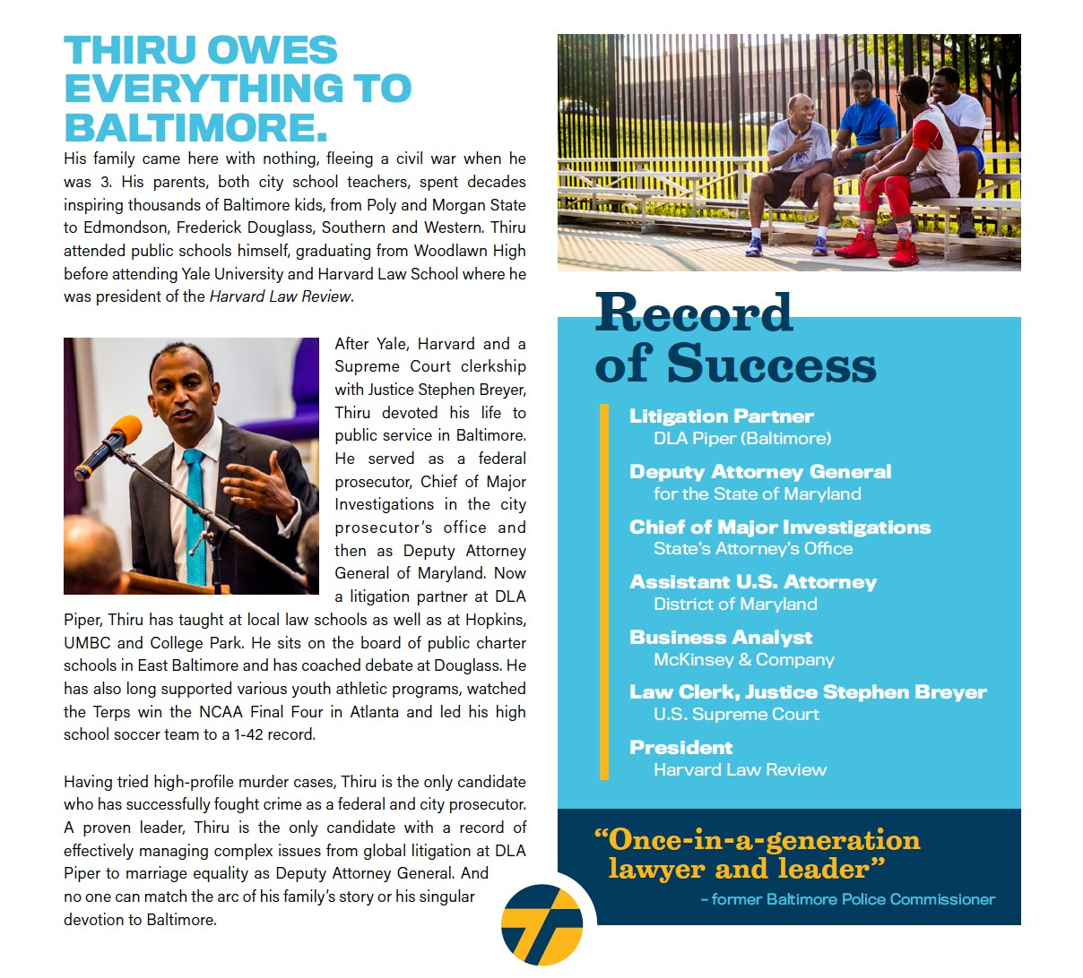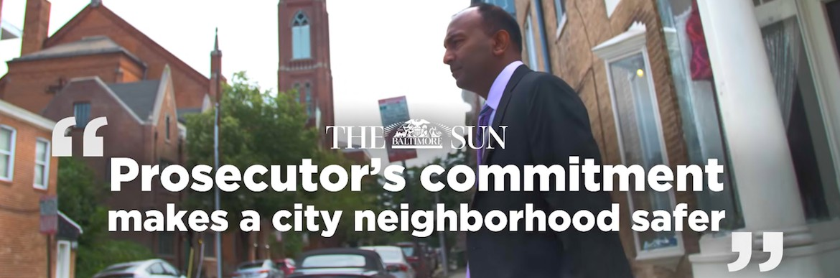

**EXECUTIVE SUMMARY**

Violent crime is the dominant, defining challenge facing Baltimore. It ravages neighborhoods, drives families out of the city, deters business investment, and destroys the lives of too many of Baltimore’s sons and daughters. The next Mayor’s top focus must be to end the bloodshed.

Thiru’s “End the Bloodshed” plan sets forth a comprehensive, detailed, and actionable strategy that goes beyond the platitudes and empty prescriptions that have been recycled and repackaged for decades. It accounts for the current deficit in police officers and the constraints of the federal consent decree; it builds on the crime reduction plans set forth by others, including that of Commissioner Michael Harrison, which is understandably focused on changing culture, rebuilding basic department infrastructure, and improving patrol operations in high-crime areas; it reckons with the reality of prosecuting cases in Baltimore City where juries respond best to cases where police and eyewitness testimony is corroborated by forensic evidence and camera footage; it creates two new positions in City Hall and promises a monthly ComStat open to the public; it brings accountability and transparency principles featured in adult prosecutions to the juvenile justice system; it establishes and expands specific cost-effective diversion and reentry initiatives; and it takes seriously a citywide commitment to reconceive crime in Baltimore as a public health crisis in need of acute interventions as well as systemic solutions.

It accomplishes all of this while pledging a leaner police budget, prescribing a timetable for action, and presenting clear metrics of success.

Thiru and his team took note of the various crime plans that have been released over the years, all of which recite similar themes and typically lack the kind of detail the public needs to gauge whether a plan is viable. *End the Bloodshed* certainly adopts and incorporates important components of prior plans around which there is clear consensus: special focus on violent repeat offenders; investments in schools, jobs, and youth initiatives; rebuilding the Department’s information systems; better strategies to address trauma, addiction, and mental health; reconceiving crime as a public health crisis; strengthening families; dismantling systemic and institutional racism; reforming the criminal justice system; and expanding proven programs like ROCA, YouthWorks, Safe Streets, and LEAD.

These are vital parts of any sound crime plan and represent a common foundation on which most agree. On top of this, Thiru’s plan contains proposals that are specific, actionable, and unprecedented. The following are illustrations of 20 features unique to *End the Bloodshed*:

* For the first time, Baltimore will **conduct simultaneous wiretap investigations** targeting gangs and drug organizations in the city’s 12 deadliest neighborhoods, culminating in coordinated arrests of 150-250 violent criminals around April 2025, just before the annual summer surge of gun violence. (The arrest of a couple hundred defendants pales in comparison to the tens of thousands arrested every year in Baltimore.)
* For the first time, Baltimore will **refer to the U.S. Attorney’s Office for automatic review** all carjackings, bank and commercial robberies, and felon-in- possession cases for potential federal prosecution. (These are categories of crimes over which there is federal jurisdiction.)
* For the first time, Baltimore will get off the ground—with public disclosure— the **aerial surveillance program** to aid detectives with violent crime investigations, this time with specific limits to respect community privacy and confirm the program’s legal validity.
* For the first time, Baltimore will offer $100 rebates to residential and commercial property owners who purchase cloud-based security cameras and register them with BPD, with the ultimate goal of **adding 10,000 ground cameras** to the city’s private camera network.
* For the first time, Baltimore will use private grant funding to **clear the backlog of untested burglary crime scene evidence**, which will be used to pursue burglary prosecutions against individuals who have committed robberies, carjackings, shootings, and murders, but have escaped prosecution for these more serious violent crimes.
* For the first time, Baltimore will **launch a cold case initiative** within City Hall, which will coordinate with BPD, as well as other law enforcement agencies, to keep open or reopen murder investigations involving high-caliber weaponry, 10 or more casings, and headshots.
* For the first time, Baltimore will facilitate **anonymized monitoring of juvenile cases**, so the public can better track outcomes in violent crime cases involving juvenile offenders.
* For the first time, Baltimore will prepare a **non-public list of repeat violent juvenile offenders** and develop customized strategies to ensure they are brought to justice.
* For the first time, Baltimore will **create a Deputy Mayor for Public Safety** who will ensure interagency cooperation to support BPD fully in the fight against crime, a post that will be filled by a respected crime fighter.
* For the first time, Baltimore will **form the Office of the Public Advocate**, which will ensure that policing satisfies community expectations and constitutional standards, a post that will be filled by a respected community activist and civil rights leader.
* For the first time, Baltimore will **dedicate $10 million to a diversion program** that permits qualifying juvenile offenders and adults charged with low-level offenses to avoid prison by agreeing, as a condition of probation, to enroll in skills training, workforce development, and a job placement program. (The campaign unveiled this initiative—the “Court to Career” program—two weeks ago with the support of Ravens linebacker Matthew Judon.)
* For the first time, Baltimore will **forgive outstanding debt owed to the government** by returning citizens if they maintain stable employment and avoid criminal conduct for two years.
* For the first time, Baltimore will **launch its “Faith in Justice” reentry initiative**, securing $5,000,000 in federal grant money from the Second Chance Act, which is dispersed to 100 nonprofits and faith organizations selected by 500 returning citizens to support their reentry.
* For the first time, Baltimore will **create a College Cadet program** to recruit 100-150 graduating seniors each year from local universities, particularly HBCUs like Morgan State and Coppin State, in order to rapidly produce a net gain of 600 officers and forge a more diverse, local, and professional force.
* For the first time, Baltimore will drive BPD recruitment by **lifting arbitrary police eligibility restrictions**, including the ban on permanent resident non- citizens and people who have used marijuana in the last three years.
* For the first time, Baltimore will **redeploy 90+ school resource officers** (SROs) from their posts inside public schools to perform much-needed foot patrols in the neighborhoods around their schools, instead of fueling the school-to-prison pipeline.
* For the first time, Baltimore will free up detectives to return to doing detective work **by hiring private security in limited, site-specific contexts** to ensure adequate coverage of business districts and public events.
* For the first time, Baltimore will deter police corruption by **instituting automatic audits of overtime** where an officer has claimed more than $10,000 in overtime compensation.
* For the first time, Baltimore will publish an **annual report of public health indicators that drive violence** to ensure that the work of all agencies is evaluated in the fight against crime.
* For the first time, Baltimore will once a month **open ComStat to press and the public** in order to promote police accountability and greater transparency.

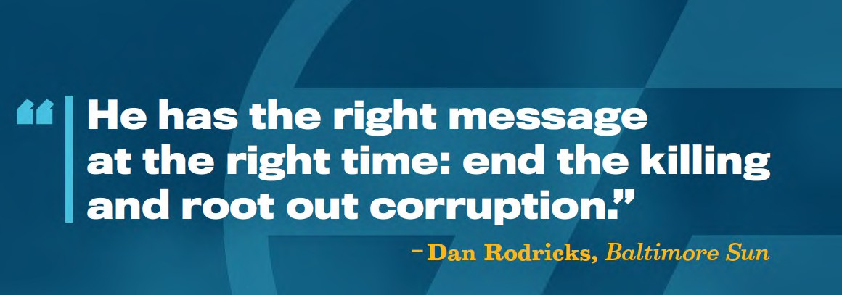

**Drive Down Citywide Murder Rate**

We know gun violence is driven by a small number of identifiable repeat offenders, typically members of gangs, who ravage essentially the same neighborhoods year after year. Because of this, **dramatically reducing gun violence does not require mass incarceration, zero tolerance, or cash bail.** What is needed is relentless focus on the deadliest neighborhoods, deadliest criminals, and deadliest crimes. City Hall has failed to deliver that focus and, as a result, has failed to deliver justice to countless Baltimore families.

As Mayor, Thiru will drive down the number of murders to below 200 within three years. This will not happen by accident. It will happen because city leaders will develop a battle plan and execute it. Here are the cornerstones of Thiru’s plan to end the bloodshed.

* Launch simultaneous wiretap investigations in the City’s 12 deadliest neighborhoods with coordinated arrests before the killing months of summer.

**Between 2015 and 2018, 26% of all murders occurred in 12 neighborhoods.** Because these consistently high murder rates are fueled by gangs feuding over consistently profitable drug territory, wiretap investigations are a potent, proven method of shutting down the violence.

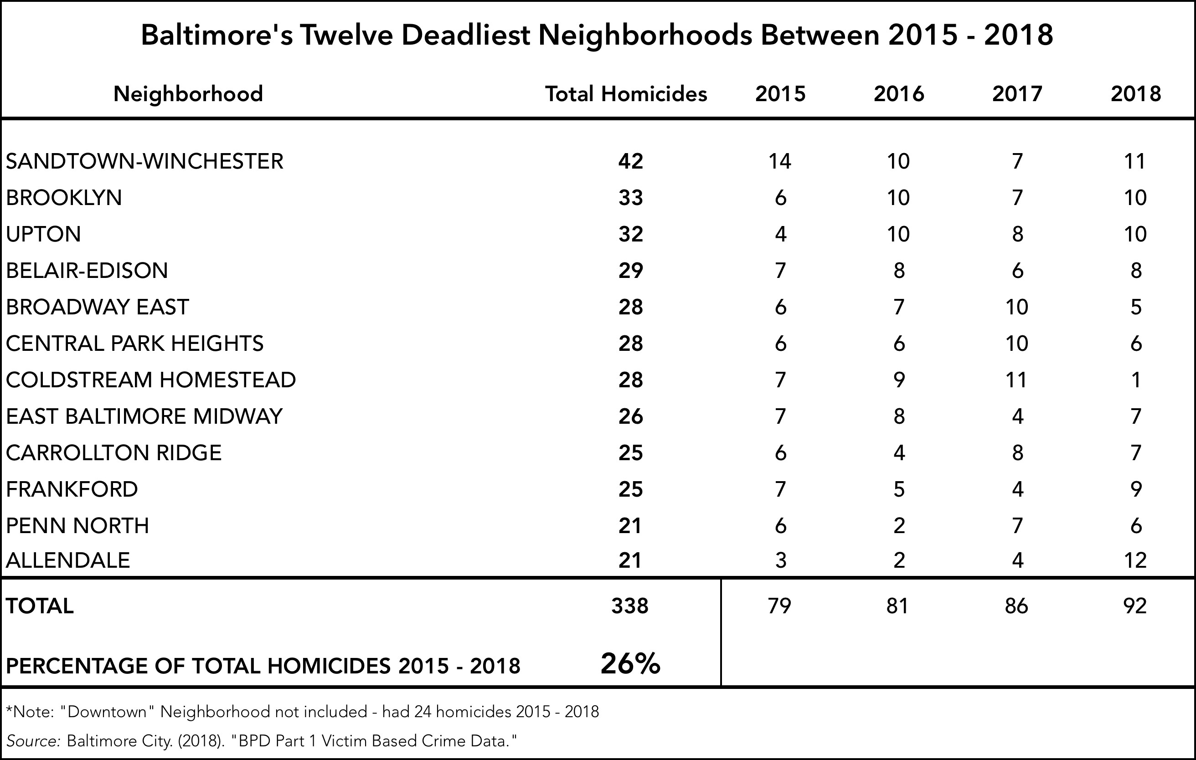

THIS DATA NEEDS TO BE UPDATED; AT THIS MOMENT DATA IS ONLY AVAILABLE FROM MAY 20th 2019 through all of 2020

These surgical investigations do not require police to clear corners or pursue the irresponsible stop-and-frisk policies that have characterized discriminatory approaches of the past. Instead, law enforcement should develop intelligence to identify the shooters, killers, and leaders in each of these 12 neighborhoods, launch wiretap investigations using undercovers and forensic technology, and after a thorough investigation, extract the violent organization, root and branch.

**We know this strategy can work.**

In November 2013, police and prosecutors, under Thiru’s leadership, brought a first- of-its-kind gang prosecution to a neighborhood that had endured nearly a murder or shooting every month for five years. For 18 months, that same neighborhood didn’t see a single murder. Not one. That strategy did not displace violence; it eliminated it.

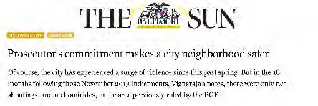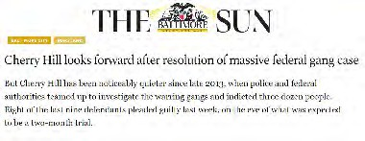

A similar strategy was deployed in Cherry Hill, where federal and local prosecutors conducted a collaborative gang investigation. Cherry Hill went some 700 days without a single shooting.

This was an anchor strategy that brought murders to below 200 just a few years ago. Even back then, the City tended to conduct these investigations one at a time, rather than simultaneously. And, for the past 5 years, this approach has been all but absent.

As Mayor, Thiru would convene local, state, and federal law enforcement partners, develop a tactical battleplan dividing responsibility among the FBI, DEA, ATF, MSP and BPD, and execute the intelligence gathering, undercover buys, wiretap investigation, and arrest phases of the operation in as coordinated a fashion as possible.

12 DEADLIEST NEIGHBORHOODS IN BALTIMORE

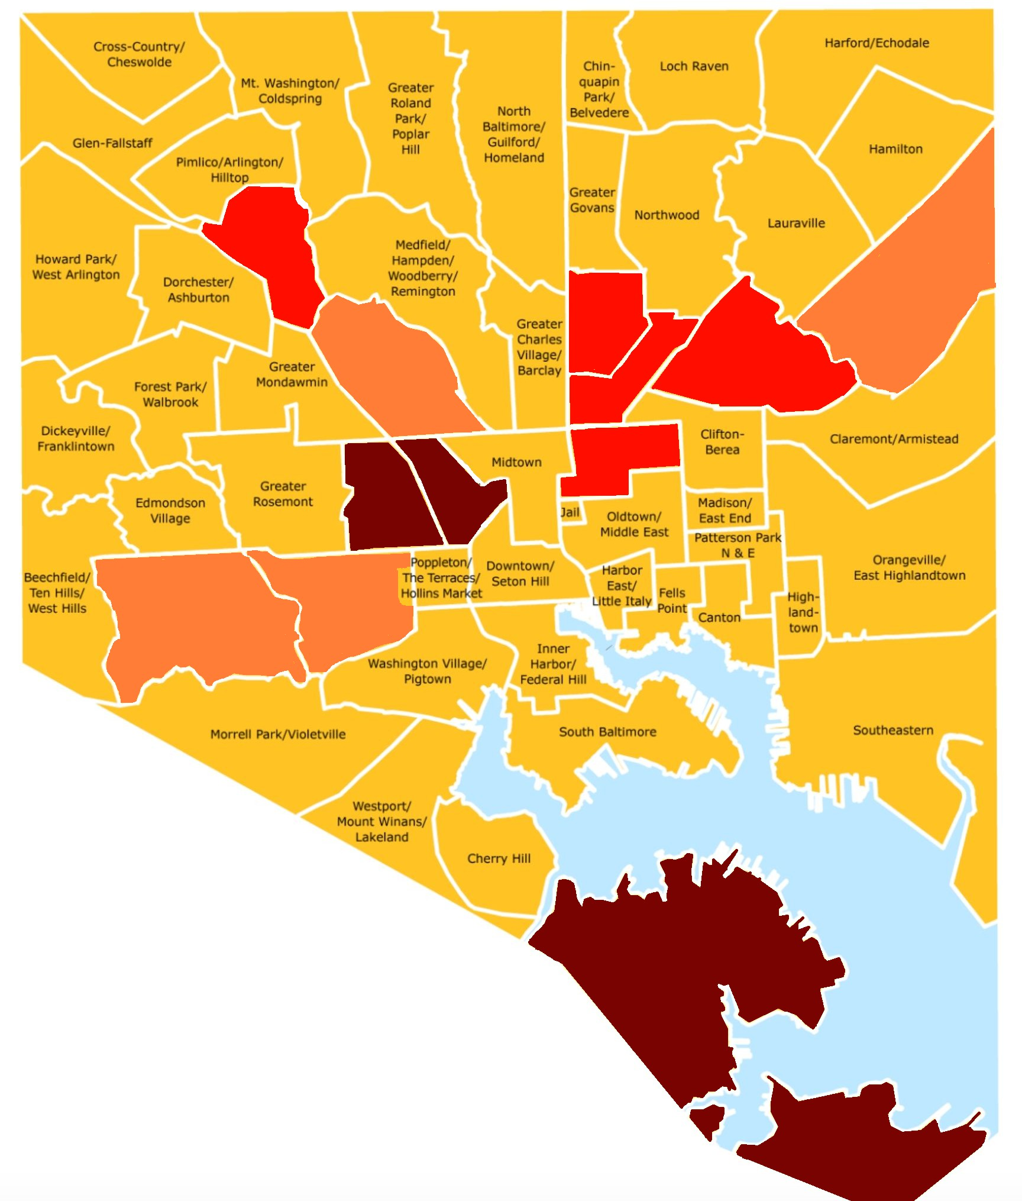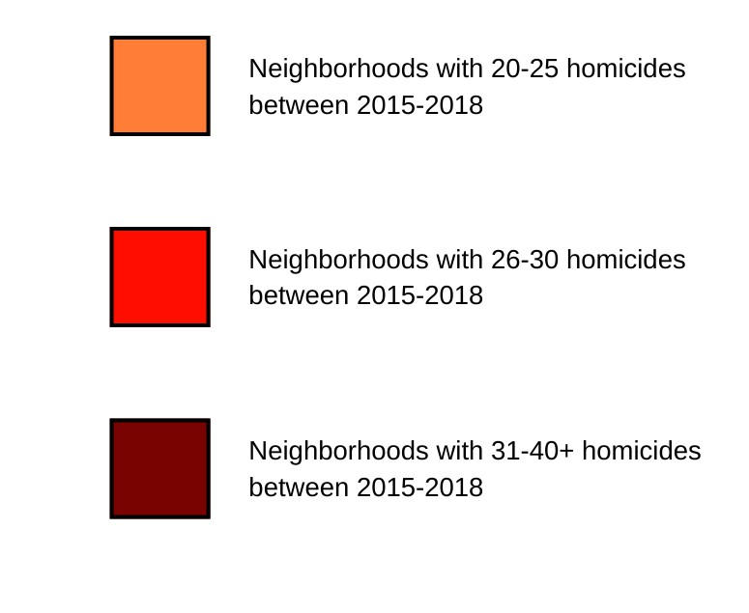

**Southern Park Heights**

**The Waverlies**

**Cedonia/Frakford**

**Penn North/ Reservoir Hill**

**Belair-Edison**

**Midway**

**Greenmount East**

**Upton**

**Sandtown- Winchester/ Harlem Park**

**Allendale/ Irvington/**

**S. Hilton**

**Southwest Baltimore**

**Brooklyn/ Curtis Bay/ Hawkins Point**

SOURCE? NEEDS UPDATE FROM SPECIFIC SOURCE

It is important to emphasize that these investigations do not require hundreds of officers nor do they end in thousands of arrests. In fact, these proactive investigations are best done with a small, experienced platoon of city officers and federal agents led by one or two federal and local prosecutors. The “End the Bloodshed” plan calls for intel workups to begin shortly after the Democratic primary (May 2024), the wiretap investigations to begin that winter (November-December 2024), with arrests just before the summer (April 2025). Rather than initiate a case or create a new initiative in response to a summer of violence, this strategy is designed to anticipate and prevent the violence just before, if history is a guide, it is set to surge.

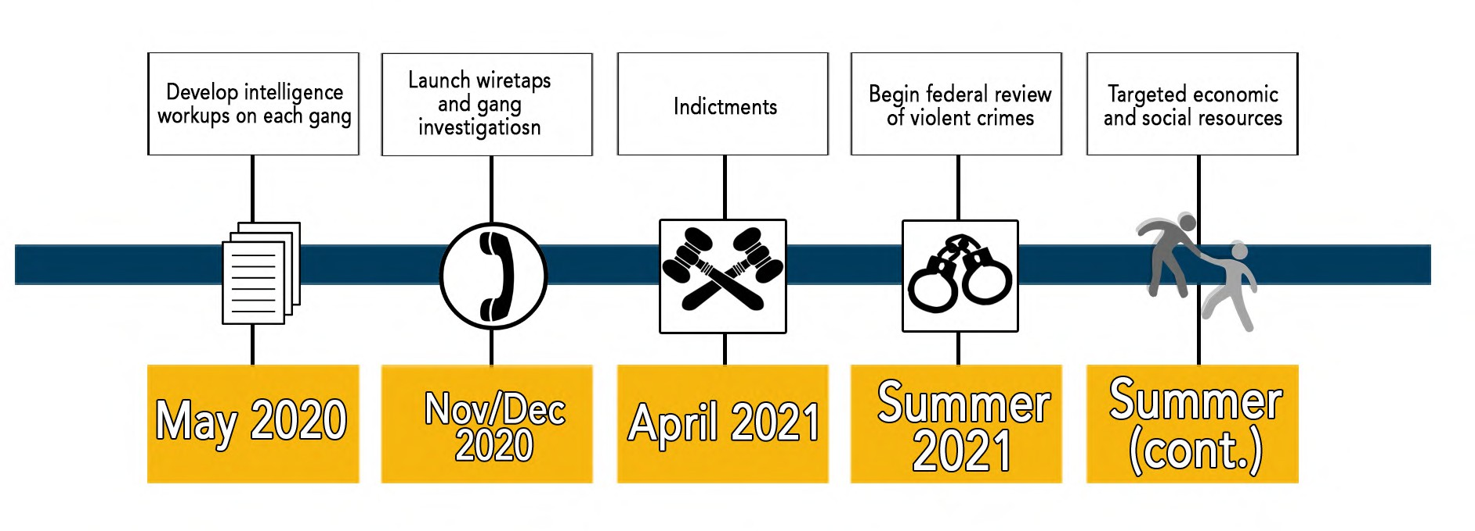

UPDATED FIGURE

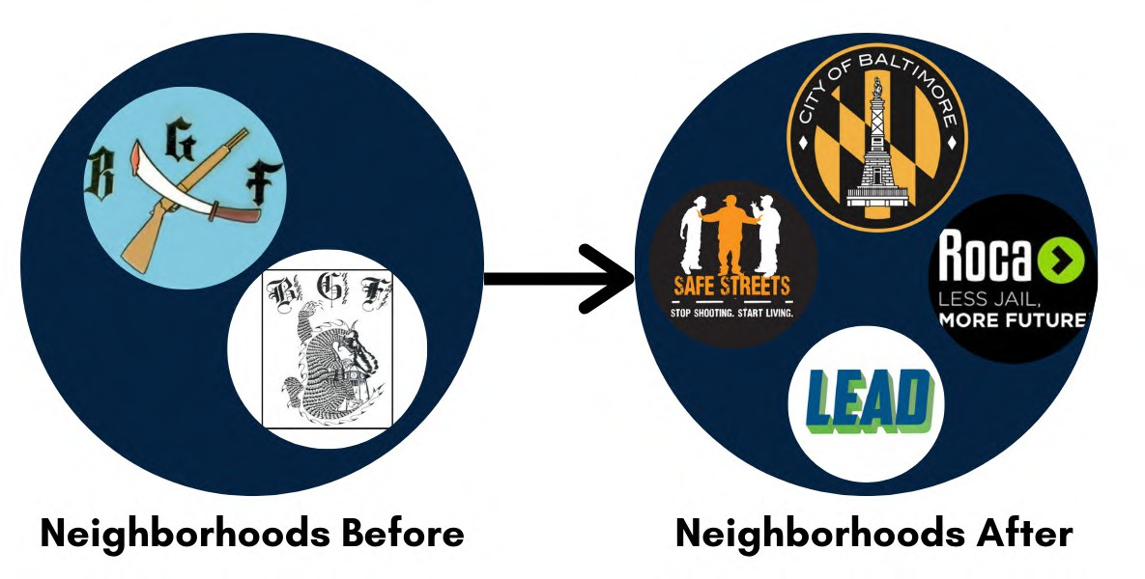The law enforcement intervention cannot be the end of the work in these neighborhoods. Rather than pushing the violence to neighboring areas, which is what traditional patrol-focused strategies tend to do, extracting the gang will bring about a period of real peace but it will also create a vacuum. New gangs and violent drug organizations cannot be allowed to fill the void. Rather, we must bring to bear a coordinated array of resources and support organizations from Safe Streets and Ceasefire (focused on the violence) to ROCA and LEAD (focused on addiction) to a bevy of operators devoted to expunging records, workforce and housing development, lead abatement, job placement, mental health, and trauma.

* Identify, investigate, and prosecute the worst violent offenders in each police district.

As Mayor, Thiru will also focus on identifying, investigating, and getting off the streets the worst violent repeat offenders in Baltimore. Each police district will use a combination of concrete metrics (prior convictions for violent crimes and gun offenses), along with on-the-ground intelligence to determine which criminals warrant greater investigative attention. A new Deputy Mayor for Public Safety will be responsible for coordinating interagency cooperation to ensure that responsible, rock solid cases are being built at local, state, and federal levels. BPD will be responsible for ensuring that resources are focused not on nuisance cases to drive public statistics, but rather on the individuals who are genuinely perpetrating violent crimes. This model of focused investigations mirrors the approach Thiru led when he was Chief of Major Investigations in Baltimore City. This initiative is all about execution and depends on strong leadership beginning with the Mayor and Deputy Mayor for Public Safety.

* Launch specialized Cold Case initiative to focus on solving high-lethality murders.

As Mayor, Thiru will create the “Never Forgotten” Cold Case initiative in City Hall, which will work with BPD, as well as MSP and other law enforcement agencies, to ensure that law enforcement maintains investigative focus on murders involving high-caliber guns, 10+ casings at the crime scene, and headshots. Families will also have a liaison in City Hall to provide any information

that can be shared about the status of an investigation that is more than a year old.

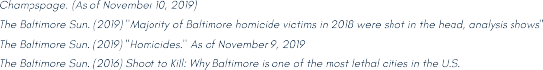

This is necessary because as clearance rates have plummeted, murders have soared, with five years of 300+ murders. So has the percentage of headshots, with a startling high of 57% of homicides last year involving fatal headwounds. Murderers in Baltimore have become the most lethal in America, with higher caliber weaponry, more shots per crime

FIGURE ON PAGE ABOVE

scene, and the highest percentage of headshots in the country. The individuals perpetrating these ruthless, calculating executions are rarely first-time offenders. They are seasoned executioners, and those homicides deserve special attention.

It should be noted that even the paltry clearance rates advertised by BPD today are somewhat misleading to the average citizen. Clearance rates are not the percentages of murders that result in an arrest, because the Department includes in the overall count of cleared cases what it calls “exceptional clearances,” a term of art that refers to an investigation that cannot lead to an arrest (most often because the supposed suspect has himself been killed). Exceptional clearances have soared recently, which means an increasingly small number of murders actually end in an arrest.

**“To deter murders, we have to solve and prosecute more murders. Not on paper. But in real life.**

**This plan helps do just that.”**

**Build a Police Force for the Next Century**

For years, the Baltimore Police Department (BPD) has been expected to effectively fight crime with a fraction of its full force. The Department once had as many as 3,300 officers. Before her resignation, Mayor Catherine Pugh estimated that BPD had 1,900 active officers, though it was authorized for 2,800 officers; this shortfall has crippled the City’s ability to fight crime and generated massive overruns in overtime expenditures. Because of poor recordkeeping, estimates vary how many recruits are needed, but most agree the Department is hundreds of officers short.

From 2002 through 2022, there was an overall loss of 1176 police officers, with 3,873 hires and 5,049 departures. The net loss from 2019 to 2022 alone is 329 officers. The loss of officers has not only made the city less safe, but has burdened taxpayers with soaring overtime costs. CHART NEEDS TO BE UPDATED

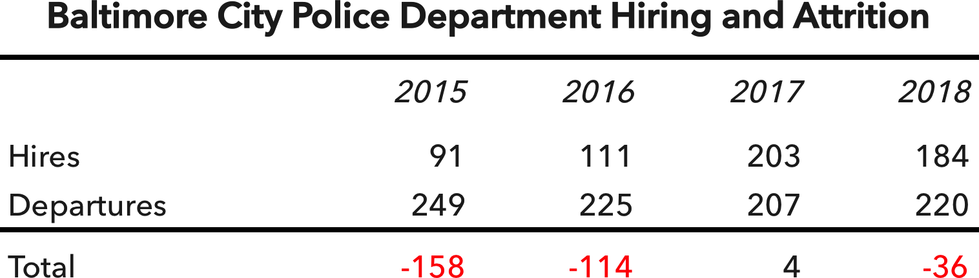

Estimates vary as to the exact magnitude of the shortfall. There are no less than hundreds of budgeted positions that sit empty, though some claim we need more than a thousand more officers. Precise number aside, the bottom line is that the police department needs more police.

This deficit in personnel should not be seen as a problem, but rather, as an opportunity. BPD has a chance to rebuild a police force that looks and acts like the Department Baltimore deserves. In this respect, reconstituting the police force is not just about bringing in more officers – it's about bringing in the right officers and keeping them here. It’s about training our officers to do the kind of effective, constitutional investigations that will restore community trust and get violent criminals out off the streets.

**As Mayor, Thiru will drive a net increase of 600 police officers who are more diverse, less costly, and more effective than ever.**

### RECRUIT, RETAIN, REVITALIZE

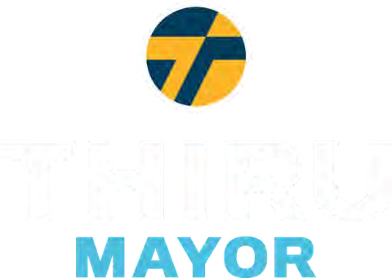

1. Launch college cadet program to grow a diverse, local police force
2. Forgive up to $25,000 in student loan debt for officers who live and serve in Baltimore for 5 years
3. Rebrand careers in law enforcement as opportunity for advancement and service
4. Provide bonuses for lateral transfers from other Maryland jurisdictions and returning servicemen and women
5. Lift arbitrary police eligibility requirements including the ban on permanent resident non-citizens and people who have used

marijuana in the last three years

1. Use housing incentives to encourage officers to live in Baltimore City and increase community policing
2. Institute rank of Corporal to promote advancement and accountability through supervision
3. Restore 20-year pension eligibility for officers subject to unjust, retroactive 25-year pension requirement

**RECRUIT | REDEPLOY | RETRAIN**

**Recruit.** We cannot wait decades for change. We must act now. Under Thiru’s plan, we will produce a net increase of 600 active-duty police officers. Baltimore will recruit hundreds more officers, redeploy police to reflect the community’s needs and priorities, and retrain officers who build stronger cases and better reflect constitutional policing in the next century. Police are not the sole answer to crime, but they have to be part of it. And the deficit of officers presents a rare chance to rebuild a Department that is more local, more professional, and more diverse, with more women, minorities, and immigrants.

As of 2022, only 16% of Baltimore’s police force was female; nor is the police force as racially diverse as it needs to be. And the Justice Department has reported that, “roughly three-fourths of Baltimore PD officers live outside the Baltimore City limits.” All of this must change. But change does not require strict rules or quotas. The Department must tailor its recruiting strategy to the types of officers it seeks to bring in, train, and keep.

We know a more diverse police force can drive lower crime and more just policing, and studies have shown that more women in a police department generates higher reporting of violent crimes against women including rape, domestic violence, and human trafficking. Here is where Thiru, as Mayor, will focus to recruit a new generation of police:

* + Recruit heavily from local colleges, particularly HBCUs, with school-year and summer internships, senior-year cadet programs, and an emphasis on building the kind of community-based police force we can all be proud of.

There is plenty of local talent at our local colleges and universities. In 2015, 567 graduates of Baltimore City high schools went off to attend 13 colleges in the Baltimore area. They are now seniors looking for a job, and many of them are Baltimore natives looking to come home. As Mayor, Thiru will implement a recruiting initiative that does for the policing in Baltimore what Teach for America did for teaching across the country. Instead of a cadet program that focuses solely on high school students who are several years away from being eligible to enroll as officers, an expanded cadet program would have a dozen openings at each local college and university for seniors who would be placed on the fast-track into the Department. Semester and summer internships even

earlier in college would expose students to the critical work police are doing in Baltimore and to the senior cadet initiative for college seniors.

By making local college students feel they are part of the solution when it comes to perceived problems with policing in America, we can set up clear pathways to well-paying positions with stable benefits and career advancement opportunities. This is a guaranteed renewable source of motivated young professionals who could quickly replenish the foundation of the Baltimore Police Department.

* + Remove recruitment impediments by lifting marijuana restrictions, prioritizing mental fitness assessments over physical fitness tests, and allowing immigrants to serve.

The department should focus more on psychological evaluations and reevaluate physical fitness tests, an outmoded hurdle that results in far fewer female officers. Also, neither permanent-resident immigrants nor anyone who has smoked marijuana in the last three years can currently apply to be a Baltimore City police officer. These are arbitrary restrictions that mean young, diverse applicants from Baltimore can go to law school and medical school or serve in the U.S. Army but cannot apply for a job with the BPD. As Mayor, Thiru will push to remove these senseless obstacles and get worthy, otherwise qualified applicants immediately into the pipeline.

We know it is harder to recruit police today than in years past. We also know that applications in Baltimore tripled overnight once the Department put the application online—which only happened last summer. If we recruit an average of just 10 new officers from each local college, we are already contributing more than 100 additional police each year, on top of our current efforts. In three years, this alone would dramatically cut the personnel deficit—and it would create the kind of diverse, local, and professional police force Baltimore residents deserve. UPDATE IMAGE

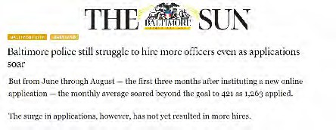

**Redeploy.** In light of current police shortages, we must seek to redeploy police officers and get short-term assistance from partner agencies. As Mayor, Thiru would pursue several strategies:

* + Redeploy school police to assist with patrol in neighborhoods around assigned schools.

Baltimore is the sole jurisdiction in Maryland with a sworn school police force. While the debate about the advantages and drawbacks of school police continues, there is little question these 90 well-trained officers could perform a valuable patrol function in the neighborhoods around their schools. School officers are permitted to carry firearms when they patrol outside of the facility but must store them in a secure location during school hours. Put simply, right now, we need more teachers and social workers inside schools and more police on the streets. That’s where Thiru, as Mayor, would redeploy them.

* + Reestablish role of Sheriff’s Office in warrant apprehension and community policing.

The “End the Bloodshed” plan requires every available detective to work violent crime investigations. Increasing patrol at the expense of detective work in the name of community policing is a short-sighted strategy. But, to be sure, community policing is vital to Baltimore City. This is a role that the Sheriff’s Office is perfect to play. Dozens of Baltimore sheriffs could assist with community policing, building relationships in the neighborhoods and assisting with local events. This would reinforce the strong reputation sheriffs enjoy in the community and would free up detectives from working mandatory overtime patrol shifts while carjacking, shooting, and murder investigations languish.

* + Accelerate civilianization of the police force.

BPD has begun to recruit more civilian personnel but has yet to move sworn officers out of civilian roles and back onto the streets where they are most needed. Within 100 days, the Department will identify all sworn officers working in positions where civilian employees would be appropriate. Within six months, those officers would be assigned to patrol and detective units, allowing incoming civilian personnel to backfill those spots.

* + Utilize private police to reduce costs for business district and special event deployments.

Veteran detectives who have been reassigned to address patrol deficits need to return to detective work. Patrol shortages can be mitigated by relying, in the short term, on private police who can handle shifts that are currently exacerbating overtime expenditures.

**Retrain.** Building a police force for the next generation of BPD is not just about hiring new and younger officers. It also requires the Department to better train officers to police a diverse urban population with soaring crime and unprecedented mistrust in police.

As Mayor, Thiru will require BPD to develop and institute cutting-edge training modules for cadets and in-service training for veteran officers to better prepare them with respect to de-escalation strategies, crisis response, trauma and mental health, implicit bias, youth-interaction, best practices for body-worn cameras, community policing, and more. Preparing officers for next-generation policing will also require next-generation teaching methods. For implicit bias, for example, Prince George’s County began using virtual reality tools in 2018, tools that Researchers at the University of Maryland found to be a low-cost option for health care professionals, engineers, and technicians. Existing training also needs to be updated with new insights. For instance, police will need to be trained to change the presumption from “off” to “on” for body-worn cameras, so that citizens do not interpret activation of body cameras as an escalation in the encounter.

**Break the Cycle of Poverty, Crime, and Prison**

To end the bloodshed in Baltimore, we must break the pernicious cycle of poverty, crime, and prison. An estimated 73% of those individuals released from prison who return to Baltimore City are rearrested and reincarcerated within three years. This is a literal revolving door. As Mayor, Thiru would break this pattern at four separate points.

* + For the 80-100 most at-risk individuals scheduled for release to Baltimore City each month, develop a customized reentry plan for those returning citizens a full year in advance.

Preparing for successful reentry cannot begin upon a person’s return to society. It has to start much earlier. City Hall cannot assume this responsibility for all individuals returning from prison. But, for those at greatest risk of being killed or killing someone else, the Deputy Mayor for Public Safety will work with DPSCS to ensure that a comprehensive reentry strategy is in place one year before the inmate’s scheduled release. This plan will address skills deficits, trauma and addiction, and housing challenges; it will develop a plan for where the inmate will live, work, and sleep, to whom that person will report, and on whom that person can rely for support. It will impose strict conditions of release so that their progress can be monitored and assessed. The aspiration cannot be to expect everyone to turn their lives around immediately, but to reverse expectations so that instead of three out of four returning to prison, more than 75% move in the direction of a constructive, sustainable life.

* + Remove structural impediments that prevent and discourage returning citizens from pursuing gainful, legal employment.

For many returning citizens, unpaid child support debt—debt owed to the government that has already been paid to the spouse primarily responsible for the child—carries consequences that make lawful employment highly unappealing. A returning citizen’s driver’s license can be suspended, and two-thirds of a person’s reported income is garnished to service the unpaid debt. Under the current system, less than 2% of the overall debt is ever collected. Yet we maintain these draconian consequences, which only makes it more likely that a person returning from prison will return to illegal activities to

make money rather than take a job that, on paper, pays $12 an hour but, in reality, yields $4 an hour.

As Mayor, Thiru will establish smarter, more rational incentives, guaranteeing that one quarter of the debt is forgiven or repaid by the City after a returning citizen has maintained stable employment and stayed out of trouble for six months, one half at one year and the full amount at two years. The City would also work with the relevant state agencies to end the practice of suspending driver’s licenses as a method of encouraging repayment of debt. It is counterproductive and wrong.

* + Launch the “Faith in Justice” reentry initiative to match returning citizens with 100 nonprofits and faith organizations who will each support five individuals returning to Baltimore.

Federal laws like the Second Chance Act provide for federal grant money for reentry initiatives. As Mayor, Thiru will launch the “Faith in Justice” reentry initiative, securing $5,000,000 in federal grant money from the Second Chance Act, which will be dispersed to 100 nonprofits and faith organizations selected individually by 500 returning citizens to support their return to Baltimore. Because the nonprofit or faith organization is chosen by the returning citizen, there is no constitutional impediment to government money being provided to tax exempt religious institutions. At the same time, this would provide about

$10,000 per returning citizen for the church or synagogue or nonprofit to allocate, in coordination with the individual, to best support his or her success. Participating organizations would be expected to maintain scrupulous records and assessments would be made annually, evaluating concrete metrics such as reported taxable income and the number of months of safe and stable housing.

* + Establish the “Court to Career” adult diversion program and a parallel “School to Success” program for diverting juvenile offenders.

As Mayor, Thiru will ensure that City Hall takes responsibility for working with the courts to identify appropriate adult and juvenile candidates and establish partnerships with apprenticeship programs, workforce development initiatives, and welcoming business partners who together will provide a reliable pipeline for qualifying juveniles and individuals charged with low-level offenses to enter workforce development and job placement programs as a condition of their probation.

This initiative will ultimately divert 10,000 individuals each year from the revolving door of poverty, crime, and prison to a constructive path of skills training and job placement. Each year we charge tens of thousands in Baltimore with offenses ranging from drug possession to simple assault. To end the bloodshed, we have to bring to bear the resources we have and concentrate them on violent crime. Low-level offenses cannot be altogether ignored, but diverting thousands of these individuals and their cases to a more constructive path than incarceration will free up much-needed resources that are essential to combat and curb violence in Baltimore.

Between the “Court to Career” program (C2C) and the “School to Success” pipeline (S2S), Baltimore will pioneer a new approach to diversion, using interactions with the criminal justice system as an opportunity to divert juveniles at risk of entering the school to prison pipeline and adults at risk of incarceration for low-level offenses to workforce development and employment opportunities. Key features of these initiatives will be:

* Offering petty, non-violent offenders a permanent extinguishment of charges in exchange for the completion of an apprenticeship program that provides skills and training followed by specific job placement
* Offering qualifying juvenile offenders an opportunity to avoid a finding of delinquency if the individual, as a condition of a probationary period, pursues an apprenticeship and commences a paid employment opportunity of their choice
* Securing $10 million in funding through public-private partnership, to expand the existing “District Court Reentry Project” and ensure that there is a sufficient number of case workers, with a dozen being hired during the initiative’s first year
* Extending employment alternatives by partnering with Baltimore employers who are committed to hiring ex-offenders that have devoted apprenticeship programs and opportunities for future employment

These public-private partnerships will invest $10+ million to expand and bring to scale the Baltimore City District Court Re-Entry Project (DCREP), a model program that currently receives virtually no support from City Hall or the City

Council. That program, which long operated with only one full-time employee, is supported by judges and volunteers and has a recidivism rate of less than 6% — a far cry from the 73% of returning citizens in Baltimore City who are rearrested and reincarcerated within three years of leaving prison. More can be done, more efficiently.

In its first full year, C2C and S2S will help divert 1,000 individuals who are charged with low-level offenses first to job training and then to paid employment opportunities as a condition of receiving a probation before judgment (PBJ). This will require partnerships between district court judges and juvenile masters, probation officers, case workers, skills training programs, apprenticeships, and employers who are prepared to hire at-risk individuals and give them a second chance. Only when individuals complete the program, having demonstrated stable employment and no criminal activity, are they taken off probation with their records expunged. For juveniles, the programs will adopt apprenticeships and work schedules that are compatible with school and other vital obligations.

**“Every election, candidates talk about tearing down prisons and creating opportunity. After the election, nothing gets done. Nothing changes. Baltimore needs more than soundbites, spin, and slogans, more than ribbon-cuttings and press conferences. We need real investment in concrete programs that work.”**

**Assemble Stronger Cases for City Prosecution**

CLEAR THE FORENSIC BACKLOG

Law enforcement in Baltimore has to build stronger cases. City prosecutors are dropping too many prosecutions, pleading out felonies to unjustifiably lenient sentences, and losing over 80% of cases that go to trial. To help prosecutors succeed, particularly inexperienced ones, police officers must build stronger cases that will withstand the scrutiny of judges and juries.

Unexamined forensic evidence presents one opportunity to strengthen cases. Baltimore has a massive backlog of untested rape kits and burglary crime scene evidence. As of 2022, the city had 991 untested rape kits. The current practice of not testing burglary crime scene evidence is also an enormous missed opportunity, since 40% of DNA and fingerprints from burglary crime scenes match a profile in the federal CODIS database.

Clearing these backlogs should be a priority. Current legislation already mandates that rape kits be tested in “a timely manner," but forensic labs are often so inundated with evidence that they lack the capacity to test within a reasonable time frame. As Mayor, Thiru will secure and allocate resources to ensure the timely testing of rape kit and burglary crime scene evidence as part of the larger push to identify repeat and violent criminals.

Testing the backlog of burglary crime evidence, given the high yield rate, would permit police and prosecutors to distinguish between, on the one hand, low-level offenders whose conduct is in the past and, on the other hand, repeat violent offenders who may be readily prosecuted for a burglary even if there is insufficient evidence to expect a shooting or murder prosecution.

EXPAND THE GROUND AND AERIAL CAMERA NETWORK

In a city without the resources to consistently patrol every block and street corner, it is hard to protect homes and businesses from criminal activity. A rampant illegal drug trade and soaring gun violence have contributed to Baltimore’s spot on America’s most violent cities list. As a result, Baltimore’s understaffed police department has

trouble devoting the requisite person-power to finding perpetrators of muggings, robberies, and fatal assaults.

Baltimore’s storeowners and landlords often keep surveillance cameras on their properties in order to help identify offenders, but these cameras have minimal storage and are not easily accessible.

As Mayor, Thiru will provide $100 rebates for all businesses and residences to install up-to-date, networked security cameras and to register them with BPD. In the event of a crime, police can request footage from the camera owners who can consent or decline. Some are already using home camera networks and working with police to solve crime in their neighborhoods.

In addition, Thiru has pledged to re-launch the aerial surveillance program, this time after public input and with specific restrictions to ensure its legality. While the last effort in 2016 to use the technology in was indefensible and likely unconstitutional, aerial surveillance is ultimately a potent tool to solve violent crimes. Investigators can follow captured pixels tied to a crime to determine where the subject came from and went. When the pixel passes a street camera at a particular time, police have an opportunity to get a closer look. The tandem of aerial footage that traces the path of “dots of interest” coupled with a sprawling network of higher-resolution, ground cameras could significantly improve clearance and conviction rates.

**Thiru has called for several restrictions before launch:**

* Aerial surveillance footage would be available to the police only to help with certain violent crime investigations involving homicides, shootings, and carjackings.
* Except in emergencies (*e.g.*, an active shooter scenario), police would need to get a warrant signed by a judge supported by probable cause in order to obtain the footage.
* Every three to six months, the city would publish a list of the cases in which surveillance was obtained and indicate whether that crime was solved.
* To help defend their clients, attorneys would be entitled to subpoena footage that could be used to undermine a witness’s testimony, challenge a statement of probable cause in a search warrant affidavit, and more broadly hold officers accountable.
* The program would be overseen by a five-member civilian oversight board, composed of city residents selected by the mayor and other community stakeholders.
* Aerial view footage and all related data would be archived for a fixed period but could never be shared with or sold to anyone, public or private, and could not be accessed by the operator or anyone else without a court order.

**“Unparalleled violence demands unparalleled ingenuity, and we must leave reasonable options on the table as we prevent, solve, and deter hundreds of murders each year.”**

**Strengthening Partnerships and Policing**

Baltimore also needs to build a better network of relationships with its law enforcement partners at local, state, and federal levels, state agencies involved in juvenile justice, re-entry, parole and probation, and the broader Baltimore community.

Under the *End the Bloodshed* plan Thiru will seek the following objectives:

* + For the first time, Baltimore will **refer to the U.S. Attorney’s Office for automatic review** all carjackings, bank and commercial robberies, and felon-in- possession cases for potential federal prosecution. (These are categories of crimes over which there is federal jurisdiction.)
  + For the first time, Baltimore will facilitate **anonymized monitoring of juvenile cases**, so the public can better track outcomes in violent crime cases involving juvenile offenders.
  + For the first time, Baltimore will prepare a **non-public list of repeat violent juvenile offenders** and develop customized strategies to ensure they are brought to justice.
  + For the first time, Baltimore will **create a Deputy Mayor for Public Safety** who will ensure interagency cooperation to support BPD fully in the fight against crime, a post that will be filled by a respected crime fighter.
  + For the first time, Baltimore will **form the Office of the Public Advocate**, which will ensure that policing satisfies community expectations and constitutional standards, a post that will be filled by a respected community activist and civil rights leader.
  + For the first time, Baltimore will deter police corruption by **instituting automatic audits of overtime** where an officer has claimed more than $10,000 in overtime compensation.
  + For the first time, Baltimore will publish an **annual report of public health indicators that drive violence** to ensure that the work of all agencies is evaluated in the fight against crime.
  + For the first time, Baltimore will once a month **open ComStat to press and the public** in order to promote police accountability and greater transparency.

**A FINAL NOTE**

The Thiru for Baltimore Team hopes that this initial plan can be understood as a call to initiate both the “sprints” necessary in the short-term to drastically reduce crime, as well as the first few miles of a much longer marathon to break the cycles of poverty, inequity, and injustice that keep too many Baltimoreans from achieving the success and prosperity that they deserve.

We also hope this document fuels serious discussion about the standards we accept – for our elected officials, our police department and its officers, as well as ourselves when it comes to confronting and tackling the issues that have plagued the narratives about and the realities within our city for decades.

We welcome your thoughts and ideas at [outreach@thiru2024.com,](mailto:outreach@thiru2024.com,) for after all…

***We cannot unleash the promise of Baltimore until we address violent crime. But we can, and we will – together.***

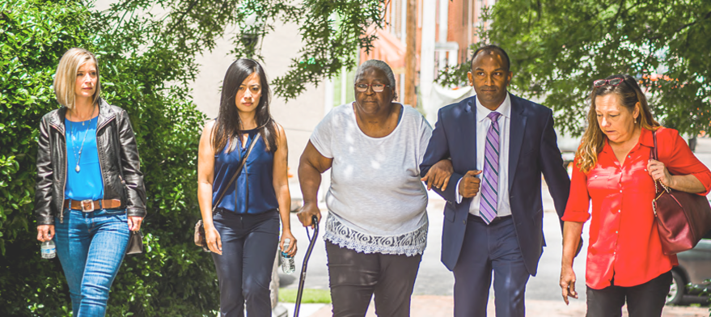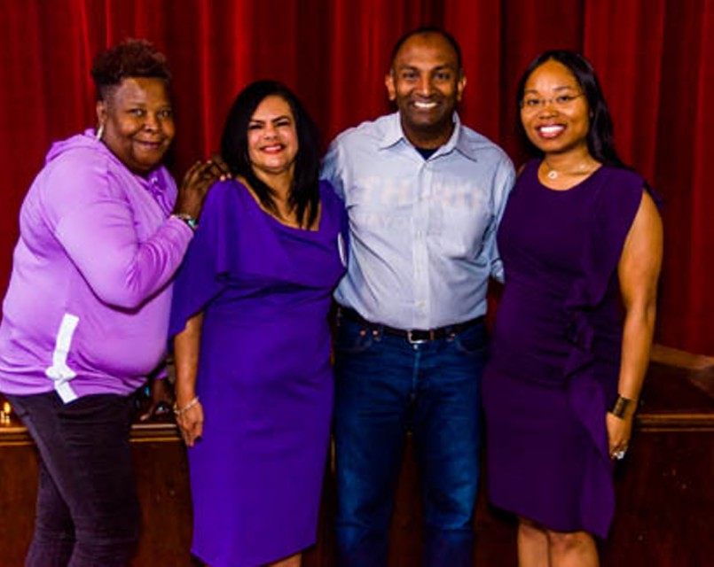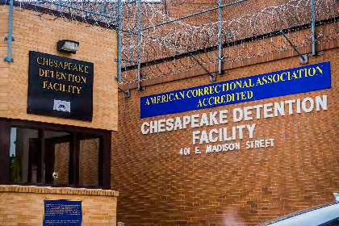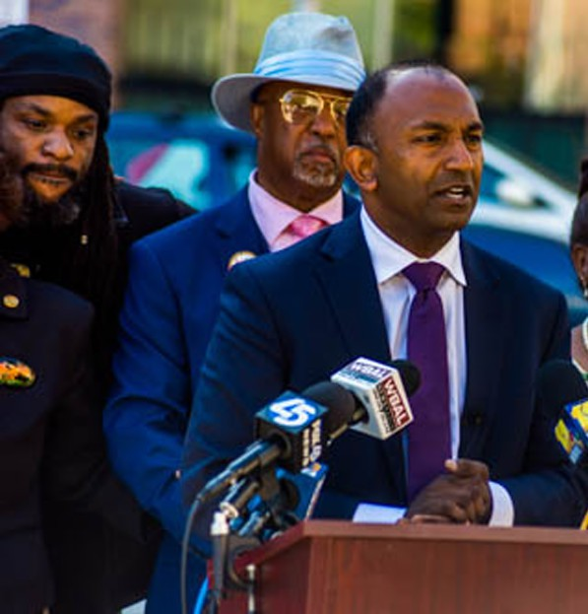



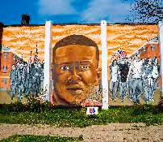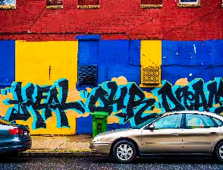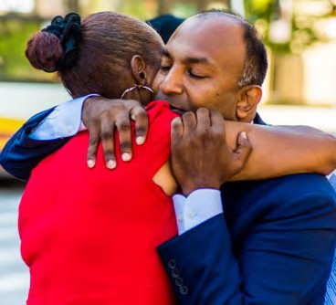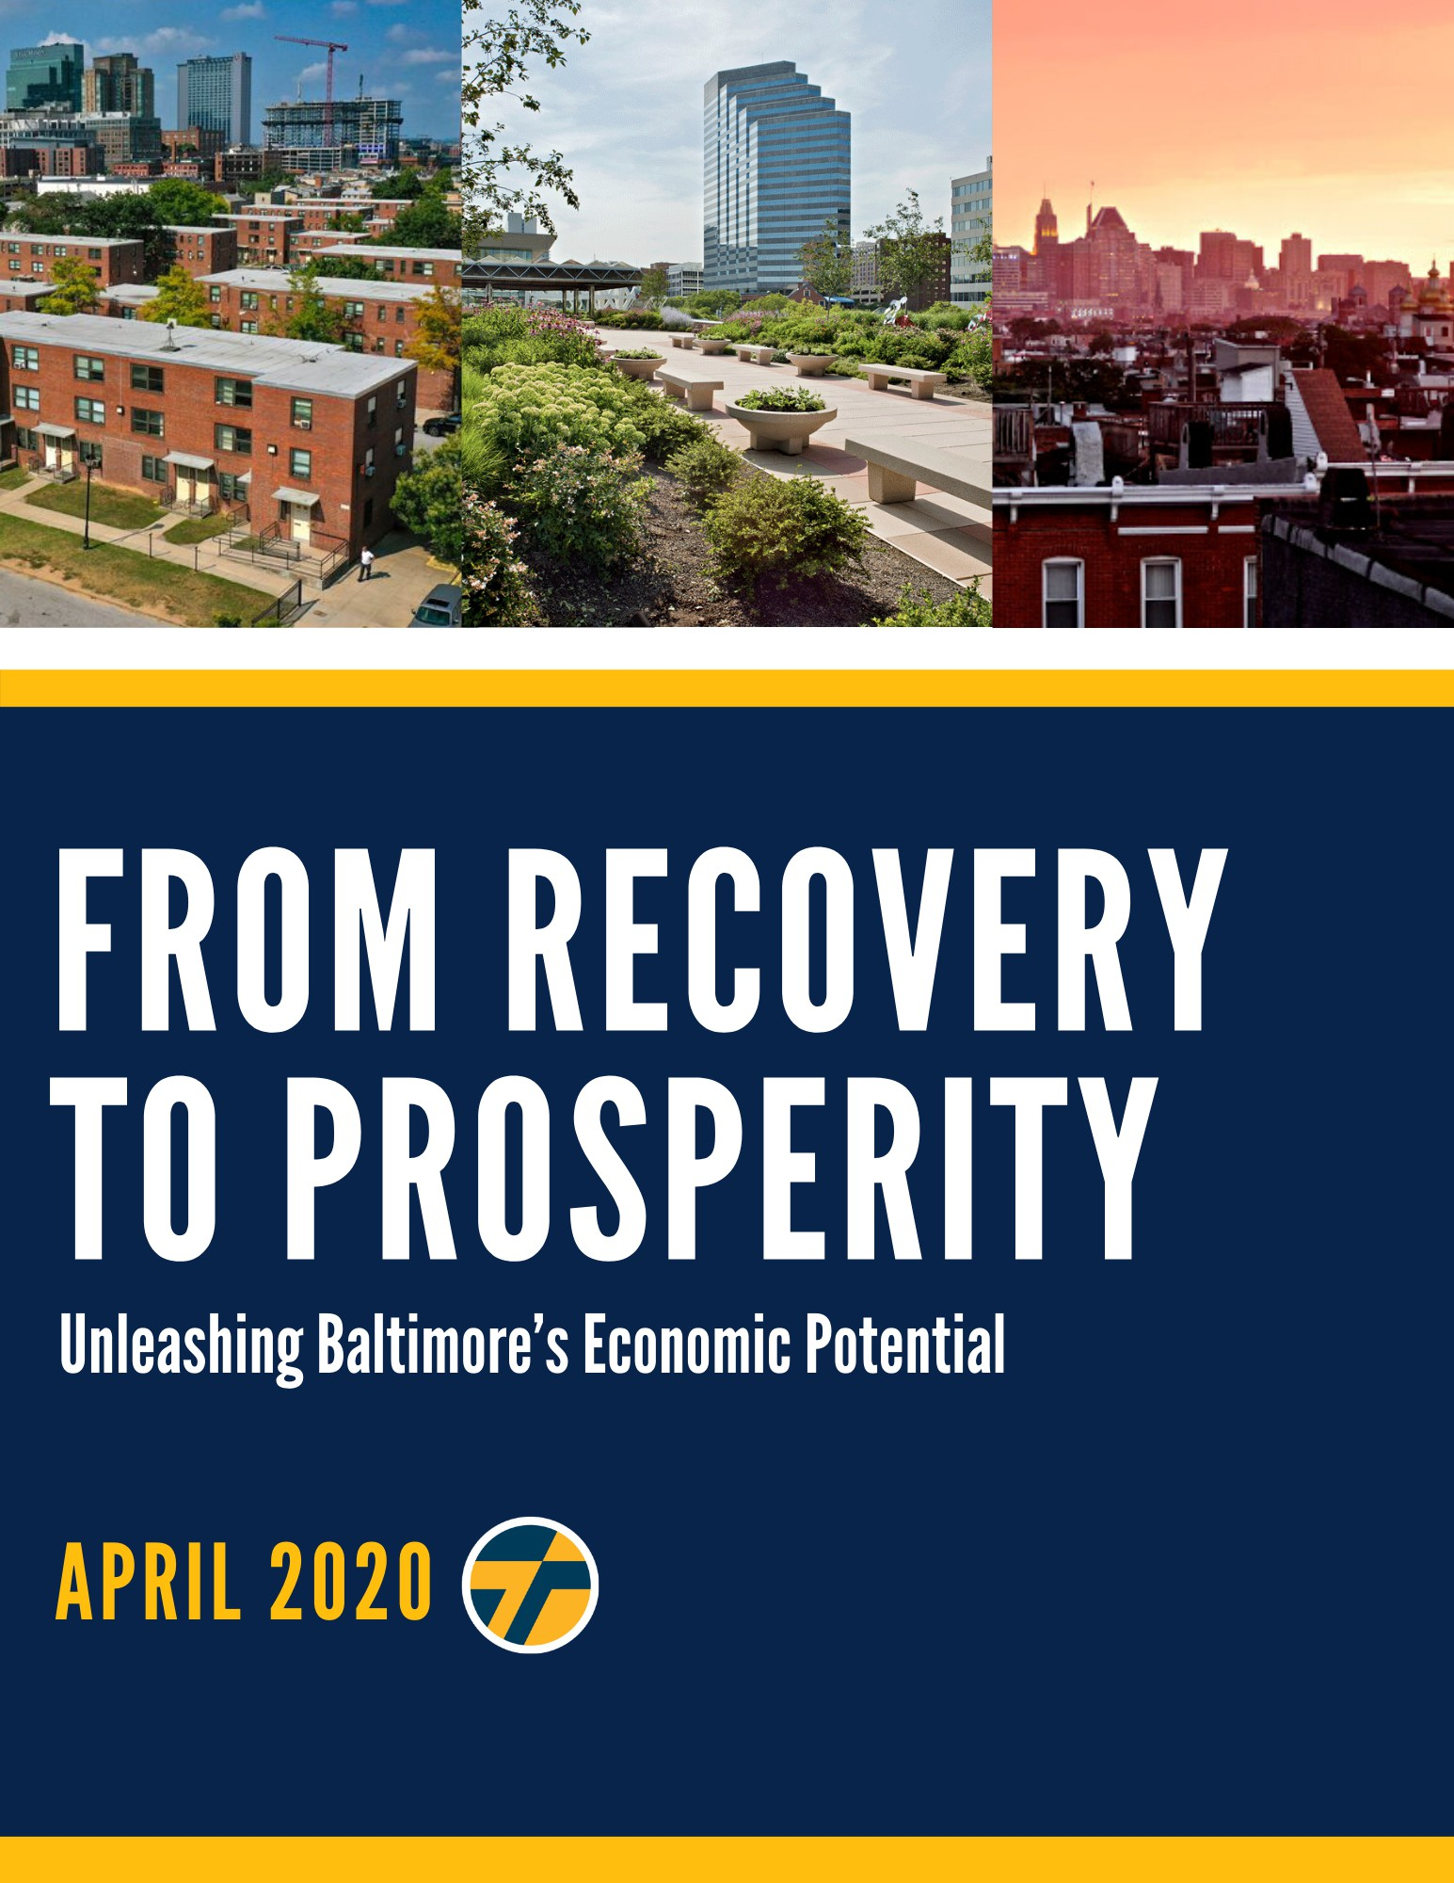

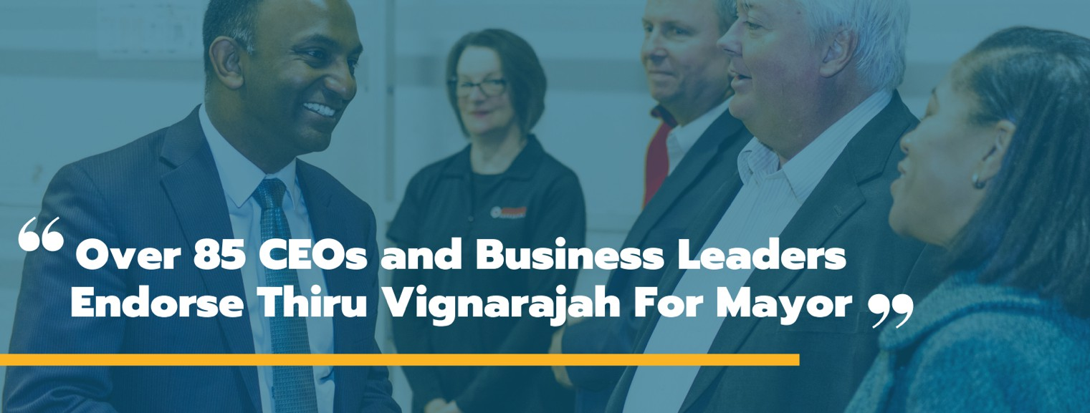

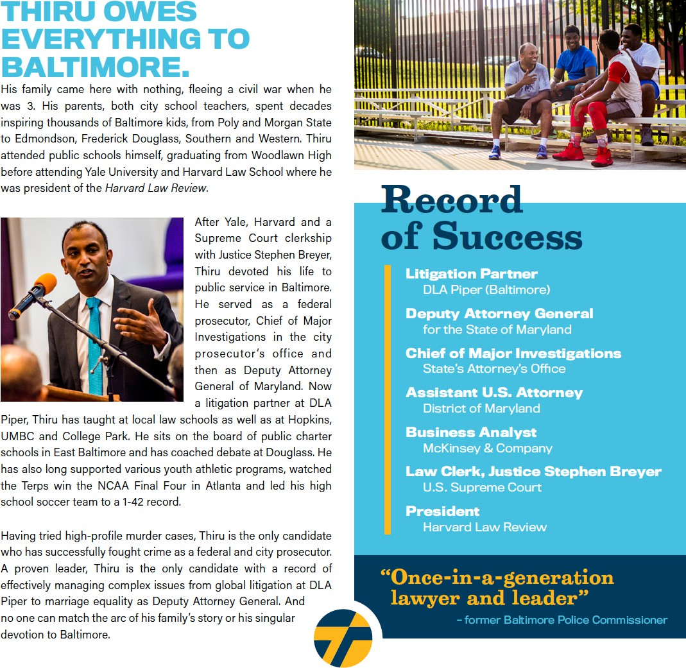



###### EXECUTIVE SUMMARY

The global pandemic presents a once-in-a-century challenge to our city, the country, and the world. It also offers a rare opportunity to rebuild, reinvest, and reimagine the economy and infrastructure of Baltimore for the 21st century.

Like disaster relief in the immediate wake of a hurricane, our plan for economic development will require innovative, short-term investments that address the acute needs of individuals and small businesses. As we head toward recovery, our strategy must also account for the substantial impact and unique difficulties caused by the closing of schools and a statewide stay-at-home order. Finally, a visionary blueprint must aim to rebuild Baltimore with innovative strategies and propel it into the future as we reimagine our local economy around industries of the future.

“From Recovery to Prosperity” is a three-phase roadmap across the relief, recovery, and rebuilding phases. Just as we rebuilt parts of Baltimore after the Great Fire a century ago, we have to address immediate needs over the next several months, seize opportunities for recovery in the following six- to 18-month period, and lay the groundwork for a five- and 10-year plan to reimagine a prosperous and inclusive economy.

This plan goes well beyond the limited proposals of other candidates who underestimate the challenges facing Baltimore and have proposed narrow solutions, limited largely to tapping into anticipated federal funding and dipping modestly into the city’s financial reserves. At a different time in a different city, that may be satisfactory to some. But, in this city at this moment of profound crisis and opportunity, the people of Baltimore need and deserve much more. This roadmap begins to chart out an ambitious course from where we are to where Baltimore could be.

Immediate: Provide Relief to Support Individuals, Families, and Small Businesses

* Inject $250 million immediately into the local economy, by drawing down Baltimore’s “Rainy Day Fund” and borrowing against our AA bond rating
* Issue municipal bonds to build digital infrastructure, including fiber optics to ensure free, universal high-speed connectivity to bridge the digital divide, prioritizing students requiring educational access
* Accelerate road repair and construction projects at lower costs and less inconvenience to the public during a prolonged period of limited usage of city streets and bridges
* Complete installations of heat and air conditioning in public schools with inadequate systems while students, teachers, and staff are absent from these facilities for no less than five months
* Stabilize the finances of first responders by guaranteeing appropriate overtime and hazard pay and by offering free local housing to avoid putting family members of essential workers at risk
* Support mid-sized non-profits overlooked by federal stimulus and minimize burden on small businesses by waiving bills on minor privilege fees and extending deadlines on business invoices due to Baltimore City
* Ensure adequate sick leave compensation to prevent essential workers from becoming vectors

Six to 18 Months: Build the Road to Recovery as We Reopen Our Economy

* Commence schedule to cut property taxes in half over 10 years in equal incremental reductions
* Stimulate development of promising growth industries that would become anchors of Baltimore’s economy for the next century, including: biotech, cybersecurity, small businesses, arts & music, cannabis, culinary arts, cancer research, driverless vehicles, port logistics, and tourism & hospitality
* Raise property taxes on abandoned properties to ensure that real estate speculators are induced to promptly begin development or sell property holdings to investors who will
* Cut vacant housing stock by using eminent domain to seize property with excessive code violations and unpaid taxes and transfer it to affordable housing organizations
* Relaunch dollar-homes program with modified city subsidies to banks, reinvest in community land trusts to expand long-term affordable housing, and effectively safeguard tenants’ rights
* Launch Office of Strategic Partnerships (OSP) to coordinate investments across philanthropic, business, government, and nonprofit sectors
* Jumpstart inclusive workforce development programs by aligning the priorities of public education, trade schools and community colleges as well as diversion, prison workforce and reentry programs with personnel needs of existing and emerging industries

Five to 10 Years: Spark for Baltimore City a Next Generation New Deal

* + Launch $3-4 billion investment in infrastructure overhaul over the next decade, pledging to match federal stimulus funds with public-private city investments for five major commitments:
  + Major public transit initiatives to potentially include East-West light rail, revitalized trolley cars, Inner Harbor footbridge, above-ground circular shuttle train, and high-speed rail to DC
  + Rebuild green network of roads and bridges currently at risk of collapsing with dedicated thoroughfares for public transit; combined with bike lanes and completion of 35-mile Gwynn Falls and Herring Run trail loop
  + Bring water and sewage systems into compliance with federal consent decree, accounting for accelerated timetable for acute weather events precipitated by climate change
  + New school construction and renovations and repairs of all existing facilities, which are currently twice as old on average as schools across the rest of Maryland
  + Smart city investments including fiber optic cable, traffic and transportation analytics, a distributed network of weather and environmental monitoring systems, and automated performance tracking of municipal services

###### Letter of Hope

Baltimore’s financial health has been at risk for a generation. A confluence of factors – the absence of audits, the presence of red tape, exorbitant property taxes, soaring crime, and no accountability – have all contributed to the economic decay of an once bustling, vibrant American city. This reality has only intensified as COVID-19 has closed businesses, produced widespread unemployment, and heightened uncertainty across numerous sectors and industries. People in Baltimore are scared and they are suffering, many of whom have borne the brunt of disinvestment decade after decade.

The next mayor will need to fight a two-front war: one against entrenched economic inequities emboldened by a global pandemic, and another against the relentless violent crime that stunts our city’s capacity to reach its fullest potential. I am prepared for precisely that.

For some, COVID-19 has temporarily exposed the pain many feel in our city each day: not feeling safe to leave home or go to work or school, or not being able to provide for one's family. With protective measures like social distancing, expanded testing, and an eventual vaccine, we will get through this public health crisis. In the same breath, we will still have to contend with the economic shock left in its wake. We need a plan that will not only answer the immediate economic harm of COVID-19, but will also target the structural issues that perpetuate crime, inequality, and lack of opportunity.

*From Recovery to Prosperity: Unleashing Baltimore’s Economic Potential* features twenty (20) major tenets – some focused on the short-term and medium-term, and others focused on fundamentally reimagining Baltimore’s local economy.

Our plan for inclusive economic growth recognizes the urgency of this crisis, but offers a vision for how we can put to work some of our city’s greatest strengths and assets.

Baltimore’s full promise is waiting to be unleashed. There is no question the road ahead will prove difficult, but together, we can set the groundwork for a future of prosperity, for all residents, no matter their zip code.

Sincerely,

*Thiru Vignarajah*

Immediate: Provide Relief to Support Individuals, Families, and Small Businesses

There is no question that COVID-19 will have a profound economic impact on the city of Baltimore. In early April 2020, the Board of Estimates outlined a $68.7M projected loss of revenue for the year as a result of the pandemic, in addition to an anticipated $100M hit for fiscal year 2021. Given unparalleled uncertainty, we’ll likely see that estimate increase. While a portion of relief is on the way via the federal government's $2 trillion stimulus package, which issues hundreds of millions of dollars for cities like Baltimore, we cannot sit idly by.

Extraordinary challenges demand extraordinary solutions. We must do something affirmative and bold. Thiru would pursue the following seven initiatives in response to COVID-19, bridging recovery efforts to an inclusive, overarching economic vision for Baltimore.

1. Inject $250 million immediately into the local economy by drawing down Baltimore’s “Rainy Day Fund” and borrowing against our AA bond rating

Baltimore already predicts a $42.3 million deficit in the budget due to reduced revenues from changes to our behavior and projected reductions in hotel and income taxes. In response, City Hall instructed all City agencies to reduce spending by 5%. This response focuses exclusively on budget constraints and fails to recognize the services needed to aid residents and businesses in this fight and the ensuing recovery. We need fiscal common sense that both prioritizes the immediate needs of our city and investments in our future, accounting for Baltimore’s situation on the cusp of an exponential growth trajectory. Thiru has proposed a massive $250 million stimulus injection to promote spending and investment, and to support our most vulnerable individuals and communities.

The purpose of the Budget Stabilization Reserve, also called the “rainy day fund,” is to provide a fiscal contingency plan that eases the effects of downturns. COVID-19 has triggered a dramatic downturn in our city that requires City Hall to support our community using the funds put aside for a moment exactly like this.

We have advocated for comprehensive financial audits to identify and subsequently address wasteful spending across City agencies. Correcting that inefficiency will more than offset the funds used from the Budget Stabilization Reserve so that we can expand and enhance needed critical care and services for vulnerable populations.

Baltimore City boasts a stellar Aa2 and AA credit rating from Moody’s and Standard & Poor. Despite the strong full faith and credit of our City, we take a conservative approach to debt issuances and, therefore, make minor investments in infrastructure that serve as a band aid on a crumbling system. In this time of unprecedented need, it is critical that we tackle the gaping holes in our infrastructure and provide assistance and services to communities hit hardest by the crisis by using funds borrowed against our bond rating.

We propose immediately withdrawing $50 million from our rainy day fund and borrowing $200 million against our AA bond rating to (1) follow the lead of San Francisco and expand sick-leave payments, specifically for high-risk essential workers, (2) support small businesses by streamlining and temporarily waiving minor privilege fees and help locally-owned restaurants and hotels by extending the deadline for business invoices related to food and beverage taxes and hotel/motel taxes, (3) offer low-interest loans to small businesses in underserved areas and delay loan repayment, (4) ensure universal internet access, (5) accelerate road repair and construction projects, (6) install H-VAC systems and energy efficiency upgrades in all city schools, (7) launch a public and philanthropic donation fund to support first responders and their families, and (8) extend assistance to people experiencing homelessness in partnership with non-profit organizations.

1. Issue municipal bonds to build digital infrastructure, including fiber optics to ensure free, universal high-speed connectivity to bridge the digital divide, prioritizing students requiring educational access

In response to COVID-19, Governor Hogan made the unprecedented decision of closing schools indefinitely. Baltimore’s students, who for a variety of reasons often fall behind state averages of achievement, are disproportionately affected by this deficit of instructional time. Even without a clear end to social distancing in sight, it is imperative that we find ways to keep students engaged in their studies. Many jurisdictions, even our neighboring counties, have decided to turn to virtual instruction. However, Baltimore City faces a “digital divide” that leaves low-income communities and, disproportionately, communities of color without internet access or access to electronic devices conducive to learning. In 2018, the National Digital Inclusion Alliance ranked Baltimore the 60th worst- connected city in America, in a study of households without any broadband internet. It found that 21.96% of Baltimore households, or 52,084 families, lacked broadband internet access of any kind.

To bridge this divide and ensure equal access to online learning, we will designate funding to pay for the purchase and distribution of laptops and internet access to families. The city should also partner

with philanthropic and community organizations to set up a fund for lightly-used laptops that can be refurbished and distributed to families in need. The Digital Harbor Foundation, for example, recently partnered with the Baltimore Robotics Program to provide free community Wi-Fi in southwest Baltimore. City Hall should fund initiatives like theirs while propelling them to a larger, citywide scale.

City Hall should also partner with broadband internet providers to offer free or significantly reduced- priced essential services to low-income households without access.

Thiru will ensure universal internet access across the city to not only educate our children in this time of virtual learning, but also ensure that adults have the resources to apply for jobs and play their bills in an era of unprecedented economic uncertainty.

1. Accelerate road repair and construction projects at lower costs and less inconvenience to the public during a prolonged period of limited usage of city streets and bridges

Given the reduced road traffic stemming from Governor Hogan’s stay at home order, City Hall has an opportunity to address top-level issues in our transit system: filling potholes, moving forward with traffic light synchronization, and conducting road repairs. While we have released our broader transit plan of substantial, longer-term investments to build an equitable and green transit grid, there is immediate work to be done. City Hall should use borrowed funds to bolster the Department of Transportation’s efforts and hire locally.

CleanStat is one of CitiStat’s initiatives to track the progress of the Department of Public Works, the Department of Transportation, the Code Enforcement team from the Department of Housing, and Bmore Beautiful. The site has been collecting data on the headway made as a part of Mayor Young’s 50-Day Pothole Challenge, which was launched on February 12, 2020. The program set a goal to fill 5,000 potholes in 50 days; but as of March 10, 2020, CleanStat has uploaded no further data on the project’s completion. City residents are still owed action, as promised, to fill the potholes. With less road traffic now than ever before, prioritizing pothole filling is common sense.

For years, Baltimore’s commuters have lamented the frustrating congestion caused by non- synchronized traffic lights. The city has 1,300 city traffic signals, roughly three-quarters of which are designed to operate under one cohesive system, where timers are purposed to prevent constant red lights and speeding drivers. However, only half of those 974 signals were operating as designed under the timer system in 2017, resulting in clogged streets, an influx of run red lights, and more accidents.

City Hall should invest in a timing-optimization program and Intelligent Transportation System technology (ITS) to coordinate the signals of all 1,300 lights, minimizing traffic congestion and promoting safety.

1. Complete installations of heat and air conditioning in public schools with inadequate systems while students, teachers, and staff are absent from these facilities for no less than 5 months

We hear our kids tell us how difficult it is to focus when they are sweating or shivering in classrooms. Year after year, we see identical headlines lamenting students sent home early when the weather turns especially hot or cold. A Johns Hopkins Study concluded that school closings due to inadequate facilities have resulted in 1.5 million educational hours collectively lost. In city schools with the largest achievement gaps, which often have student populations with disproportionate amounts of students of color and low-income students, this lost classroom time is even more detrimental. One Harvard study was able to determine that the difference in exam performance on a 90 degree day compared to a 72 degree day results is equivalent to a quarter of the Black-White student achievement gap.

With students out of schools due to COVID-19, the city has a rare opportunity to conduct repairs on aging buildings that are too-often without air conditioning in the summer and heating in the winter. With proper social distancing measures and safety precautions, we urge City Hall to hire locally to install critically needed H-VAC systems into the forty-seven schools lacking them.

Map of Baltimore City Schools Without Air Conditioning

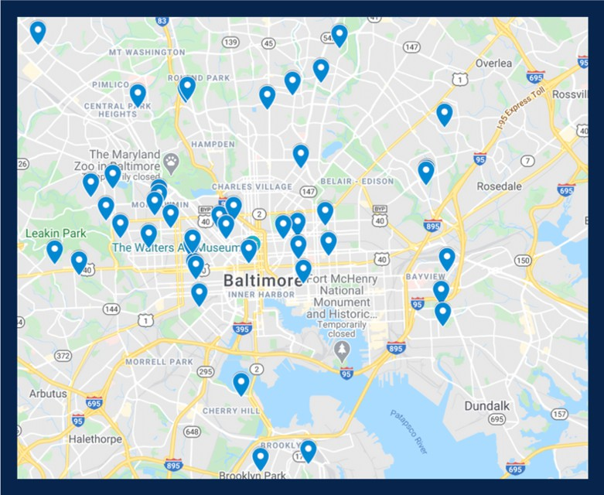

Source: [https://www.baltimorecityschools.org/ac](http://www.baltimorecityschools.org/ac)

1. Stabilize first responders by guaranteeing appropriate overtime and hazard pay and by offering free local housing to avoid putting family members of essential workers at risk

We are forever indebted to the brave first responders putting themselves on the front lines of COVID- 19 to save lives and flatten the curve. City Hall will collect donations from both the public and philanthropic partners to establish a fund supporting these first responders and their families. Relief efforts paid for through these donations will be focused on alternative housing for self-isolation, hazard pay, and a catchall fund for necessities such as groceries.

1. Support mid-sized non-profits overlooked by federal stimulus and minimize burden on small businesses by waiving bills on minor privilege fees and extending deadlines on business invoices due to Baltimore City

Small businesses and startups serve a fundamental role in our economy, and they have suffered severe damage from the crisis. Eventually, will be safe for entrepreneurs and their employees to return to work. But the city has to do everything in its power to help keep small businesses afloat until public health leaders inform us that it is safe to return to life as normal.

At a regulatory level, the city can provide temporary relief for small businesses in the immediate crosshairs of coronavirus. The city could also provide a backstop for small businesses by halting commercial evictions for the duration of the crisis; and both streamlining and temporarily waiving minor privilege fees. Baltimore could help locally-owned restaurants and hotels by extending the deadline for business invoices related to food and beverage taxes and hotel/motel taxes.

In collaboration with state partners and leadership, Thiru will work to impose a temporary sales tax holiday and delay business tax payments for restaurants, hotels and motels, and other small businesses.

Also, non-profits working to serve Baltimore, particularly during COVID-19, are struggling. The Y in Central Maryland, an employer of more than 500 people, was considered too big to receive federal relief in initial stimulus. The organization has admirably stepped up for the community, but it has been left behind with a major loss of revenue. This gap is one the City should fill.

1. Provide sick leave payments for high-risk essential workers

The Maryland Department of Labor has suggested that essential individuals who have not been quarantined but feel ill should use employer-paid time off. For a myriad of reasons, that time off may have already been used up, and – regardless – employers cap the amount of paid sick leave allotted. For many families, this limit means an impossible choice between putting food on the table and paying the bills or risking getting others or their family members sick.

Cities like San Francisco have realized the importance of sick leave in fighting this crisis – especially for high-risk essential workers who might not have enough leave to meet an appropriate recovery period. For those who are determined to be high-risk, or who are living with someone who is high-risk, we will leverage municipal funding to allocate funding to cover additional sick leave payments to match those originally determined by the employer. These additional sick days will remain until the stay-at-home order is lifted.

Six to 18 Months: Build the Road to Recovery as We Reopen Our Economy

Baltimore must act quickly to respond to the immediate and severe consequences of the virus, but it cannot lose sight of a brighter future on the horizon. When it is safe to begin reopening our streets and businesses, Thiru will jumpstart a vibrant, inclusive economy by beginning to cut property taxes, invigorating key industries, increasing businesses’ access to capital, ensuring affordable housing, and developing creative partnerships to invest in our city’s diverse and rapidly-evolving workforce.

1. Commence schedule to cut property taxes in half over ten years in equal incremental reductions

There is no better barometer of the health of a city than its population growth and decline – and people are leaving Baltimore in droves. This year, Baltimore was confirmed to have a smaller population in 2020 than it had in 1920.

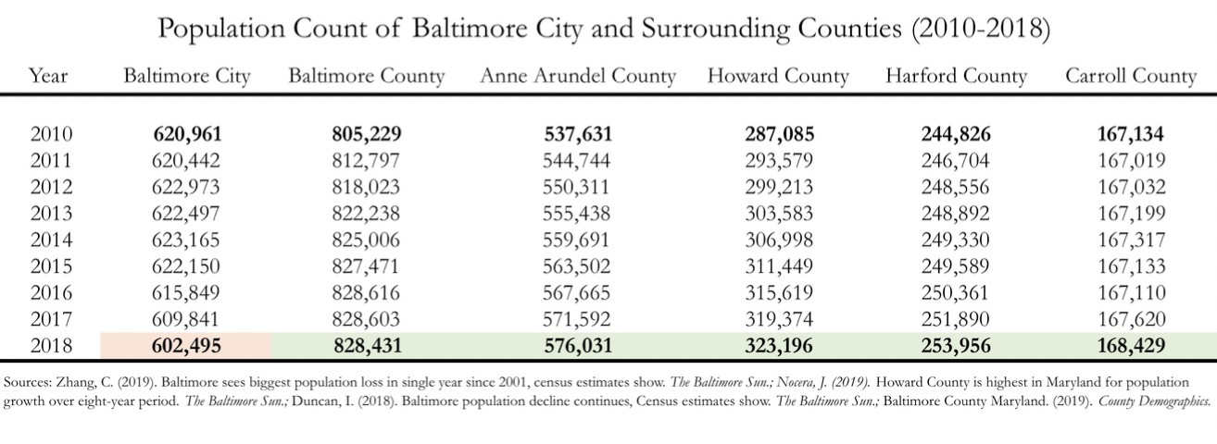

For too long, city residents have paid twice as much in property taxes as everyone else in Maryland, which naturally deflates property values, discourages investment, and induces families and businesses to leave the city. With soaring crime and broken schools, this tax rate has become harder and harder to explain. It’s no wonder more and more residents and businesses are leaving Baltimore City for neighboring counties every year. Some 7,346 residents — over a percent of our population — left last year alone. And as the population has declined in Baltimore City over the past decade, the population in every surrounding county has grown.

To be sure, property taxes drive 32.7% of Baltimore’s FY 2020 $2.9 billion operating budget. As a result, Baltimore cannot precipitously slash its tax rate without borrowing from the state or federal government or without significant reductions in services, neither of which is prudent or palatable.

But this trend should not paralyze us. While taxes cannot be realistically cut in half overnight, they can be gradually and responsibly reduced to county levels with a clear and disciplined plan. Thiru’s proposal explains the mechanics of how it will be done, what revenue reductions will mean, how the city should prepare for these cuts, and what compensatory actions the city will take.

* + *Reduce the property tax rate by .01 every year for 11 years (.22 to .21 to .20 and so forth) until it plateaus at .11, achieving equilibrium with other Maryland counties.*

Baltimore will responsibly cut property taxes while improving services by reducing the property tax rate by $.11 per $100 of assessed value each year for 10 years until it is competitive with neighboring jurisdictions. Over the decade, for a $200,000 home, these reductions will save a homeowner over $12,000. Under this plan, Baltimore City will adopt this preset schedule of tax reductions. As mayor, Thiru will require budgets prepared and ratified by City Hall to adhere to this schedule and will fix this schedule in a charter amendment.

Even without greater discipline in agency budgets, there are several reasons why city revenue is projected to grow as property taxes are lowered.

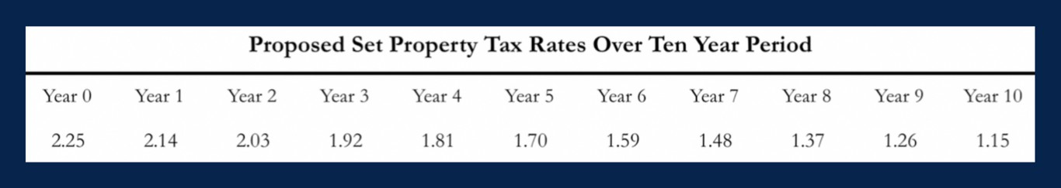

First, as cities like Boston and San Francisco have seen, pinning property tax rates can halt population flight and catalyze growth, which will generate both more property and income tax revenue in Baltimore. This is because new home purchases are based on price points determined by homeowners’ maximum monthly payment. For example, a family willing to purchase a home at $500,000 at a property tax rate of 2.2% will pay the same in property taxes ($11,000) as a family that purchased a home at $550,000 with a tax rate of 2.0% ($11,000).

* + *Crack down on fraud and require agencies to identify 1.5% annually in wasteful spending.*

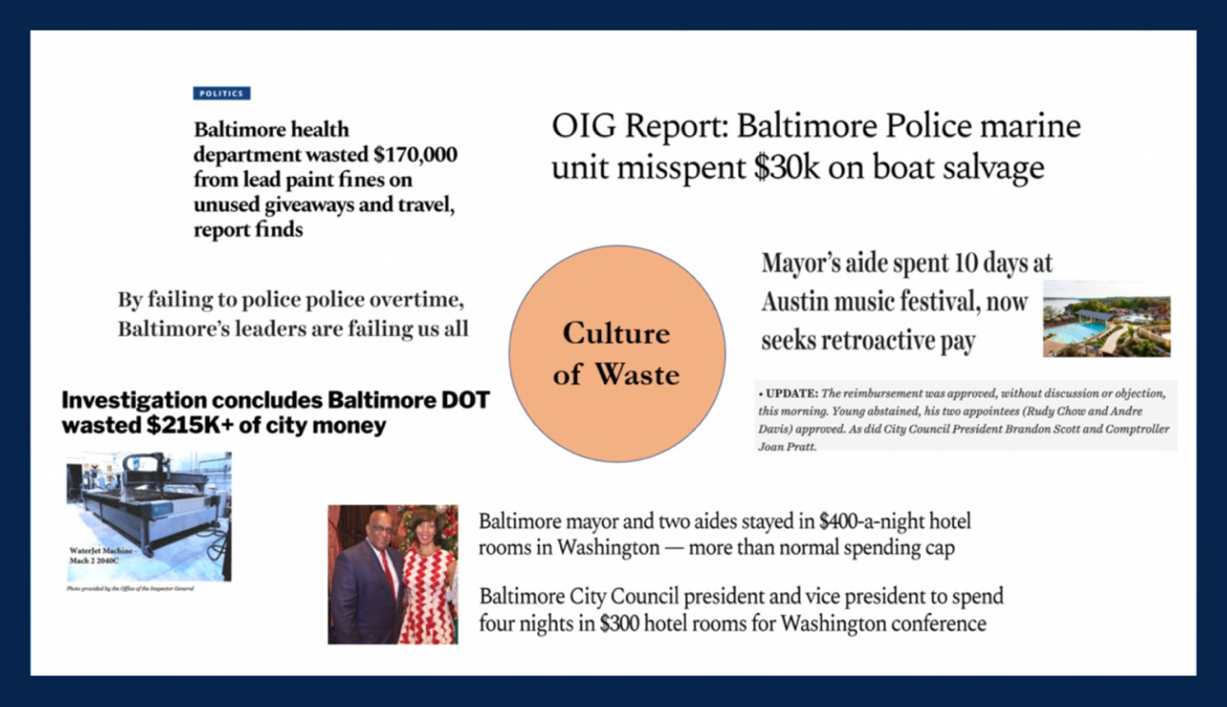

This tax cut will be complemented by required waste reduction initiatives across all city agencies. Because property taxes account for some 36% of the City’s budget, proposed cuts will reduce revenues by as much as 1.8%. In response, agencies will cut $40 million in waste and fraud, each identifying 1.5% annually in wasteful spending based on annual, top-to-bottom independent audits of City Hall. Thiru will direct agency heads to crack down on waste, inefficiency, and fraud while preparing disciplined budgets consistent with the schedule of tax rate decreases. Unjustifiably high taxes are particularly offensive when taxpayers see consistent examples of misspent funds and fraud going unchecked.

* + *Raise taxes and penalties on absentee real estate speculators on vacant, unused properties.*

Even as Thiru reduces property taxes for property in active commercial and residential use, his plan will increase code violation penalties and property taxes on vacant properties being held at virtually no cost by property speculators, many of whom are not even based in Baltimore or Maryland. This kind of strategy has generated millions in revenue for cities like Washington, D.C., which raised the commercial property tax rate for vacant property from $1.65 to $5 for

$100 in assessed value and to $10 per $100 of assessed value for blighted property. The prospect of increased taxes will either prompt development, raising the property value and thereby generate additional revenue; or the sale of the property to an owner prepared to make active use of the land.

* + *Pursue legal action to seize property from absentee slumlords and speculators on vacant and abandoned properties with unpaid taxes and persistent code violations. Tax increases and legal action will not be directed at property in residential or commercial use.*

Baltimore loses significant potential tax revenue each year because of “hypervacancy” — a term referring to neighborhoods where vacant buildings comprise more than 20% of that area’s housing stock. The level of hypervacancy in Baltimore increased from 7.5% of census tracts across the city in 1990 to more than 30% by 2018.

Following a model adopted by St. Petersburg, Florida, Baltimore will fight blight and generate revenue by taking ownership of vacant property with delinquent taxes or persistent code violations and sell them on auction or to affordable housing developers to further programs like Vacants to Value. In St. Petersburg, 800 vacant homes across the city owed $4 million in liens and unpaid assessments. Pursuing legal action reduced vacant homes by 75% in 4 years and generated $2.1 million in revenue. Baltimore has 17,000 vacant homes.

This plan is meant to reflect a new kind of leadership for Baltimore at a time when taxpayers are desperate for change. Lowering property taxes will not alone reverse the dual crises Baltimore faces. But alongside systemic changes – combating crime and corruption, strengthening our schools and transit grid, and addressing the inequities that define too many neighborhoods – a competitive, common-sense tax rate will create the climate Baltimore needs to attract investment, create jobs, and grow our population.

1. Stimulate development of promising growth industries that would become anchors of Baltimore’s economy for the next century, including biotech, cybersecurity, small businesses, arts & music, cannabis, culinary arts, cancer research, driverless vehicles, port logistics, and tourism & hospitality

Turnaround stories in other cities, like Pittsburgh and Detroit, involved fostering investment in targeted industries where cities hold a distinct advantage. In the aftermath of COVID-19, rapidly investing resources into fast-growing, profitable industries will be critical to jumpstarting the economic reversal Baltimore needs. Thiru plans to devote resources into building up these ten high-potential industries vital to Baltimore’s future:

1. *Biotechnology and Health Care*

Few cities in the world boast world class institutional anchors like Johns Hopkins and the National Institutes of Health. In addition to the rich tradition of research and ingenuity that defines both institutions, Baltimore also already has a blossoming entrepreneurial culture. Coupled with Centers for Medicare & Medicaid Services (CMS), the University of Maryland, and UMBC, Baltimore’s promise is limitless. To stimulate the biotech and healthcare industries in Baltimore, Thiru will lower taxes for biotech companies and invest in city-owned affordable incubator centers, located near prominent universities and research and development facilities, for biotech startups. This will include the city-subsidized expansions of AccelerateBaltimore and ETC Baltimore.

1. *Cybersecurity and Coding*

Cybersecurity is already emerging as a massively profitable strength for Baltimore. Several startups with meteoric trajectories have headquarters at Port Covington. U.S. cyber command is located at Fort Meade, just eighteen miles south of Baltimore City; and graduate programs in and around Baltimore have been educating the next generation of cybersecurity analysts and experts – creating an important talent pool for local employers. As mayor, Thiru will encourage and incentivize businesses and startups to find their home in Baltimore.

1. *Small Businesses and Entrepreneurship*

Small businesses comprise the backbone of any successful city. Especially in the wake of COVID-19, small business owners and employees need more support than ever before. To work towards rebuilding after the pandemic, Thiru pledges to introduce low-interest rainy-day loans and tax credits to owners, while organizing the philanthropic community’s resources to operations that need assistance getting back on their feet.

Small businesses will struggle with liquidity both during and after the crisis, leaving many in the unenviable position of cutting costs and reducing payroll. Though the federal government has set up targeted loans through the Small Business Administration and Federal Main Street Business Lending Program, these time-intensive resources likely may prove “too little, too late” in reaching our business owners. Baltimore City must do all it can now to protect its small business sector. In the short term, Baltimore should follow the lead of cities like Chicago, who partnered with local Community Development Finance Institutions to provide $100 million in low-interest small business loans directly targeting historically under-resourced communities.

Through partnerships and mechanisms like public entity and city government funds, City Hall can amplify and match philanthropic and private relief.

Even after the crisis, businesses may struggle to reopen their doors. On average, small businesses only have 27 days cash-on-hand – a number likely lower after the stress of COVID-

19. The city should ensure that loan repayment does not inhibit business’ ability to recover by allowing delayed repayments until the crisis has subsided. Additionally, Baltimore has a number of innovative microfinance programs to support small business growth and development; the mayor should work directly with these organizations to help promote their efforts and facilitate their ability to reach businesses in need of capital.

In order to recruit and retain more small business in Baltimore, Thiru has proposed three initiatives. First, as previously stated, he will streamline minor privilege and permitting fees that are costly and time-consuming. Second, he will pledge health insurance coverage for up to seven employees to companies that stay in Baltimore for at least 5 years. Lastly, Thiru is committed to ensuring that Baltimore’s small businesses are representative of the great diversity our city has. He has promised to provide tax incentives to LGBTQ, female, immigrant, or minority-owned small businesses.

All of these initiatives are meant to be carried out in conjunction with Thiru’s detailed plan to reduce violent crime and cut the murder rate in half. Small businesses cannot thrive in a city with 348 homicides a year. To specifically help small business owners, their employees, and consumers, Thiru has pledged to provide incentives to purchase, install, and register cloud- based security cameras and give financial assistance to small businesses interested in partnering with security firms.

1. *Arts, Film, and Music*

Baltimore’s rich history in art, film, and music has historically been an engine for growth. Baltimore has all the promise to once more become a cultural leader in the arts. As mayor, Thiru will be committed to reigniting the arts industry through several initiatives.

Thiru will expand and support the creation of additional arts and entertainment districts. Thiru recently stood with Peter Brooks, grandson of Jazz legend Cab Calloway, to protest the demolition of Calloway’s historic childhood home in the midst of the COVID-19 pandemic. He is committed to preserving the legacies of Baltimore’s many successful Black and Brown musicians and artists and building inclusive spaces for the new generation of trailblazers. As

mayor, he will extend tax-free income benefits in art districts to include a more inclusive concept of “artists” by allowing, for example, musicians, spoken word artists, and filmmakers.

From *The Wire* to *Hairspray*, Baltimore has been the stage of incredible shows and movies. Thiru will re-establish financial incentives to encourage television producers and filmmakers to set their works in the city and provide jobs for hundreds of Baltimoreans.

Thiru has also planned to lead a capital campaign to raise funds from private donors to reinforce the shaky financial foundation of the Baltimore Symphony Orchestra.

1. *Culinary Arts*

There are three reasons why culinary arts have become a critical part of Baltimore’s future. First, the food and beverage industry provides accessible opportunities to build successful careers – the industry is the highest percentage employer of ex-felons in the country, and over a fifth of restaurant workers are immigrants. Second, while there are numerous entrepreneurs in this industry who have been contributing to the cultural experience of our city for generations, Baltimore has a number of innovative restaurant owners, chefs, and industry players who are pushing the industry to new heights. Third, Baltimore’s restaurant industry attracts consumers within and beyond Baltimore who are willing to pay a premium for the quality of experiences our businesses offer. Thiru will inject capital and resources into up-and-coming culinary districts and introduce tax benefits for employers willing to hire returning citizens.

1. *Medical and Recreational Cannabis*

The marijuana marketplace in Baltimore is currently a chaotic free-for-all, contributing to record violence while depriving taxpayers of hundreds of millions of dollars. Illegal trade occurs unimpeded as police and prosecutors publicly squabble about whether to enforce current laws, even as street marijuana is increasingly laced with fentanyl and K-2. Medical cannabis is booming, but cannot be taxed and has virtually no licensees of color.

The bottom line: a billion dollars is spent on cannabis products each year, which largely ends up either in monopolized hands of untaxed licensees or violent gangs and drug organizations.

This is the worst of all worlds. Violence is unabated, avoidable overdoses persist, and drug proceeds remain locked in a violent black market. Moving the cannabis trade out of the shadows and into a well-regulated, transparent market will (1) reduce gun violence driven by

competing gangs, (2) decrease overdose death from laced marijuana, (3) mitigate the racial wealth gap, and (4) provide vital revenue to fund universal pre-K, finance repairs and upgrades at K-12 school facilities, guarantee free college in Maryland for public school graduates, and grow HBCU endowments. Baltimore City cannot afford to wait for indecisive lawmakers in Annapolis to take action while the City suffers from the failed war on drugs.

Just as Colorado and other states have issued permits and taxed the sale of cannabis despite its legal status under federal law, so too should Baltimore City issue sales permits and tax cannabis. The same people who think Baltimore City has to wait for Maryland law to change thought Colorado had to wait for federal law to change.

It’s time for Baltimore to lead, not follow.

* Issue Permits to Baltimore Businesses to Aid Communities of Color

When it comes to marijuana, the war on drugs has been a colossal failure. For decades, communities of color have disproportionately shouldered the costs of Baltimore’s enforcement policies. Now that America is realizing its mistake, the communities who were most devastated by the failed policies of the 1980s ought to be the first to benefit from this emerging market.

Permits will be preferentially issued to enterprises owned, operated, and controlled by historically-disadvantaged, local business owners of color and to those who commit to hire employees with non-violent criminal records who are seeking legitimate employment opportunities.

* Require Tax Proceeds be Spent Strictly on Public Education Programs

The emerging cannabis market would produce $250 million in annual revenue for Baltimore City. Maryland and others will inevitably legalize marijuana, but there is a first- mover advantage in this industry that the City should seize. In the past, residents have been promised funds for education from controversial ventures like casinos only to see money diluted or redirected to other priorities. This won’t happen again.

All cannabis tax proceeds will be strictly dedicated to key education programs, starting with (1) universal pre-K for every 3- and 4-year-old child, (2) repairs and improvements at K-12 facilities, (3) free college, community college, or trade school for public high

school graduates, and (4) funding to grow the endowments of HBCUs. These funds will be used only to support new programs and to supplement, not replace, current funding sources for the expansion of existing programs.

* Establish Infrastructure to Manage Complex Emerging Market

The City will establish a commission comprising community members – with the requirement that no member holds a conflict of interest – who will manage and make permitting decisions. The process and decision-making will be fully public and transparent so there are no doubts who made the decision and why.

Baltimore will create a city-operated credit union that holds the proceeds of cannabis sales, and distributes taxes to vital education programs, and eventually makes its reserve funds available for low-interest student and small business loans.

Thiru will appoint a safety board that will ensure that recreational cannabis is safe and free of dangerous additives like fentanyl and will create and communicate clear regulations about when, where, and how the product can be sold and used.

In theory, prosecutors in states like Colorado could bring charges under federal drug laws at their discretion. In practice, they never have. The premise of the proposed approach is that prosecutors in Baltimore have better things to do with their time than to go after permitted, minority-owned cannabis dispensaries based in Baltimore who hire residents desperately trying to obtain legitimate employment to turn their lives around. Issuing city permits and collecting taxes would no more make the sales legal under state law than issuing state licenses makes the sales legal under federal law. But, with ingenuity and leadership, we can still bring the marijuana trade out of the dangerous shadows—where gangs kill over turf—and create a safer market that redresses racial inequities and generates massive tax revenue at a time when Baltimore desperately needs it.

1. *Cancer Research*

Baltimore boasts world-class medical institutions and research facilities that have recently been alienated from partnerships with City Hall. Thiru will support these stakeholders to make our city a magnet for medical innovation and discovery. Thiru is committed to shaping Baltimore into the nation’s hub for groundbreaking cancer research. Under his leadership, we will partner with Johns Hopkins and the region’s many neighboring colleges and universities to find a cure.

1. *Driverless Vehicles*

Autonomous vehicles will still need years of development and millions of miles of training their neural networks with live drivers behind the wheel. The hesitation of other cities, which is already starting to dissipate, presents a tremendous opportunity for Baltimore. Particularly given the critical importance of Baltimore‘s port — which remains a destination of choice for car manufacturers in Europe and Asia – this is a chance for Baltimore to become the next century’s Detroit in terms of manufacturing and innovation. With immediate access to the vital I-70 interstate, this industry of the future is one Baltimore City should dominate.

1. *Tourism & Hospitality*

In 2017, 26.2 million people visited Baltimore, spending $5.7 billion in direct sales and generating $100 million in sales tax revenue. The tourism industry is a major employer in Baltimore, supporting over 85,500 jobs in Baltimore and its surrounding areas. However, travel restrictions due to COVID-19 have only exacerbated the strain on the industry, its workers, and their families. While we must ensure that all employees within the tourism and hospitality industries earn a living wage and have opportunities for upward mobility. Given Baltimore’s location and enormous cultural assets, there are tremendous growth opportunities to make tourism a vibrant economic engine.

Tourism thrives when Baltimore thrives – first, we need to make our city safe. Thiru pledges that his 20-point crime plan of unprecedented strategies will cut the murder rate in half. When we see real change on our streets, tourism will rise.

1. *Port Development*

Three advantages – Baltimore’s proximity to Washington D.C., its location along the I-95 and Amtrak corridor, and its large and booming port – make the city not only easily and quickly accessible, but an area marked for its potential for economic development.

Baltimore boasts the 11th largest U.S. port regarding the handling of international cargo and is the country’s 9th largest measured by value. Our port has both public and private terminals that, in 2018, imported and exported 43 million tons of cargo and is set to be the departure point for 100 cruises next year.

As mayor, Thiru will invest even more into the development and renovation of Baltimore’s port to incentivize more traffic and generate stable, well-paying jobs for Baltimoreans. First, he will ensure the reconstruction of the Howard Street Tunnel. An expansion of the freight tunnel will increase freight clearances and allow for more transport of goods from Baltimore’s port to other jurisdictions while creating hundreds of construction jobs. The federal government has already granted money for this project, and private partnerships can mitigate remaining costs.

1. Raise property taxes on abandoned properties to ensure that real estate speculators are induced to promptly begin development or sell property holdings to investors who will

Given the overwhelming evidence linking neighborhoods of concentrated disinvestment to violent crime, it is impossible to discuss the epidemic of violence in Baltimore today without accounting for our city’s history of housing segregation. A lack of affordable housing in the city often results in inherent instability for low income residents and contributes to the rise of abandoned blocks across the city. Unable to afford a safe place to live, tenants are often forced to either settle for substandard housing or become regular defendants in Baltimore’s rent courts.

This lack of stable housing affects more than just the roof over one’s head. Every house is linked to a community which provides (or deprives) a family access to good schools, quality food, and a safe environment. It is no surprise that quality stable housing is linked to longer and healthier lives. In Baltimore, this difference is visible in the variation of life expectancy across the city - with residents of Roland Park living an average of 14 years longer than those from Sandtown-Winchester.

For too long, Baltimore has focused its time and resources towards a few select areas of the city. The long-term solution rests in ensuring adequate investment across the city so that Baltimore is a united city, rather than a checkerboard of opportunity. While the city lacks the funds to directly invest in all neighborhoods, it possesses strong economic and political tools to redirect capital equitably.

With over 17,000 vacant properties, Baltimore is sitting on untapped housing potential. Several cities in California have moved to tax properties that are unoccupied for an extensive period of time. This diminishes incentives for speculators who acquire properties and hold them until their value is raised for resale or they can command a higher rent. By taxing long term vacancies, the city can push property holders to either increase recruitment efforts to find tenants, or reduce rents to more reasonable levels. Property owners who are unwilling to do this will face taxes that help the city fund initiatives to combat the known impacts of high levels of vacant housing.

1. Cut vacant housing stock by using eminent domain to seize property with excessive code violations and unpaid taxes and transfer it to affordable housing organizations

Baltimore city code permits city acquisition of abandoned property when the property is deemed a public safety threat and the owner of the property has failed to take the proper course of action to correct the problem. Despite having this authority for years, city leadership has failed to leverage their power and reclaim property from absentee landlords who have let it fall into disarray. In most of the incidences in which the city has exercised its authority - it has done so to demolish properties rather than invest in their revitalization or future development.

When done properly, the city’s ability to condemn and seize property can work to the public’s benefit. Evidence from St. Petersburg showed a near 75% reduction in vacant homes when the city began efforts to hand these properties to non-profits, who used them to construct affordable housing for residents. This effort functions to prevent abandoned housing from bringing down the value of entire blocks while also returning properties from absentee landlords to communities who could put them to good use. Thiru plans to seize abandoned homes from owners who refuse to care for them and subsequently sell these properties to community housing organizations.

1. Relaunch dollar-homes program with modified city subsidies to banks, reinvest in community land trusts to expand long-term affordable housing, and effectively safeguard tenants’ rights

*Relaunch Dollar Homes Program*

Thiru commits to finally act on the words and promises of past politicians and bring back the Dollar Homes Program. Under the program, residents can buy a vacant home from the city for only $1 if they promise to (1) commit 100k towards renovating the property and (2) live in the residence for at least 5 years. The program will be directed at supporting local living for law enforcement and first responders, teachers, and social workers.

In order for this program to succeed, Thiru will explore partnerships with local banks and lenders to ensure that those looking to buy a home through the program have access to the financial support they need in order to rehabilitate the property. City Hall will commit to purchasing insurance against the value of the home, then provide lending institutions guarantees that their investments are secure.

As necessary, the city will co-invest to cover any differential between appraised value of the home and money needed to rehabilitate it. By working with banks to secure low-interest loans, Dollar Homes can be made accessible to residents who otherwise may not be able to access home ownership.

*Invest In and Support Community Land Trusts*

Given the disparity in homeownership rates in the Baltimore area – white residents are three times more likely to own a home than black residents – City Hall needs to do more to ensure that homeownership is accessible to black and low income residents. Community Land Trusts (CLTs) are a promising means of collective ownership of land and capital. CLTs are nonprofits that buy land and maintain ownership of homes in the city, and then enter long-term, renewable leases with homeowners at affordable rates. When the homeowner sells, the family earns a portion of the increased property value as a stakeholder in the CLT, while the remainder is kept by the trust to preserve the affordability of the housing.

Examples from Boston have shown the ways in which CLTs can provide homeownership opportunities to individuals who would normally be limited to rental options. In Baltimore, the Northeast Housing Initiative has taken similar steps to build community ownership of property. However, given the amount of time and support these initiatives require, it is important that we look to their long-term value – not just their immediate payoffs. Each home that a CLT secures helps their initiative expand further, and is a guaranteed affordable home for generations to come. Every resident who owns a CLT home feels the pride and reaps the benefits of owning their own home, but also is securing their future by investing in their land trust’s equity. Given that homeownership is one of the key means of generating wealth for Americans, it is imperative that Baltimore support CLTs and other means of affordable homeownership. Thiru will partner with community organizations with the knowledge that these impacts take generations to see, but are incredibly important to strive for today.

*Guarantee Legal Assistance for Tenants Facing Rent Court*

Rental agreements are underlined by a power imbalance between renter and landlord. When facing eviction, tenants often are rushed through rent courts with little understanding of the system or their rights. Tenants rarely have representation and few know how to defend their cases in court, presenting landlords with the upper hand.

Thiru will commit to increasing public attorney resources to defend tenants facing evictions in rent court, allotting them a fighting chance at repelling invalid eviction charges. While the city would be unable to provide a personal attorney for all cases – 150,000 cases interact with rent court annually –

the city should provide a centralized access point to legal resources regarding Rent Court procedures, the status of their cases, and housing assistance services to halt eviction.

Thiru will also support adding city renter protections that prevent evictions unless the landlord could prove just cause for eviction, similar to those implemented recently in San Jose.

*Expand Eviction Prevention Policies and Post-Eviction Rehousing Services*

It is time that we stop considering homelessness a problem once the person has already lost their home. Baltimore can reduce costs associated with emergency housing and prevent tenants from needing to uproot from their communities by expanding eviction prevention policies safeguarding renters in need of short-term assistance. The HomeStart program, based in Boston, seeks to prevent tenant evictions by helping manage the cases of at-risk tenants, negotiating agreements with landlords and covering back rent payments when necessary. Landlords avoid the high costs of eviction, the city spends less on emergency housing services, and tenants can continue to stay in their homes. Thiru will launch a similar initiative in Baltimore, implementing partnerships that seek to provide tenants with guidance and low-to-no interest loans to cover rent on rainy days. By loaning small sums from the city, tenants can avoid predatory lending practices and stay out of rent courts during periods of hardship.

Not all evictions are preventable, and some extreme circumstances will still push tenants out of their homes and onto the streets. For these individuals, Thiru will shore up emergency housing shelters and expand the services that these centers provide without imposing arbitrary constraints on length of stay. Emergency housing shelters should serve as a point for residents to bounce back to stable housing, not a means of keeping them off the streets.

1. Launch Office of Strategic Partnerships (OSP) to coordinate investments across philanthropic, business, government, and nonprofit sectors

It is the duty of city government to lead effectively – with integrity and urgency – in the face of tremendous obstacles. We are in the middle of a once-in-a-century challenge that demands an alliance between business, philanthropic, and civic and nonprofit actors. To tackle the stark inequities and consequences of long-standing disinvestment in some of our most struggling communities, which is further highlighted by the devastating wake of COVID-19, we need to work together.

We are fortunate to have scores of local private and social players dedicated to creating a brighter future for Baltimore. Foundations understand that City Hall could be a partner in their push for scaled

impact and systems change. Community organizations and nonprofits have been tirelessly committed to their constituents, and would benefit from additional opportunities for collaboration and partnership. And, many private firms see social responsibility and civic engagement as essential for employee retention and community development – in other words, businesses do well by doing good.

Cities like Memphis, New York, and Asheville have proven the importance of a shared vision of progress, where cross-sector initiatives and clear metrics resulted in job creation, a more efficient city government, and drastically lower crime rates. However, because of failed leadership in City Hall, we have long gone without a coordinated strategic plan. We need to unite our best assets and key stakeholders under a comprehensive plan – across silos and barriers – to sustainably lift up individuals and communities in every neighborhood.

Thiru’s Strategic Partnership Initiative will spur equitable growth and drive the cross-sector partnerships needed to solve our city’s most challenging problems. As part of this initiative, Thiru has pledged to:

* + Create an Office for Strategic Partnerships (OSP) in City Hall to promote capital development in Baltimore through public-private partnerships and to coordinate city resources with greater efficiency and transparency. During and after the COVID-19 crisis, there should be close coordination across sectors to provide care to underserved communities.
  + Lead a Collective Impact Taskforce to convene public, private, philanthropic, and nonprofit stakeholders to more effectively and holistically address the core challenges affecting Baltimore City. In light of the COVID-19 crisis, we will divert resources to food delivery, health services, and affordable housing development.
  + Establish a City-affiliated Strategic Partnerships Fund to incentivize and support resident-driven development initiatives that bring together neighbors, small businesses, and community organizations and institutions.

1. Jumpstart inclusive workforce development programs by aligning the priorities of public education, trade schools and community colleges as well as diversion, prison workforce and reentry programs with personnel needs of existing and emerging industries

With higher unemployment rates than any other jurisdiction in the state and a much higher rate than the national average, Baltimore is in desperate need of new pipelines to success. Thiru will invest in

industries that will put our natural assets to work and create career and training opportunities for everyone from PhDs at Hopkins to individuals entering the workforce without a GED.

In order to help curb recidivism and to meet individuals returning to society from prison with an apprenticeship and a job, Thiru will scale proven programs, such as the District Court Re-Entry Project, and launch both the Court to Career Program and School to Success Initiative. He has already proposed his Court to Career (C2C) Program, which is an adult diversion initiative; along with its parallel program, School to Success (S2S), which is purposed for diverting juvenile offenders. Both programs match individuals with employment opportunities with room for advancement and growth.

In its first full year, C2C and S2S will help divert 1,000 individuals who are charged with low-level offenses from the revolving door of poverty, crime, and prison to a constructive path of job training and paid employment opportunities as a condition of receiving a probation before judgment (PBJ). This will require partnerships between district court judges and juvenile masters, probation officers, case workers, skills training programs, apprenticeships, and employers who are prepared to hire at-risk individuals and give them a second chance. Only when individuals complete the program, having demonstrated stable employment and no criminal activity, are they taken off probation with their records expunged.

For juveniles, the programs will adopt apprenticeships and work schedules that are compatible with school and other vital obligations. School to Success will prioritize programs geared to all facets of enterprise and academic achievement. Thiru will ensure expanded opportunities for vocational school instruction, university-level coursework, and internships/apprenticeships, making them more readily accessible to students completing their junior and senior years of high school.

Five to 10 Years: Spark for Baltimore City a “Next Generation New Deal”

From forging the first leg of the American railroad to mapping the stars with the Hubble Space Telescope, Baltimore’s history is defined by industry and innovation. Though our city has suffered from job erosion and disinvestment, Baltimore’s potential is tremendous. We are a city that pioneers the cutting-edge of medicine, launches next-generation businesses, and sets the standard for creativity in the arts. Our restaurants make headlines while creating community. We welcome immigrants while celebrating businesses that have thrived in Baltimore for generations. Baltimore has nearly 14,000 businesses, both big and small; and one third of our labor force – one of the highest percentages in the country – devotes their careers to service through the nonprofit sector. We are a city shaped by individuals dedicated to the promise of progress.

Thiru will offer Baltimore a New Deal for the next generation by injecting a massive stimulus investment, redesigning our transit network and water – sewage system, rebuilding our crumbling schools, and leading the nation in smart city innovations. This “Next Generation New Deal” will help unleash our city’s full promise, a promise of prosperity and equity, hope and opportunity.

1. Launch massive $3-4 billion investment in infrastructure overhaul over the next decade, pledging to match federal stimulus funds with public-private city investments for five major commitments.

As Baltimore ushers in a new era of economic development, City Hall must begin a second round of infrastructure investments. Thiru has pledged to match federal stimulus funds granted to the city by again borrowing against the city’s AA municipal bond rating, this time a sum of $3.5 billion, to invest over a five – 10-year period. This will be supplemented by leveraging philanthropic partnerships and coordinating with investors and businesses.

The funds will go towards five major initiatives: (1) the design and construction of a green transit network, (2) building a water/waste system that is in compliance with the federal consent decree, (3) launching massive renovations of city schools, (4) constructing an equitable transit grid, and (5) beginning smart city investments.

1. Major public transit initiatives to potentially include East-West light rail, revitalized trolley cars, Inner Harbor footbridge, above-ground circular shuttle train, and high-speed rail to DC

Due to necessary social distancing guidelines, Baltimore’s transit system has significantly decreased its operations by limiting lines and routes. Once the COVID-19 crisis subsides, Thiru will work with state and local transit authorities to restore Baltimore’s transit system to greater capacity than before the public health crisis, creating an equitable transit grid while also offering an array of new employment opportunities at all levels.

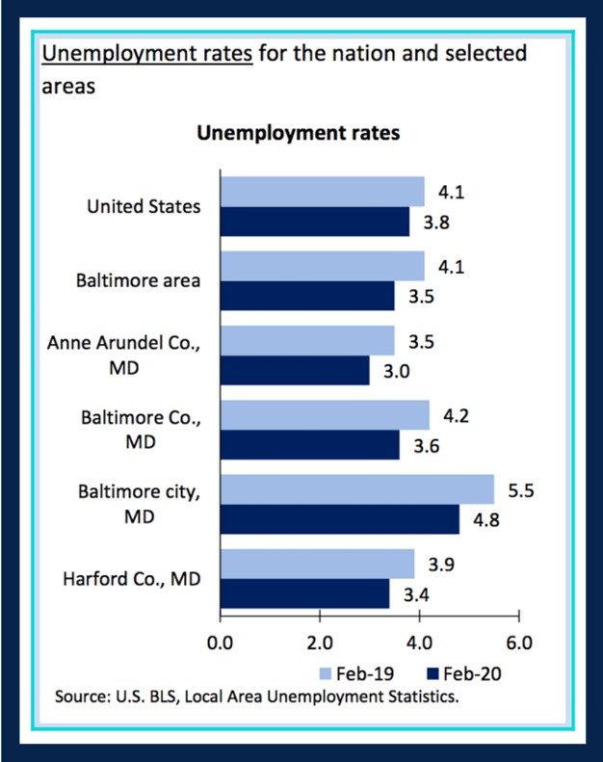Thiru will prioritize two major public works projects: expanding free circulator routes to include major west-to-east corridors and critical arteries to historically disinvested neighborhoods; and leading the charge to build the primary route of America’s first high-speed rail line, connecting Baltimore and Washington, D.C. These projects will lay the groundwork for the exploration of other transit alternatives, from a revitalized trolley car system to an above ground circulator to gondolas to a footbridge across the harbor.

The city's free transit system—the Charm City Circulator—is designed by Visit Baltimore, which is a 501c6 with municipal and corporate partners, designed specifically to market the city—not to provide widespread

public transit. We need to reform the purpose of free-fare buses to specifically target riders who lack alternative transit options. Expanding free circulator routes to East-West corridors and major arterial roadways like Pennsylvania Avenue and Harford Road will reduce pollution as ridership increases, reduce commute times, make the City more accessible, and facilitate economic development by providing realistic transportation to job centers and employers. Economic empowerment through transit is critical to Baltimore, which suffers higher unemployment rates than neighboring jurisdictions. Thiru will lobby to start construction of the proposed 14-mile East-West transit line between Baltimore County and downtown, connecting the Light Rail, Metro Subway, and MARC train and instituting a comprehensive transit grid.

Thiru will lead the fight to break ground on the first American leg of high-speed rail connecting DC and Baltimore with a 13-minute bullet train, guaranteeing substantially discounted commuter fares based on income, and induce competitive, international bidding to reduce overall project costs.

1. Rebuild green network of roads and bridges, which are currently at risk of collapsing, with dedicated thoroughfares for public transit, combined with bike lanes and completion of 35-mile Gwynn Falls and Herring Run trail loop

Thiru will execute a Complete Streets redesign that considers the racial and socioeconomic equity of our roads and bridges. This will enable safe pedestrian traffic across the city, including East-West avenues reserved exclusively for green and active transit: pedestrians, bikes, scooters, and buses.

In addition to planning designated bike lanes and green transit avenues, Thiru will fund the creation of the Gwynns Falls Trail and Herring Run Trail 35-mile trail loop will integrate transit and nature by connecting 80% of neighborhoods to greenspace and recreational trails.

1. Bring water and sewage systems into compliance with federal consent decree, accounting for accelerated timetable for acute weather events precipitated by climate change

Our water infrastructure is crumbling, in violation of federal law and posing a grave public health risk. Faulty, cracked sewer systems caused the 32,000 gallon sewage leak into Jones Falls, a waterway into the Chesapeake Bay. Pipes inundated after a big rainfall lace sewage with stormwater, entering our waterways and taking a toll on local wildlife.

1. New school construction and renovations and repairs of all existing facilities, which are currently twice as old, on average, as schools across the rest of Maryland

City public school students are substantially disadvantaged by old buildings, facilities, and equipment as well as inadequate school supplies and resources. In addition to bond-supported funds for new school construction, Thiru will commit $100 million to finance discretionary maintenance and

renovations, earmarking funds for next-century educational infrastructure (e.g., platforms for robust remote learning).

Spending on education has the highest return of any investment in public goods or services. Education spending is about investing with low-cost capital now to generate future tax revenue and savings in areas like health and criminal justice. Using available social financing tools and leveraging opportunities for impact investing, Baltimore can rebuild, revitalize, and reimagine its education system with funds from an array of private sources.

1. Smart city investments including fiber optic cable, traffic and transportation analytics, a distributed network of weather and environmental monitoring systems, and automated performance tracking of municipal services

Thiru will usher Baltimore into a new era of technology and innovation as well as introduce major structural changes to city infrastructure that use data analytics to cut waste and promote efficiency. Following the leadership of cities around the world, Thiru will begin massive data collection on traffic patterns, utility (internet, water) usage, and environmental and weather patterns to then digitally transform our systems and procedures.

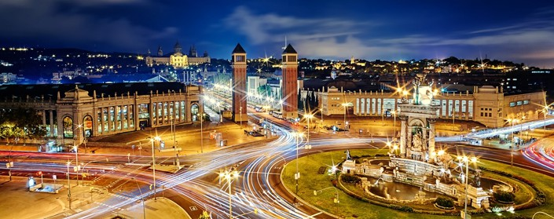Around the world, investments into digitalization and “smart” technology have been proven to save money. Barcelona reported savings of more than €75 million (over $81 million) following infrastructure investments in smart water, lighting, and parking. There is massive opportunity for local job creation and industry development, transforming Baltimore into a hub for technological innovation.

Barcelona Smart City

In the short-term, Thiru will invest in a timing-optimization program and Intelligent Transportation System technology (ITS) to coordinate the signals of Baltimore’s 1,300 traffic signals, minimizing traffic congestion and promoting safety.

Thiru also plans to develop a citywide, digitized pothole detection program. We will use sensors attached to city-owned vehicles, which naturally traverse the city, to measure width, depth, and severity of potholes; and then log that data into a publicly-available system. This monitoring serves as a measure of accountability, ensuring that the public can track and visualize the completion of 311 calls and that the most severe and significant potholes are filled first.

Baltimore’s current water billing system is inherently flawed, and notoriously issues exorbitantly high bills to residents resulting from undetected, yet often preventable, leaks. When a resident sees a high bill and calls in to complain, the Department of Public Works (DPW) examines hourly water usage; if the meter is constantly running all day and all night long, DPW naturally concludes there may be a leak, big or small, and then takes action. But there is no reason DPW should wait for residents to call-in about data DPW already has in its possession. As mayor, Thiru will implement computer monitoring of hourly meter rates to detect sudden spikes in usage or constant water flow that are symptoms of water leaks. Leaks left undetected and unattended, combined with crumbling infrastructure, have direct consequences – like Poe Homes being left without water for weeks, and recurring stories about sinkholes developing in and around our city. Catching leaks early and taking steps to fix them will reduce costs for the city, save families money, and lower the risk of catastrophic water main breaks.

Thiru will lead the effort for universal fiber optic internet infrastructure made free for public consumption. He will initiate competitive bidding among providers before laying the groundwork to ensure coverage in all neighborhoods, making Baltimore the national leader in internet accessibility.

Smart technology can be designed to serve two purposes: to reduce energy consumption and promote sustainability, and to reduce operation costs. Thiru will install LED bulbs into streetlights, which can be dimmed and brightened in accordance with data on location, weather, and time of day. City Hall will also prioritize research and data collection on air pollution and waste management in order to develop the cleanest possible policies and procedures.

###### A FINAL NOTE

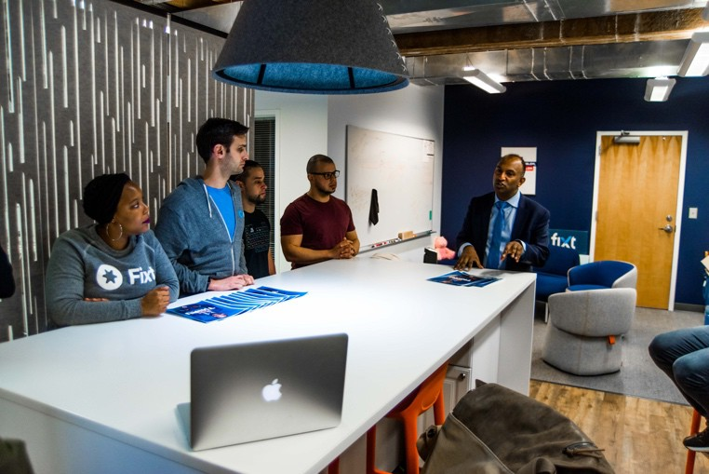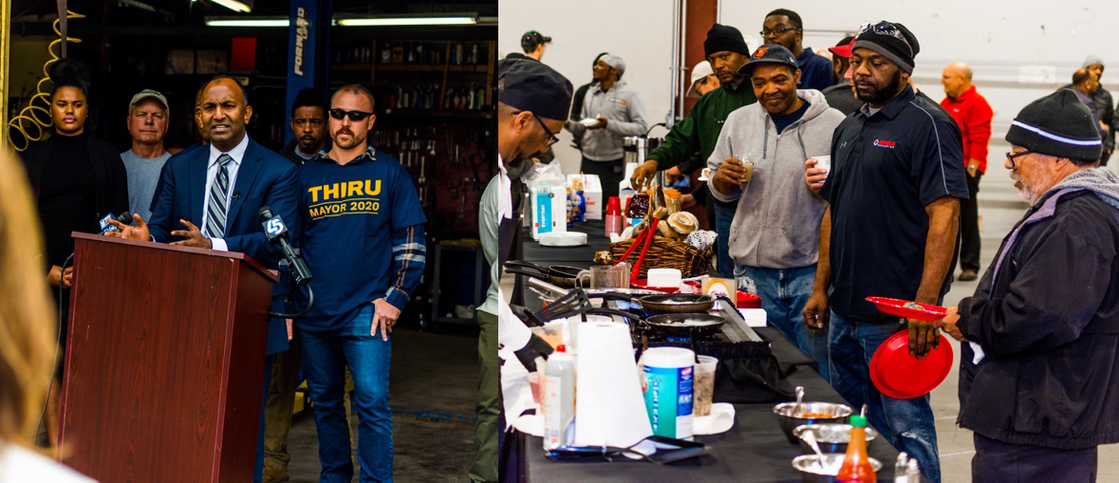

We will make Baltimore all it can be by building an economy that works for all of us – in all neighborhoods, across all walks of life. Acting on this clear, inclusive vision is exponentially more important as we enter a period of economic uncertainty resulting from the COVID-19 pandemic. Our campaign knows that low-income and minority communities are hit harder by the virus, and will face the brunt of the economic challenges it brings. Implementing long-term investments through these three-phase initiatives will directly support those most impacted by the crisis in the short-term, while ushering in a new era for Baltimore’s economy as we move to a brighter future. *The city that built the first leg of the American Railroad can once again be a nationwide leader in innovation and development. Thiru is the leader to get us there.*

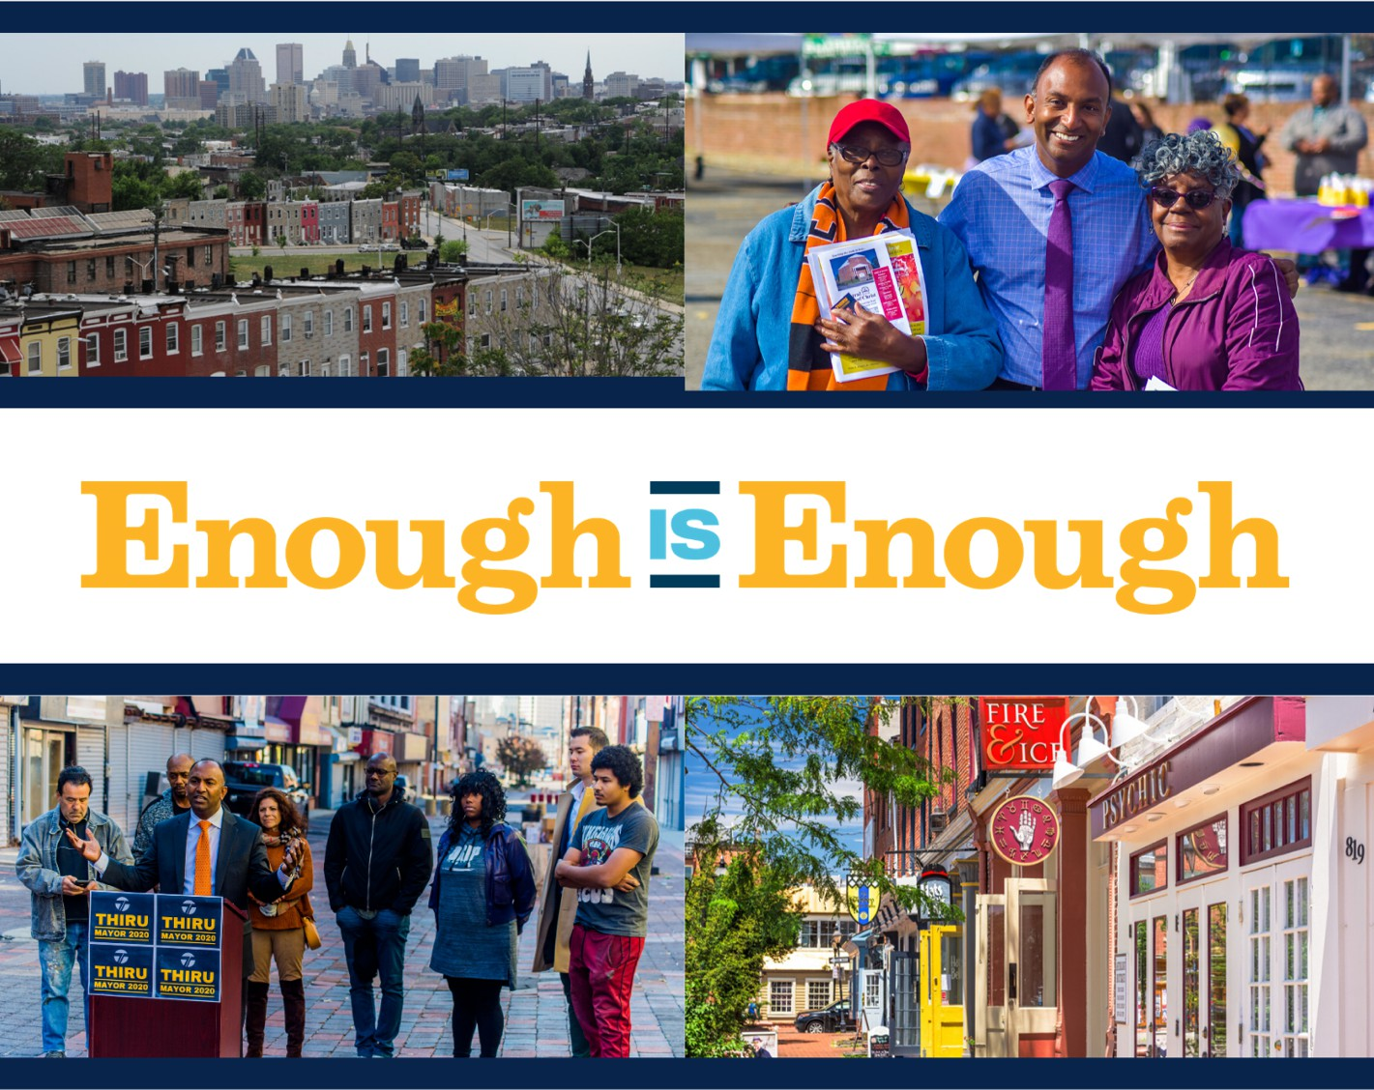

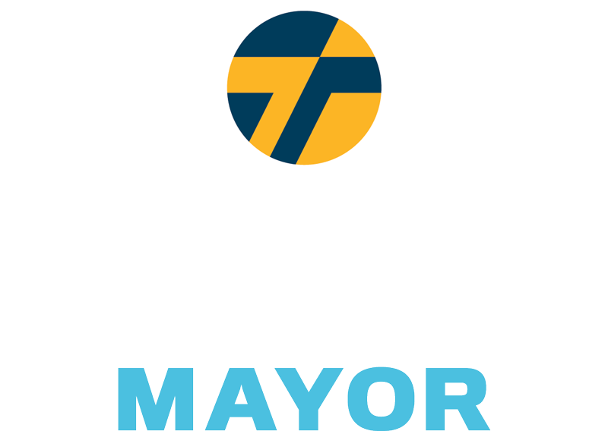

Bending the Curve on Racial Health Disparities During the COVID-19 Crisis

The COVID-19 global health crisis has exposed stark disparities in health care across Baltimore. Thiru believes everyone is entitled to equitable resources and health care, especially in times of incredible need and uncertainty. Here's his five-point plan to adress racial disparities in COVID-19 testing and treatment.

Increase Testing & Drop Referral Requirement for at-risk Populations

Right now, you must have a doctor's referral to be tested for COVID-19. Access to doctors is not universal. To protect at-risk populations, the doctor referral requirement should be lifted for anyone over the age of 50 living in the hardest hit neighborhoods, like 21215.

House Essential Workers in Hotel Rooms for Self-Isolation

Essential workers who are unable to isolate themselves at home should be offered free, alternative housing at hotels and motels for a 14-21 day period. Priority should be given to residents living in zip codes deemed to be COVID-19 hotspots.

Partner with Community Leadership and Prominent Health Care Institutions

Baltimore is home to world-class medical research facilities and hospitals. To ensure that communities that need increased testing receive the resources and treatment they need, City Hall should join our medical institutions in strategic partnerships with non-profit organizations, faith communities, and volunteers already well-established and connected on the ground.

Halt Non-Essential Demolition and Construction in COVID-19 Hotspots

Following the lead of New York and Boston, Thiru is calling for the suspension of all non- essential construction and demolition projects. Exceptions should be approved through the submission of an Essential Construction request.

Establish Modern Healthcare Infrastructure in Disconnected Communities

Thiru will partner with philanthropic organizations to provide internet and computer access to public housing units. The pandemic has revealed the importance of telemedicine infrastructure that allows patients to immediately and conveniently communicate with care providers.

Close the Medicaid and Private Health Insurance Gap

Lack of insurance forces individuals to make impossible decisions between financial security and health care. Thiru plans to restructure our insufficient insurance coverage by providing year long, city-backed medical grants to all uninsured adults that do not qualify for Medicaid coverage due to income limits.



**Beyond Data: Bending the Curve on Racial Health Disparities During the COVID-19 Crisis**

It is now clear that people of color will be infected and pass away from COVID-19 at higher rates in the United

States. Nowhere will that be more acute or obvious than in America’s cities. Here in Baltimore, city politicians

have been slow to act. Tracking the evidence will confirm for posterity what we already know, that communities

of color will be ravaged by this public health crisis just as they are disproportionately impacted by most public

health threats. We have to do better. City Hall must take drastic action to protect its citizens now and to address

the growing inequity in health care access.

In cities across the U.S., African-Americans and people of color account for a significantly higher percentage

of coronavirus deaths than their corresponding population share. Black Chicagoans are dying at six times the

rate of their white neighbors, with 68% of deaths being Black individuals who make up only 30% of Chicago’s

population. African-Americans are only 32% of Louisiana’s population; yet they are 70% of known coronavirus

deaths. Baltimore's population is 62% Black. We know that Baltimore is at risk of, if not already victim to, the

same disproportionate outcomes along racial lines.

Thiru is imploring city leadership to implement the following initiatives to help reduce coronavirus cases and

related fatalities, particularly among black and brown communities, now, and to overhaul the longstanding

inequities and systemic disinvestment that places them at higher risk. Specifically, Thiru proposes four near-

term solutions and three initiatives looking towards the horizon.

**To address immediate health care disparities in the fight against coronavirus, Thiru proposes:**

1. **Eliminating the Health Care Professional Referral Requirement for Testing**

Currently, individuals need a referral from a health care professional to receive a test for COVID-19. The

Maryland Health Department reported that 94% of COVID-19 related deaths, 284 of 302 as of April 14, were

individuals 50 and above. To further protect our most at-risk population, the health care professional referral

requirement should be suspended for Baltimore City residents who are over 50. Mass-testing is the only viable,

immediate solution to identifying and isolating individuals who are infected to prevent further spread of the

virus to vulnerable populations.

1. **Halting Non-Essential Demolition and Construction**

Non-essential demolition and construction work not only increases the potential for workers to contract

COVID-19, it can also cause respiratory problems for nearby residents with underlying health conditions. Cities

such as New York and Boston have already suspended all non-essential demolition and construction sites.

Following their lead, Baltimore should suspend all non-essential construction and demolition projects.

Exceptions will need to be approved through the submission of an Essential Construction request.

1. **Housing Essential Workers in Hotel Rooms for Self-Isolation**

Based on employment data by demographic, African-American employment is concentrated in essential

services. Four industries account for 63% of all jobs for African-Americans in Baltimore: retail trade;

transportation and warehousing; health care and social assistance; and administrative and waste management

services. We do not know the exact racial breakdown for essential employees. However, based on the sectors

that have been deemed necessary, including health care services, waste management services, transportation,

grocery stores, warehousing, and select retail stores, it is likely that African-American and Hispanic

Baltimoreans are subject to increased exposure to COVID-19. We must protect these individuals, who are

providing essential services, from unnecessarily contracting this virus.

Essential employees need the ability to self-isolate to protect their families and reduce the likelihood they

contract or spread COVID-19. Self-isolation requires individuals to have a single-occupancy room in their

home or place of residence. Following New York City’s lead, residents considered essential workers who are

unable to isolate themselves at home should be offered free, alternative housing at hotels and motels for a 14-

21 day period. Alternative accommodation should be allocated by priority based on the following: the number

of individuals at-risk of exposure in their household; if the individual lives in a zip code deemed to be a COVID-

19 hotspot; and, whether or not the individual is a member of a vulnerable or at-risk population.

1. **Increasing Testing Capacity Using Strategic Partnerships**

Baltimore is home to world-class hospitals and health research facilities. We must work with these institutions

to expand testing capacity and establish equitable distribution of resources. University of Maryland School of

Medicine, in partnership with University of Baltimore, is launching a state-funded, large-scale testing plan to

test 20,000 people per day. This will currently take months to ramp up.

To ensure communities receive resources and treatment, our medical institutions and City Hall must strategically partner with non-profit organizations, faith centers, and volunteers already well-established and connected on the ground. Particularly for low income individuals without access to private transit, some may only receive treatment at the most severe stages of their infection.

Developed partnerships will also facilitate distribution of accurate information and COVID-19 tests through pop-up centers, adequately staffed for screenings, in transit deserts and hotspots. If we are unable to safely transport potential vectors to testing locations, we must directly bring the resources to hotspot locations.

**Health care disparities will not vanish when the current pandemic abates. To restructure how Baltimore treats health needs, Thiru proposes:**

1. **Providing Access to Telemedicine Infrastructure**

Thiru has pledged to guarantee free, universal access to high-speed wifi across the city. We know families need access now, and the digital divide leaves disinvested neighborhoods at a further disadvantage -- this was true prior to this crisis, emboldened during COVID-19, and, if we do not act now, will remain a reality for years to come. City Hall will partner with philanthropic organizations to provide internet and computer access to all public housing units. The current pandemic has revealed the importance of telemedicine infrastructure that allows patients to conveniently communicate with care providers. Telemedicine eradicates transit barriers to visiting a professional and enables real-time assessment of health issues, in turn enabling quick action to treat serious concerns. Investing in digital infrastructure will also create overarching benefits to public health by allowing children to remain engaged with their education, granting access to information and news updates, and eliminating barriers to job and assistance program applications.

1. **Launching Health Intervention Program in Collaboration with Faith Communities**

Addressing entrenched health care disparities requires collaboration between the public sector and community stakeholders. The Mecklenberg Health Department demonstrated this expertly with their Village HeartBEAT program, which facilitates fun, healthy competition amongst faith based congregations to improve health metrics. In addition to competition on health indicators such as weight, exercise, tobacco use, and dietary choices, the program trains community awareness ambassadors and connects members to health services. Establishing a network in Baltimore that both encourages daily changes to improve health and identifies need for additional information and services would benefit people who have historically faced insurmountable barriers to health care.

1. **Expanding Medicaid Coverage for the Uninsured**

Testing and treatment for COVID-19 may cost up to $73,000 out-of-pocket for individuals without health insurance. According to the 2020 American Census, approximately 6.4% of Baltimore City residents under the age of 65 do not have medical insurance coverage. A global pandemic only exacerbates the existing health care inequities in our communities and victimizes those with pre-existing conditions, which occur at higher rates in minority populations. City leadership should embrace this opportunity to restructure our insufficient insurance coverage in Baltimore City by providing year long, city-backed medical grants to all uninsured adults that do not qualify for Medicaid coverage due to income limits. The Affordable Care Act provides subsidized health insurance for individuals from 100-400% of the Federal Poverty Line. These grants would provide the balance of the health insurance cost under the Affordable Care Act for those who are not covered by Medicaid. These grants can be renewed for the duration of the crisis, and/or until the recipient obtains employee-sponsored coverage or can independently afford insurance coverage.

Paid for by Thiru Vignarajah for Baltimore Tunji Williams, Treasurer

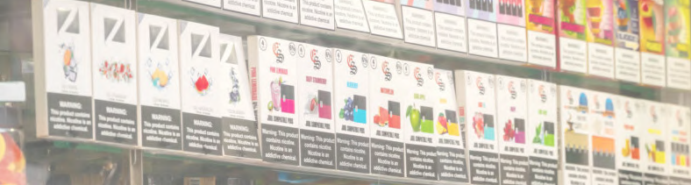

"Vignarajah’s aggressive plan to stop JUUL and the other tobacco companies will put Baltimore at the forefront of protecting the public from the dangerous and addictive e-cigarettes that are expanding the tobacco epidemic.”



*ENDING THE E-CIGARETTE EPIDEMIC*

Baltimore will ban flavored tobacco products including e-cigarettes

As the FDA and CDC have cautioned, flavored vaping and tobacco products, like cigarillos and menthol cigarettes, present a grave health risk, particularly to children. It is no accident the use of e-cigarettes and vapes among young people has exploded, as 7 out of 10 teens are exposed to e-cigarette ads. Major e-cigarette makers are pushing colorful tobacco products, using mobile platforms like YouTube and Twitter, and promoting teen-friendly flavors. Already, 10% of high school students use e-cigarettes—and more than

60 toxins have been identified in liquid flavored products. Baltimore should follow cities from San Francisco to Chicago to Minneapolis, which have prohibited flavored products to protect their citizens and children.

Enact complete prohibition of e-cigarettes in indoor public spaces

The CDC has reported that e-cigarettes not only contain nicotine, but also have lead, nickel, tin, volatile organic compounds, and diacetyl, a chemical linked to a serious lung disease. Secondary aerosol inhalation increases the risks of asthma in young children, sudden infant death syndrome, and respiratory symptoms and infections. Baltimore should build on its partial indoor prohibition, close the loopholes, and forbid smoking of e-cigarettes in all places cigarette smoke is banned, including bars and restaurants.

Initiate city lawsuit against e-cigarette manufacturer JUUL

New York City and DC recently filed major lawsuits against JUUL for illegally targeting youth and intentionally misleading consumers about the consequences of its products. According to the CDC, a single JUUL or e-liquid pod contains the same amount of nicotine as roughly 20 packs of cigarettes. Just as we sued drug companies for fueling the opioid crisis, Baltimore should join the movement of cities suing this industry for creating the latest youth health crisis.

Impose tax on e-cigarettes to fund children’s health screenings at city elementary schools

Like neighboring locales, Baltimore should impose a 50% wholesale tax on vaping products (between Montgomery County’s 30% and DC’s 96%), plus an additional $0.10/mL tax on e-liquids containing nicotine. The tax proceeds would pay for comprehensive health screenings of city elementary school children, as well as youth prevention efforts and treatment for those addicted.

Keep tobacco money out, refuse campaign donations from industry and lobbyists

Our campaign pledges to refuse political donations from tobacco and e-cigarette companies, as well as from their executives and lobbyists. The tobacco industry has made significant contributions to Baltimore leaders in order to block regulations that would protect our children from their harmful products. Citizens deserve to know that their health and safety comes first, not campaign finances and industry profits.

***“I want Baltimore to become the most inviting and hospitable city in the country for the LGBTQ+ community. No one should be judged for who they are or who they love. As a city, our policies, practices, and institutions must reflect that commitment.”***

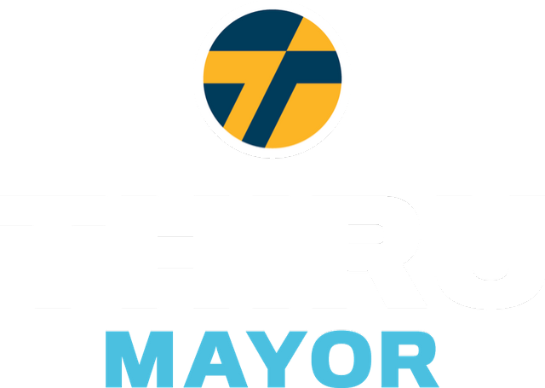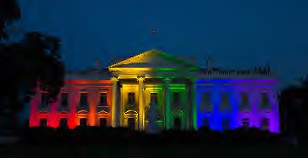

#### Thiru's policy framework for fighting discrimination and protecting the civil rights of LGBTQ+ citizens in Baltimore:

1. Promote LGBTQ+ owned small businesses, entrepreneurs, and city districts
2. Enable services to account for challenges facing LGBTQ+ youth in Baltimore
3. Prioritize inclusive workplace policies and trainings for all city employees
4. Appoint an official LGBTQ+ Liaison within the Mayor’s Executive Office
5. Address the needs of at-risk LGBTQ+ populations including veterans and seniors
6. Protect transgender citizens from crime and discriminatory police enforcement
7. Improve and expand health services for members of the LGBTQ+ community Broaden LGBTQ+ Commission’s responsibilities to include training and privacy- sensitive data collection for evidence-based policy making

8

Thiru, an advocate and ally, led the drafting of a report by the Maryland Attorney General, *The State of Marriage Equality in America*, which was cited by the Supreme Court in its landmark decision, *Obergefell v. Hodges.*



**Vignarajah Declares Solidarity, Announces Plans to Make Baltimore Most Inviting City in America for LGBTQ Community**

Our city has a vibrant and proud LGBTQ community. Thiru is dedicated to safeguarding their rights and fostering diversity and inclusivity within Baltimore. While Baltimore has made progress, members of the LGBTQ community continue to face systemic discrimination with regard to healthcare, housing, education, and employment, as well as in their day-to-day lives in the forms of stigmatization and outright violence. Thiru stands as a proud ally to the LGBTQ community and will work with local leaders to promote policies that account for the reality that discrimination manifests itself differently depending upon race, sexual orientation, and gender identity.

Thiru’s policy framework will focus on a range of issues important to Baltimore’s LGBTQ community

and aim to break remaining barriers to full equality, including:

1. Promote LGBTQ-owned small businesses, entrepreneurs, and city districts
2. Enable services to account for challenges facing LGBTQ youth in Baltimore
3. Prioritize inclusive workplace policies and trainings for all city employees
4. Appoint an official LGBTQ Liaison within the Mayor’s Executive Office
5. Address the needs of at-risk LGBTQ populations including veterans and seniors
6. Protect transgender citizens from crime and discriminatory enforcement
7. Improve and expand health services for members of the LGBTQ community
8. Broaden LGBTQ Commission’s responsibilities to include training and privacy-sensitive data collection for evidence-based policy making
9. **Promote LGBTQ-owned small businesses, entrepreneurs, and city districts**

Baltimore must invite small businesses and create business alliances across the board. That said, it can take steps to specifically assist and accommodate local LGBTQ-owned businesses as well. Thiru will incorporate LGBTQ-owned businesses into the incentive programs that function through the Office of Minority and Women-Owned Business Development, in order to rightfully acknowledge their role in providing services to the citizens of Baltimore and in creating a more inclusive, diverse space for community. Building on residential and commercial districts that serve and celebrate LGBTQ culture, Thiru will also prioritize city and private investment in welcoming, inclusive neighborhoods.

1. **Enable services to account for challenges facing LGBTQ youth in Baltimore**

*Protecting LGBTQ Identities in Schools*

In April of 2019, the Baltimore City Board of School Commissioners passed [Policy JBB](https://www.osibaltimore.org/2019/04/baltimore-city-school-board-passes-policy-to-protect-trans-students/), which ensures that transgender students have access to the restrooms of their preference and are referred to by the right gender/pronouns in class and on official documents and records. To make Baltimore’s public schools even more inclusive, Thiru will establish LGBTQ-inclusive curriculum and support LGBTQ youth anti-harassment campaigns.

*Catering Homeless Shelters to LGBTQ Youth*

According to a recent study, roughly [40%](https://nationalhomeless.org/issues/lgbt/) of the homeless youth population in the United States identify as LGBTQ. Thiru will employ the Mayor’s Office of Human Services to equip Baltimore’s pre-existing homeless shelters, along with transitional and supportive housing, with the resources to best serve LGBTQ youth, such as increased counseling staff, tailored job training, and access to health services.

*Founding a LGBTQ drop-in center*

The Department of Health and Human Services shows that LGBTQ individuals are far more likely to experience clinical depression and are roughly three times more likely to complete suicide. For these reasons, [New York City has just pledged 4.8 million dollars to opening a new 24 hour drop in center](https://www.aliforneycenter.org/programs/drop-in/) [for LGBTQ youth.](https://www.aliforneycenter.org/programs/drop-in/) Baltimore should follow the example of other cities and create its own drop-in center. The center would unite resources and actors, like schools and community organizations, around our LGBTQ youth.

1. **Prioritize inclusive workplace policies and trainings for all city employees**

Discrimination in the workplace is an unfortunate reality for many in the LGBTQ community. Baltimore City Agencies must take proactive steps to combat prejudice against their employees. In an effort to increase accountability and establish a welcoming, respectful environment for LGBTQ employees, Thiru will implement mandatory and recurring inclusivity training for city employees, beginning with new hires. The city’s existing LGBTQ Commission will head training efforts. In addition, Thiru will require there to be at least one gender-neutral bathroom in all city-owned buildings and adjust city government forms to include gender neutral language and non-binary identities.

1. **Appoint an official LGBTQ Liaison within the Mayor’s Executive Office:**

To increase the awareness of LGBTQ issues within the mayor’s executive office, Thiru will establish an official LGBTQ Liaison. The LGBTQ Liaison will convene with community members, local organizations, and relevant city entities to learn about the issues that Baltimore’s LGBTQ people face every day. The liaison will review city policies and services, communicate to government leaders when proposals fail to meet standards for LGBTQ equality, and serve as a resource for constituents who want to bring LGBTQ-related issues to city government but hesitate in fear of dismissal or misunderstanding. The appointed individuals would collaborate alongside the city’s existing LGBTQ Commission, its selected Chairperson, as well as the Liaison Officer within the Baltimore City Police Department.

1. **Address the needs of at-risk LGBTQ populations including veterans and seniors**

[Veterans who identify as LGBTQ face increased health risks and unique challenges in health care.](https://www.baltimoresun.com/health/bs-hs-elderly-lgbt-20150927-story.html) Thiru will lead Baltimore in conjunction with the Veterans’ Commission to collect data on LGBTQ veterans and provide them with the appropriate health benefits and services. He will also employ legal experts to aid veterans who were wrongfully subject to discrimination during service or the “Don’t Ask Don’t Tell” policy upon discharge.

Thiru will also strive to aid Baltimore’s LGBTQ population, who are more prone to health issues and suffer from rising housing costs. He will prompt the LGBTQ Commission and LGBTQ Liaison in the Executive Office to advocate on behalf of the senior LGBTQ population, push for affordable housing options, and inform senior-care facility managers, employees, and residents of relevant anti-discrimination laws.

1. **Protect transgender citizens from crime and discriminatory enforcement**

The nationwide surge in violent hate crimes against the transgender community is both heartbreaking and unacceptable[.](https://www.hrc.org/blog/hrc-mourns-tydi-a-black-transgender-woman-killed-in-baltimore) [Baltimore has seen multiple incidents of transphobic related violence.](https://www.hrc.org/blog/hrc-mourns-tydi-a-black-transgender-woman-killed-in-baltimore) Thiru will work with the LGBTQ Commission Chairperson, the LGBTQ Liaison to the Executive Office, and LGBTQ Liaison Officer to bolster relationships between law enforcement and the transgender community. Further measures include 1) requiring the LGBTQ Officer to submit statistics and reports on LBGTQ-related crimes to the Mayor’s Office, 2) monitoring the Police Department’s fulfillment of and training related to [Policy 720](https://www.baltimorepolice.org/sites/default/files/Policies/720_Lesbian_Gay_Bisexual_And_Transgender_Involved_Incidents_0.pdf) [(2018 draft here](https://www.powerdms.com/public/BALTIMOREMD/documents/349766)) and 3) incorporating recruitment of LGBTQ individuals into Baltimore’s police force within crime policy proposals and halting discriminatory practices such as unnecessary trespass and loitering arrests.

1. **Improve and expand health services for members of the LGBTQ community**

*Mental Health*

[LGBTQ individuals, especially youth, are more than twice as likely to suffer from a mental health](https://www.psychiatry.org/File%20Library/Psychiatrists/Cultural-Competency/Mental-Health-Disparities/Mental-Health-Facts-for-LGBTQ.pdf) [condition compared to non-LGBTQ identifying individuals.](https://www.psychiatry.org/File%20Library/Psychiatrists/Cultural-Competency/Mental-Health-Disparities/Mental-Health-Facts-for-LGBTQ.pdf) Thiru will provide more accessible and affordable mental health services tailored to the LGBTQ community under a new mental health program within the Baltimore City Health Department. This initiative will create a new LGBTQ- specific mental health hotline and foster partnerships with school counselors and youth centers/organizations to provide mental health resources where currently insufficient.

*Appropriate/Inclusive Treatment and Care*

Often a doctor’s office can be an uncomfortable and vulnerable space for LGBTQ individuals. Thiru will encourage efforts to provide inclusive medical care to members of the LGBTQ community, following models similar to Johns Hopkins’ “Embracing the Rainbow” program. These initiatives will encourage respectful communication between LGBTQ patients and medical professionals, and emphasize training focused on gender-neutral questioning and non-binary options to medical inquiries.

*Partnerships with Health Professionals*

Institutions such as the Baltimore City Health Department the Mayor’s Office of Human Services will partner with local healthcare providers, state and federal agencies, and community groups to promote LGBTQ health and foster efficient collaboration. Health issues such as HIV prevention and treatment will receive particular attention.

1. **Broaden LGBTQ Commission’s responsibilities to include training and privacy-sensitive data collection for evidence-based policy making**

In early 2018, Baltimore City passed an executive o rder to create a city-sponsored LGBTQ Commission, which comprises 15 community members who offer insights and recommendations to promote the prosperity of LGBTQ Baltimoreans. This executive order was a vital decision to further equality-driven policymaking, but there is more we can do to integrate and support the Commission. Thiru would expand its responsibilities, while ensuring access to required resources. The Commission would lead research on issues pertaining to the community and manage inclusivity and diversity training for city employees and external parties.

Too often we fail to collect LGBTQ specific data to inform the allocation of resources, rendering the massive disparities experienced by members of the LGBTQ community — particularly transgender people — invisible to policymakers. With the Commission’s help, Baltimore can study, investigate, and close the gaps in health, income, and well-being outcomes that the LGBTQ community experiences, collecting data that respects individual and community privacy. Involvement through government or third-party training, in schools or medical facilities, will heighten the Commission's visibility and fulfill an essential arm of community outreach.

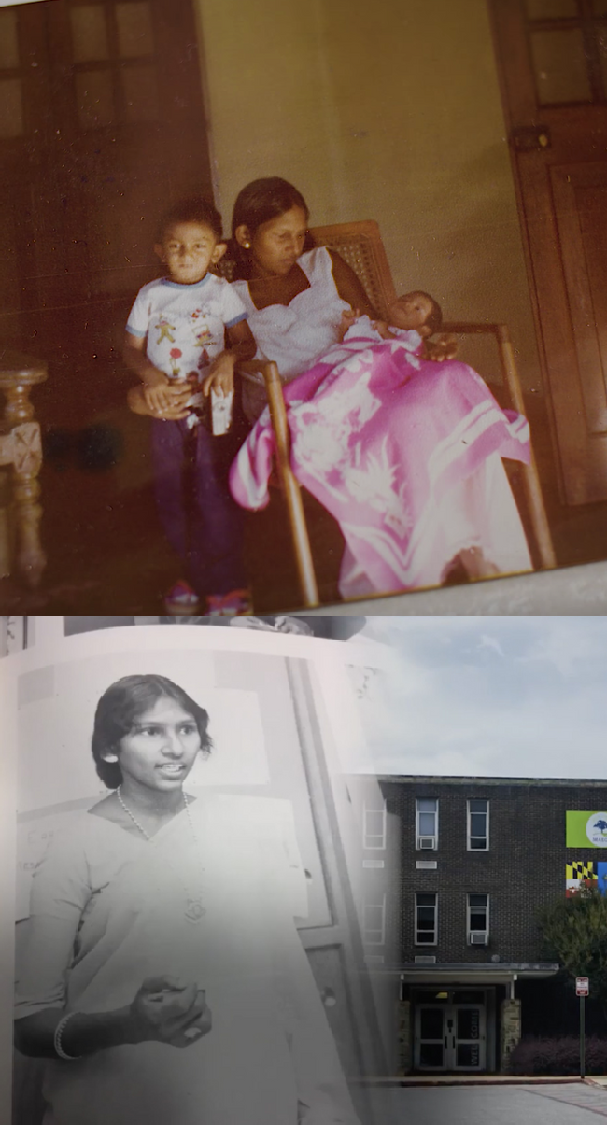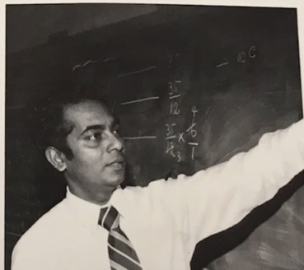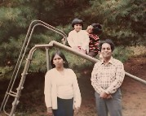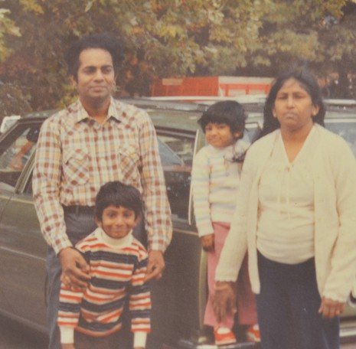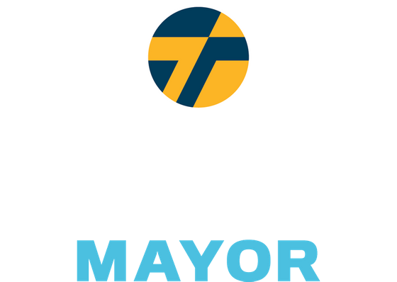

*Aspiring to become the most inviting and hospitable city in the country for immigrants and refugees, Baltimore should be the Plymouth Rock and Ellis Island of the next century."*

*Thiru's Plan to Safeguard & Support Immigrants*

Thiru's family fled a civil war and came to Baltimore when he was three. Both dedicated city school teachers, his mother taught at Poly and Morgan State, and his father taught at Edmondson, Douglass, Southern, and Western. His family's commitment to public service is not an unfamiliar story. Immigrants have always been an essential force in forging Baltimore’s vibrant culture and history. Thiru strives to make Baltimore welcoming to immigrants from all around the world: a place to raise their families, build a life, and call their home.

*This is not just the American Dream – it is the Baltimore Dream too.*

Guarantee Legal Proceedings & Right to Counsel

Amend the city charter to guarantee legal proceedings and a right to counsel, with a translator if neccessary, for those who face deportation

No Support for ICE

Promise no money or effort will be directed towards supporting ICE

Bar ICE from sensitive locations like places of worship, hospitals, and courthouses Encourage victims and witnesses to cooperate in human trafficking, violent crime, and domestic violence cases

Prioritize Civil Resolution & Recruit Immigrant Officers

Work with state government to direct police to pursue civil remedies/diversion options prior to arrest for non-violent offenses where deportation is a disproportionate response Recruit more immigrant police officers and remove bar on permanent residence

Invite Cultural Exchange

Hold events to celebrate Baltimore's immigrant populations Offer more affordable language classes for community members

Establish H-1B Visa Matching Program

Pair immigrant workers with local employers, non-profits, and municipal agencies

Heighten Representation & Outreach

Appoint liaisons/translators to speak to City Hall on behalf of community advisory boards

Improve coordination within the Mayor's office to offer consistent, quality, and easily- accessible resources to programs and information

Expand Municipal ID Program for Non-Citizen Residents

Broaden access to city-run assistance by providing valid ID to non-citizen residents Secure non-resident participation in decisions regarding the local school board

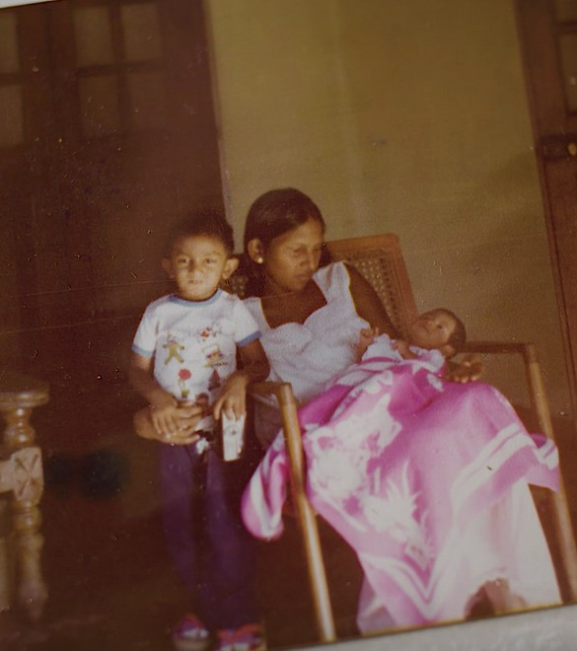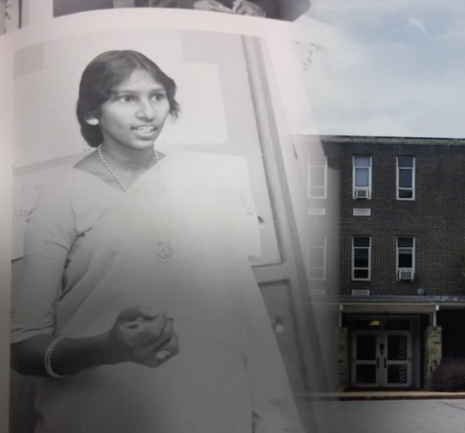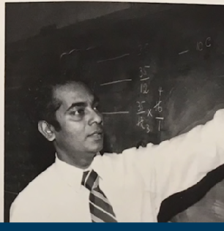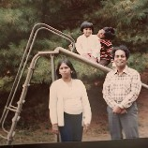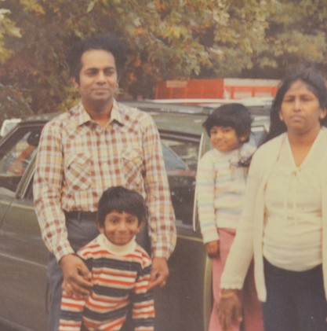

*Aspirando a ser la ciudad mas atractiva y hospitalaria en el país para los inmigrantes y refugiados, Baltimore debería ser el Plymouth Rock y Ellis Island del próximo siglo.*

*El Plan de Thiru para Asegurar y Auydar a los Inmigrantes*

La familia de Thiru escapó de una guerra civil y vino a Baltimore cuando él tenía tres años. Sus padres eran maestras dedicadas en la ciudad, su madre trabajó en Poly y Morgan State, y su padre trabajó en Edmondson, Douglas, Southern, y Western. El compromiso de su familia al servicio publico no es una historia desconocida. Los inmigrantes siempre han sido una fuerza esencial, forjando la cultura vibrante y la historia de Baltimore. Thiru se esfuerza para hacer de Baltimore una ciudad acogedora a los inmigrantes de todo el mundo: un lugar para crecer a la familia, construir una vida, y llamarlo hogar.

*No es simplemente El Sueño Americano, es El Sueño de Baltimore también.*

Garantizar Procedimientos legales y el derecho al consejo

Enmendar la Carta de la Ciudad para garantizar procedimientos legales y el derecho al consejo, con derecho a servicios de traducción, para aquellos en peligro de deportación.

No apoyo para ICE

Ni fondos ni esfuerzos serán proporcionados al ICE.

No permitir que ICE entre en locales sensitivos como iglesias, hospitales, y cortes.

Apoyar las victimas y los testigos a cooperar en casos de la trata de personas, de crimen violenta y de la violencia doméstica.

Dar prioridad al remedio civil & recultar policías inmigrantes

Trabajar con el gobierbo estatal para hacer que la policía recurra al remedio civil y desvío previo al arresto para las ofensas no violenta donde la deportación es una respuesta desproporcionada.

Contratar con mas inmigrantes para ser policía y quitar el requisito de residencia permanente

Invitar intercambio cultural

Tener eventos para celebrar la población inmigrante de Baltimore.

Dar mas clases de lenguaje económico para miembros de la comunidad.

Establecer un programa coincidente de H-1B Visa

Acoplar trabajadores inmigrantes con empleadores locales, las organizaciones sin fines de lucro, y agencias municipales.

Crecer la representación y programas de divulgación

Nombrar contactos y traductores para hablar con la alcaldía en los consejos consultivos de la comunidad

Mejorar la coordinación con la oficina del alcalde para dar recursos constantes, de calidad, y fácilmente accesible para programas y información

Ampliar el programa de identificación municipal para residentes no ciudadana

Ampliar el acceso a la ayuda de la ciudad dando identificación válida a los residentes no ciudadanos

Asegurar la participación de la gente no residente en las decisiones que afectan a las escuelas locale

*SQUEEGEEING ALTERNATIVE PLAN*

Squeegeeing emerges from the complex problems that have plagued Baltimore for generations: a lack of economic opportunity, unaccountability in our broken public schools, a sweeping opioid epidemic, and rampant crime that disproportionately affects Black and Brown communities. Getting individuals off the streets and into well-paying, stable jobs, as well as connecting them to the resources they need, will require a multifaceted, comprehensive approach.

Squeegee boys are not one monolithic group. These individuals have unique motivations and needs that prompt their decision to turn to squeegeeing. We see three distinct categories of individuals and realize each will require a personalized engagement strategy:

Those who squeegee to provide for themselves and their families

Victims of addiction, mental illness, or have backgrounds impacted by substance abuse

Those who are committed to squeegeeing regardless of diversion attempts

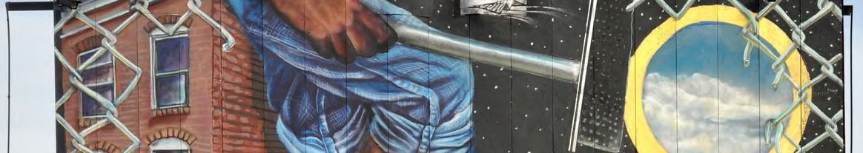

Open pathways for advancement in education or employment Provide health, addiction, housing, or job placement services Take the tools of their trade to raise the cost of doing business



**FROM SQUEEGEES TO SAFETY AND SUCCESS**

Squeegee boys have become, fair or not, a symbol of Baltimore’s current plight. To some, they are an unfortunate marker of a city led by complicit politicians and failing schools that do not provide people, youth especially, with meaningful job opportunities and career advancement pathways. For others, they represent a menacing presence that deters them from bringing their families downtown. At a different time in Baltimore’s history, these squeegee workers would not pose such a challenge to residents and elected officials. However, with record violence, they are an ever-present reminder that Baltimore’s leaders are failing to connect the dots and support the individuals who may need it most.

We know that interactions between drivers and squeegee boys can turn aggressive. In January 2020, we saw the heart-wrenching video of a man senselessly beaten by squeegee boys on the corner of President and Lombard. Not only do commuters feel threatened, but squeegee boys also put themselves into danger darting in between busy traffic. In October of 2018, a ten-year-old squeegee boy was injured after being struck by a car; in 1986, a fourteen-year-old squeegee boy was fatally hit by a vehicle. City Hall has yet to move the needle in a way that instills confidence that we can avoid another tragedy — we don’t need another incident to learn from our past.

Squeegeeing emerges from the complex problems that have plagued Baltimore for generations: a lack of economic opportunity, unaccountability in our broken schools, a sweeping opioid epidemic, and rampant crime that disproportionately affects black and brown communities. Getting individuals off the streets and into well- paying jobs, as well as connecting them to the resources they need, will require a comprehensive approach.

**Identify What Drives Individuals to Squeegeeing**

Squeegee boys are not one monolithic group. These individuals have unique motivations and needs that prompt their decision to turn to squeegeeing. Thiru and his team see three distinct categories of individuals and realize each will require a personalized engagement strategy:

1. Those who squeegee to provide for themselves and their families
2. Those who squeegee and are themselves struggling with addiction or mental illness or come from backgrounds impacted by substance abuse
3. Those who will attempt to continue squeegeeing regardless of diversion attempts

Baltimore’s existing programming and services are disjointed and do not sufficiently provide the wraparound care that will lead to sustainable outcomes. To best engage with squeegee workers, we need to personally meet them where they are. Squeegeeing is limited to the few corners with the highest traffic volume. Our team went to the street corners, collected anecdotal evidence, and spoke with these young people, realizing that squeegeeing primarily occurs on fourteen corners:

**Map of Top Squeegee Locations as identified by the Thiru for Baltimore Team**

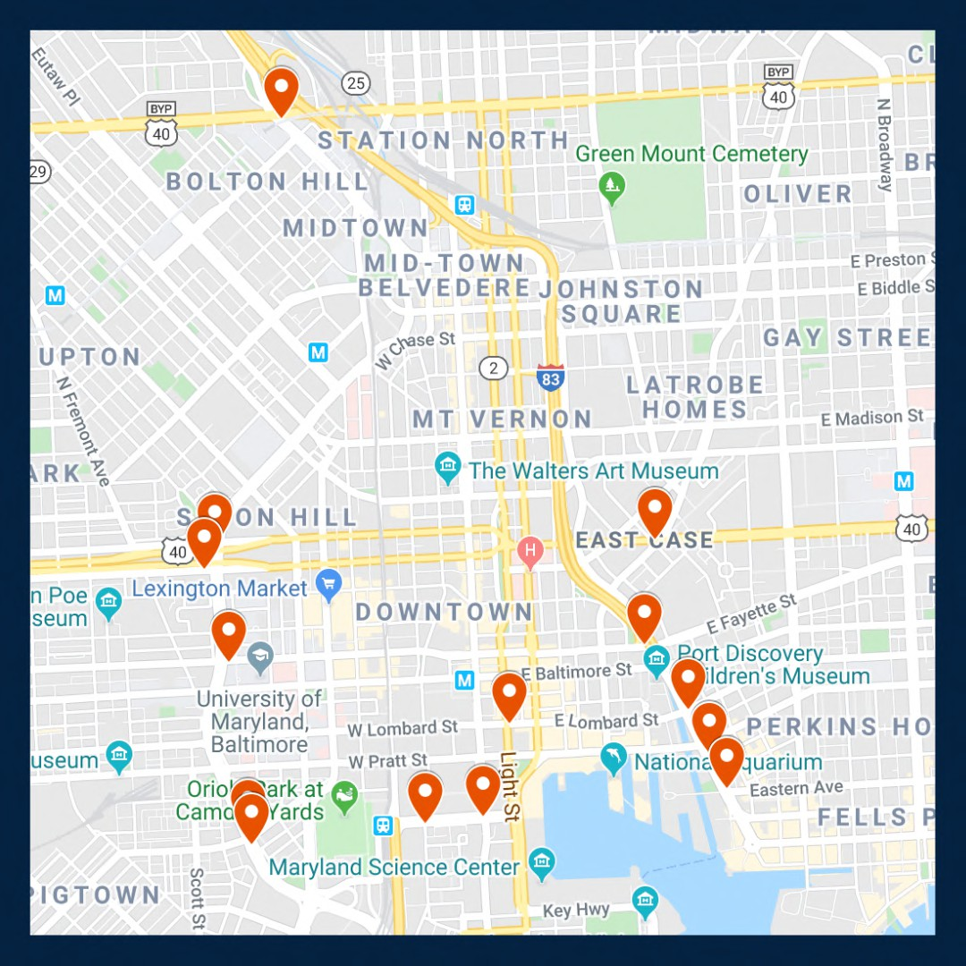

As mayor, Vignarajah pledges to:

1. Ensure squeegee boys are aptly connected to pathways to advance their education or gain secure employment with advancement opportunities
2. Recognize squeegee boys with addiction, mental illness and/or homelessness limitations that require health, addiction, housing, or job placement services and promptly facilitate access to those programs
3. In unique cases, where individuals will continue to turn to squeegeeing regardless of alternative options, take the tools of their trade to raise the cost of doing business

**Create Alternative Work Programs that Compete with the Benefits of Squeegeeing**

*Facilitate Job Interviews Between Squeegee Boys and Local Businesses*

City leaders cannot pretend that creating a stable nine-to-five job that pays $15 an hour, before taxes, can ever compete with the perks of being a squeegee boy. We must acknowledge that they can in some instances make

$30 to $50 an hour, can come and go as they please, and report to no one but themselves. Nevertheless, we must present an alternative employment opportunity that is attractive to these young people.

Thiru has already started partnering with local businesses to provide squeegee boys with secure employment and in turn, advancement opportunities. Thiru will hire liaisons to assist squeegee boys interested in pursuing a stable, permanent career and connect them with local businesses that are willing to offer employment. While meaningful employment may present new challenges to these individuals, it can teach valuable skills, such as how to build a schedule, how to remain accountable to a team, how to build a relationship with a supervisor, and how to follow codes of conduct. The greatest opportunity provided by employment in local businesses is upward mobility. These opportunities will open an avenue for progression otherwise difficult to obtain for many of these young men, and certainly not available on a street corner.

We have refused to wait for city politicians to take action, or even for the election, to implement a program that can provide immense benefits for our economy and these young men. Squeegee boys and local businesses interested in participating should email [opportunity@thiru2020.com.](mailto:opportunity@thiru2020.com)

**Station Unarmed, Site-Specific, Deputized Community Liaisons at the Busiest Corners**

*Bring Resources to Street Corners*

Deputized community liaisons will positively interact with squeegee boys in their designated zone, building relationships and trust. Liaisons will not take away resources from our struggling police force -- instead, these liaisons will receive specific training on de-escalation techniques, and curate a specific policy for positive and appropriate engagement with squeegee boys.

Part of this positive engagement will include identifying school-aged individuals, in partnership with the relevant schools and after-school employment or programming, where applicable, who should be required to return to their education. Each deputized liaison will receive access to point contact information for all middle and high schools in Baltimore City. The City can encourage and support heightened collaboration between the liaisons and educators/administrators to redirect these young squeegee boys back to the classroom, while making sure their needs are met and they have the guidance, resources, and support to thrive.

These deputized community liaisons would also be trained on identifying vulnerable individuals in need of social services and City programs. They will receive training on recognizing who is suffering from food insecurity, addiction and mental illness, or housing troubles, so as to connect those individuals to appropriate experts and resources. This will take the form of Seattle’s Law Enforcement Diversion Programs (LEAD) which provides a credible alternative to booking individuals with behavioral health needs for low-level offenses. Instead of creating criminal entanglements, LEAD diverts these individuals to community-based interventions including housing, addiction, mental illness and health services.

*Raise the Cost of Doing Business*

Baltimore’s squeegee boys are making calculations on how to make ends meet. Some will not be receptive to alternative job opportunities because of the lucrative cash flow squeegeeing provides. That being said, we need to change the calculation by not only introducing consistent and favorable options for skill development and upward mobility, but also by increasing the cost of doing business in the streets by confiscating the tools of their trade. In accordance with the Baltimore City Code and working in conjunction with Community Liaisons; site-specific, unarmed private security guards who have been temporarily granted limited policing power will have the ability to confiscate squeegees. They will have no authority beyond their stationed corners, but this narrow power will raise squeegee boys’ opportunity costs. Article 19, Section 47-4 of the code grants police the authority to restrict solicitation “from any operator or occupant of a motor vehicle that is in traffic on a public street, whether in exchange for cleaning the vehicle’s windows or otherwise.”

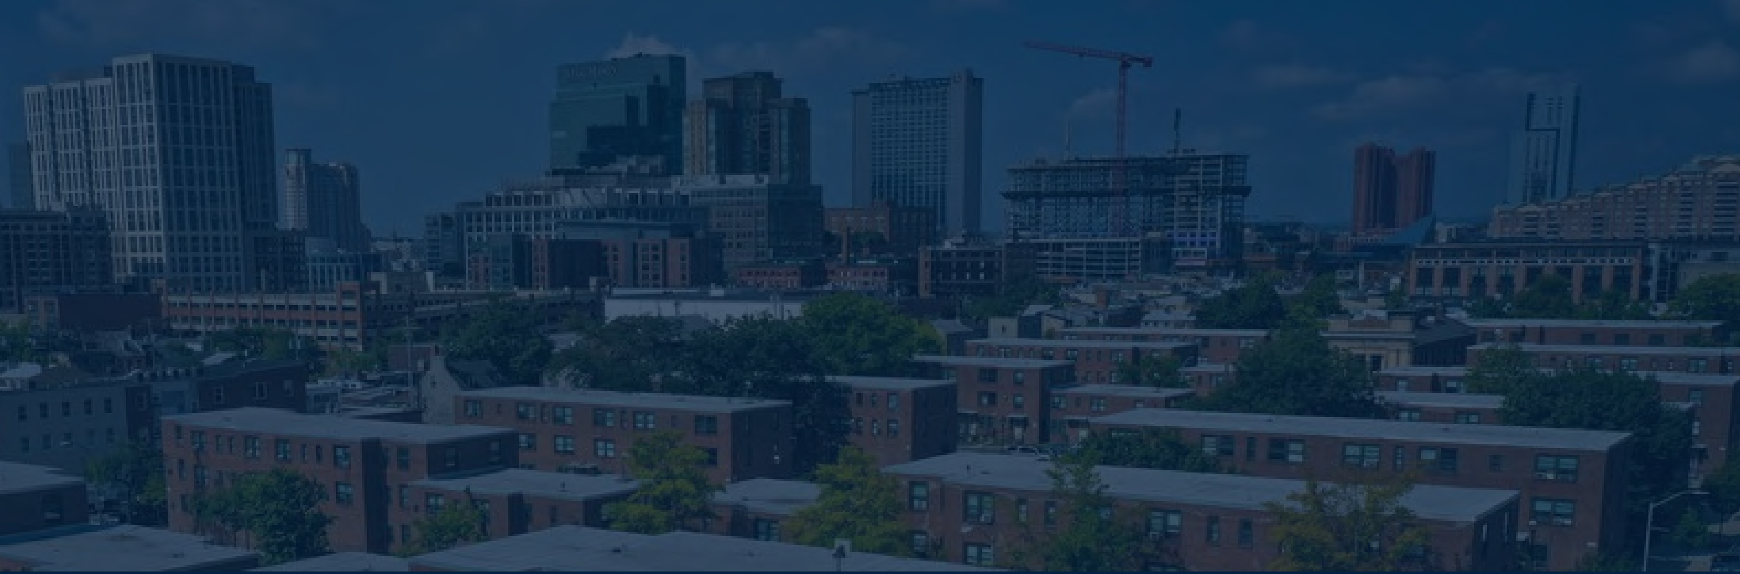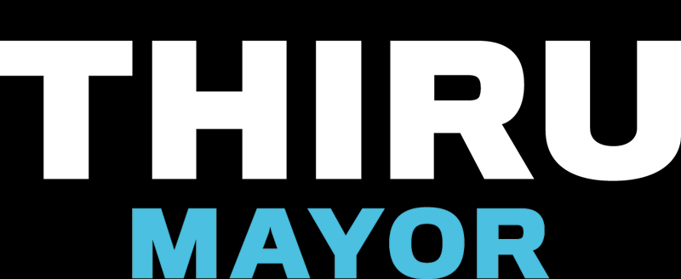

LEGALIZING CANNABIS IN BALTIMORE

The marijuana marketplace in Baltimore is currently a chaotic free-for-all. The illegal trade contributes to record violence, and the medical trade is not taxed. Mayoral Candidate Thiru Vignarajah has pledged to make Baltimore the first city in America to regulate and tax marijuana without waiting for federal or state approval.

# Devote Tax Revenue to Public Education Priorities

All City revenue would be directed exclusively to key education programs:  Universal pre-K for every 3- and 4-year-old child

 Debt-free higher education for public high school graduates, including trade school  Funding to grow the endowments of HBCUs

# Establish City Agency to Manage the New Market

Appoint board members who will develop permit criteria; fix taxes and regulations; and issue growth, processing, sale, and “cannabis café” permits

Create a safety board that will ensure recreational cannabis is safe and free of dangerous additives

# Guarantee Access and Equity for Communities of Color

Frustration continues to grow as communities of color—who disproportionately



shouldered the burdens of the failed War on Drugs—are now being effectively excluded

from the profitable new market. Baltimore will

issue

by

permits preferentially to

enterprises

owned,

operated,

and

controlled

historically-disadvantaged

minorities and those who commit to hire returning citizens with non-violent criminal

records seeking constructive employment.

Establishing a legal cannabis market in Baltimore would

produce $250 million in annual revenue for the City.



**Reduce Crime, Create Jobs & Increase Investments in Education**

**by Regulating and Taxing Baltimore’s Marijuana Market**

*Mayoral candidate Thiru Vignarajah announced a bold plan to issue permits and tax the cannabis trade in Baltimore to reduce crime, create well-paying jobs, reduce overdoses, and fund universal pre-K for every Baltimore child.*

The marijuana marketplace in Baltimore is currently a chaotic free-for-all. The illegal trade contributes to record violence while depriving taxpayers of hundreds of millions of dollars. The illegal street market operates unimpeded as police and prosecutors publicly squabble about whether to enforce current laws, even as street marijuana is increasingly laced with fentanyl and K-2. Medical cannabis is booming but cannot be taxed and has virtually no licensed distributors of color.

Bottom line: a billion dollars is spent on cannabis products each year, which largely ends up in the monopoly hands of untaxed licenses and violent gangs and drug organizations.

This is the worst of all worlds. Violence is unabated; avoidable overdoses persist; and drug proceeds remain locked in a violent black market. Moving the cannabis trade into a well-regulated, transparent market and out of the shadows will (1) reduce gun violence driven by competing gangs, (2) decrease overdose deaths from laced marijuana, (3) reduce opioid addiction and overdoses; (4) mitigate the racial wealth gap, and (5) provide vital revenue to fund universal pre-K, finance repairs and upgrades at K-12 school facilities, guarantee free college in Maryland for public school graduates, and grow HBCU endowments. Baltimore City cannot afford to wait for indecisive lawmakers in Annapolis to take action while the City suffers from the failed war on drugs.

Just as Colorado and other states have issued permits and taxed the sale of cannabis, even though it remains illegal under federal law, so too should Baltimore City issue sales permits and tax cannabis. The same people who think Baltimore City has to wait for Maryland law to change thought Colorado had to wait for federal law to change. It’s time for Baltimore to lead, not follow.

**Issue Permits to Baltimore Businesses to Aid Communities of Color**

When it comes to marijuana, the war on drugs has been a colossal failure. For decades, communities of color have disproportionately shouldered the costs of Baltimore’s enforcement policies. The communities who were most devastated by the failed policies of the 1980s ought to be the first to benefit from this emerging market.

* Permits will be preferentially issued to enterprises owned, operated, and controlled by historically disadvantaged business owners of color.
* Permits will be issued to distributors owned, operated, and controlled by local businesses.
* Permits will be preferentially issued to enterprises who commit to hire employees with non- violent criminal records who are seeking legitimate employment opportunities.

**Require Tax Proceeds be Spent Strictly on Public Education Programs**

The emerging cannabis market would produce $250 million in annual revenue for Baltimore City. Maryland and neighboring states will inevitably legalize marijuana, but there is a first-mover advantage in this industry that the City should seize. In the past, residents have been promised funds for education from controversial ventures like casinos only to see money diluted or redirected to other priorities. This won’t happen again.

* All cannabis tax proceeds will be strictly dedicated to key education programs, starting with

(1) universal pre-K for every 3- and 4-year-old child, (2) repairs and improvements at K-12 facilities, (3) debt-free 4-year college, community college, or trade school for Baltimore public high school graduates, and (4) funding to grow the endowments of HBCUs.

* These funds will be used only to support new programs and to supplement, not replace, current funding sources for the expansion of existing programs.

**Establish Infrastructure to Manage Complex Emerging Market**

* The City will establish a commission composed of community members, with no conflicts, who will manage and make permitting decisions. The process and decision-making will be fully public and transparent so there are no doubts who made the decision and why.
* The City will create a city-operated credit union that holds the proceeds of cannabis sales, collects taxes and distributes them immediately to vital education programs, and eventually makes its reserve funds available for low-interest student and small business loans.
* The City will create a safety board that will ensure that recreational cannabis is safe and free of dangerous additives like fentanyl and will create and communicate clear regulations about when, where, and how the product can be sold and used.

In theory, in states like Colorado, prosecutors could bring charges under federal drug laws anytime. In practice, they never have. The premise of the proposed approach is that prosecutors in Baltimore have better things to do with their time than to go after permitted, minority-owned cannabis dispensaries based in Baltimore who hire residents desperately trying to obtain legitimate employment to turn their lives around. Issuing city permits and collecting taxes would no more make the sales legal under state law than issuing state licenses makes the sales legal under federal law. But, with ingenuity and leadership, we can still bring the marijuana trade out of the dangerous shadows—where gangs kill over turf—and create a safer market that redresses racial inequities and generates massive tax revenue at a time when Baltimore desperately needs it.

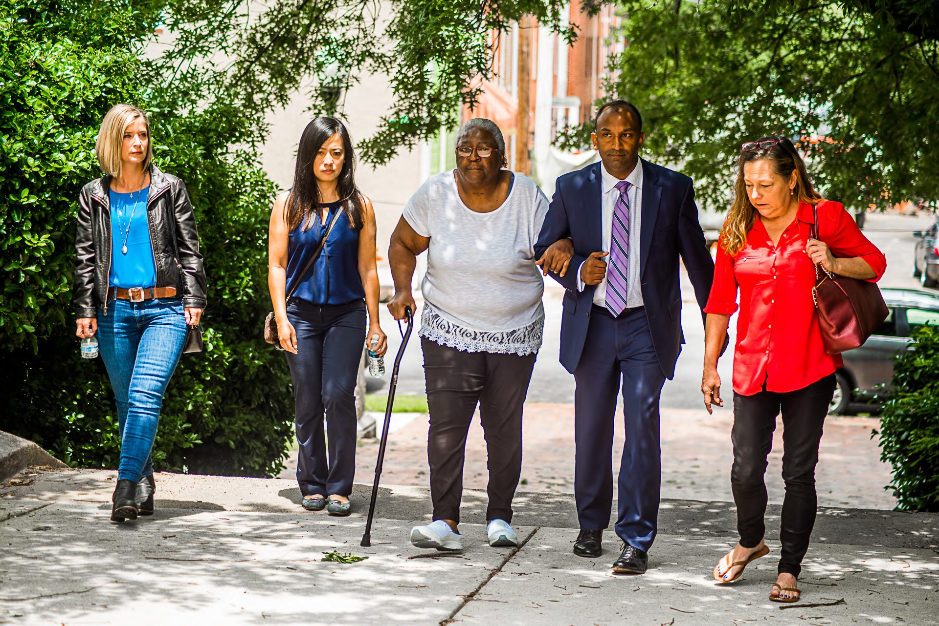

Backing Baltimore's Businesses

If Baltimore is to become the city it’s destined to be, the backbone of its economy must be small businesses. Here are Thiru's key priorities and concrete ideas to foster a welcoming, sustainable environment where businesses can thrive today and tomorrow...

#### Guarantee Public Safety

Create a safe and secure atmosphere around businesses by ensuring sufficient public and private policing

Reduce crime around businesses by providing incentives to purchase, install, and register cloud-based security cameras

#### Reduce the Costs of Doing Business in Baltimore

Cut property taxes in half over a period of ten years End minor privilege and permitting fees

Expand free parking near shops and restaurants Introduce low-interest rainy day loans for small businesses

#### Encourage Entrepreneurship, Diversity & Innovation

Pledge health insurance coverage for up to seven employees for companies that stay in Baltimore for at least five years

Recruit small businesses with a national marketing campaign

Provide tax incentives to encourage growth of small businesses owned and operated by minorities, women, members of LGBTQ and immigrant communities

YOUR DREAM HOME IS

WAITING FOR YOU.

LOCATED AT 2749 CONIFER DRIVE EVERETT, WA

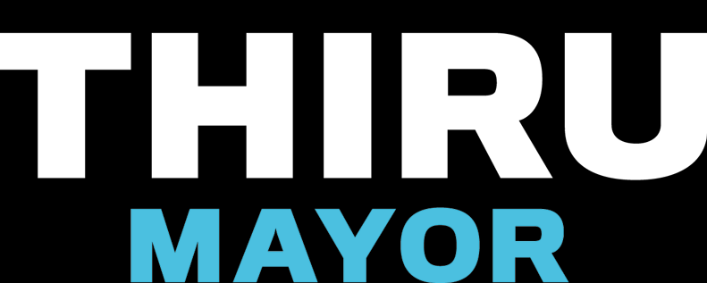

From The Wire to Veep, from the Star Spangled Banner to jazz, Baltimore’s rich history in art, film, and music is a source of pride and engine for growth.

Baltimore has all the promise to once more be a leader in the arts. But building an economy around art, film, and music will not happen on its own. City Hall must play a central role to ignite this industry.

THIRU'S PLAN TO REVITALIZE THE ARTS IN BALTIMORE

Expand and support the creation of additional arts and entertainment districts in addition to Station North, Highlandtown, and Bromo Tower

Extend tax-free income benefits in art districts to cover more artists, including, for example, musicians, spoken-word performers, and filmmakers

Create an "artists in residence" program. Participating artists and musicians would receive healthcare and a stipend in exchange for committing to teach their art in public schools and promote art in Baltimore's communities

Lead a capital campaign to raise funds from private donors in order to reinforce the shaky financial foundation of the Baltimore Symphony Orchestra

Re-establish incentives to encourage television producers and filmmakers to set their works in the city

Launch a mural initiative that matches local artists, potential donors, and community hosts to collaboratively beautify Baltimore